# 



Standard N of 1 Deployment Guide

**Version 2.2.0**

**Review and Approval Log**

|  |  |
| --- | --- |
| **Prepared by** | **Role: Author** |
|  | |
| **Reviewed and Approved by** | **Role: Product Management** |
|  | |
| **Review and Approved by** | **Role: Professional Services** |
|  | |

**Document Control History**

|  |  |  |  |
| --- | --- | --- | --- |
| **Date** | **Version** | **Description** | **Author** |
| 08/07/2019 | 1.0.0 | Initial Draft | Bhanush Goswami |
|  |  |  |  |
|  |  |  |  |
|  |  |  |  |
| **Approval Signature** | | | |
|  | | | |

**N of 1** names, logos, all related trademarks, and trade name are the property of **Digital Infuzion, Inc**. and cannot be used without its express prior written permission. All other actual product or company names may be trademarks or registered trademarks of their respective owners.

All materials contained within this document and the **N of 1** product are protected by copyright laws and may not be reproduced, distributed, transmitted, displayed, broadcast or otherwise exploited in any manner without the express prior written consent of **Digital Infuzion, Inc**.

Contents

1. Overview 6

**1.1.** **Conventions** 6

**1.2.** **Definitions, Acronyms and Abbreviations** 6

2. Prerequisites 7

**3.** **Create the new environment** 7

**3.1.** **Setup parameter values and create parameter file** 7

**3.2.** **Create environment file and shared environment file** 10

**3.3.** **Create Azure Environment** 13

4. Generate Self-Signed Certificate 19

5. Setup B2C 19

**5.1.** **Setup CORS on the storage container** 19

**5.2.** **Create azureadb2c container and upload B2C templates** 21

**5.3.** **Create B2C tenant** 23

**5.4.** **Create and configure Portal application** 28

**5.5.** **Configure Identity Providers** 32

**5.6.** **Configure Sign-up policy** 35

**5.7.** **Configure Sign-in Policy** 47

**5.8.** **Set Password Reset Policy** 52

**5.9.** **Set-up e-signature policy** 58

**5.10.** **Company branding** 64

**5.11.** **Set Self-Service Password Reset Policy** 70

6. Platform and Datawarehouse Database Deployment 70

**6.1.** **Take backup of existing database** 70

**6.2.** **Get the latest version of your database project** 70

**6.3.** **Steps for doing first time deployment** 71

7. Solr Setup 77

**7.1.** **Refresh Solr indexes.** 86

8. Setup and Deploy WebAPI and Webjobs 87

**8.1.** **Create the background App Service** 87

**8.2.** **Upload Self-signed certificate in the App service and the background App Service** 89

**8.3.** **Deploy BackgroundTaskWebJob** 91

**8.4.** **Deploy API App service** 94

**8.5.** **Create and Deploy the ServiceBusWebjob** 96

**8.6.** **Deploy OdmProcessorWebjobs** 97

9. Add templates in the Storage Container 98

10. Deploy Batch Pool Account 98

11. Setup Cosmosdb 105

12. Create Study Build 108

**12.1.** **Extract SDS for each study and version** 108

**12.2.** **Convert the SDS spreadsheet to JSON** 112

**12.3.** Fix the study build ODM file 113

**12.4.** **Create the item level ODM files** 113

13. Deploy Data-factory 113

14. Create Service bus account 119

15. Create Graph API Service Principal 121

**15.1.** Set up for password Reset 123

16. Create and Populate Configuration Table 123

17. Configure Keyvault and Upload the KeyVault Secrets 125

**17.1.** **Register an app in Azure AD for Keyvault and Generate App key** 125

**17.2.** **Add default users to the Active Directory Application** 127

**17.3.** **Add policies to access the Keyvault** 128

**17.4.** **Edit the Manifest file in the Application** 131

**17.5.** **Create Secrets table in Keyvault** 132

**17.6.** **Upload the Keyvault secrets** 133

18. Setup and Deploy DNN Portal 133

**18.1.** **Setup the Virtual Machine** 133

**18.2.** **Setup DNN Portal** 144

**18.3.** **Install Rewrite Package** 158

**18.4.** **Deploy DNN Modules** 158

**18.5.** **Deploy DNN database** 161

**18.6.** **Add Standard Users and Portal Users** 165

**18.7.** **BringToMind Configuration** 166

**18.8.** **Install the Self-Signed Certificate on the Virtual Machine** 173

**18.9.** **Install the nof1health Certificate on the Virtual Machine** 177

**18.10.** **Install OpenSSH on the machine** 181

19. Setup Powerbi 181

**19.1.** **Registering the Power BI App** 181

**19.2.** **Setting the Power BI app permission in the AD app registry** 181

**19.3.** **Set up a Master account** 182

**19.4.** **Add a Power BI Pro Subscription to the Master account** 182

**19.5.** **Creating a Power BI workspace using the Master account** 182

**19.6.** **Set the Configuration keys and values** 186

**19.7.** **Deploy PowerBI** 186

20. B2C function configuration for B2C user account display name and e-mail ID update 189

21. Backup and Recovery 189

**21.1.** VM backup 189

Overview

This document describes how to create and do N of 1 deployment on a new environment.

* 1. Convention**s**

|  |  |
| --- | --- |
| **Convention** | **Description** |
| **Bold** | Items that must be typed exactly as shown. |
| *Italic* | Parameter values or placeholders for information that must be provided; for example, if instructed to enter class-name, type the actual name of the class instead of the word or words shown in italic type. |
| Blue text | Enables you to click anywhere on the cross-reference text (the cursor symbol changes from an open hand to a hand with the index finger extended) to take you straight to that topic. For example, click on the "Work File Directory Location" cross-reference to display that topic. |
| Gray text | Image description text with numbering preceding with “Fig.” text |

* 1. **Definitions, Acronyms and Abbreviations**

|  |  |
| --- | --- |
| **Definition** | **Description** |
| *localDirectoryToSolution* | Your local directory |
| *subscriptionName* | Your Azure Subscription Name |
| *customerName* | Your customer name – For e.g. Genzyme, Sarepta |
| *Version* | Your product version predended with the letter “v” – For e.g. v220 |
| *customerIdentifier* | A short identifier for the customer e.g. nof1 |
| *environment* | Your environment for e.g dev, qa |
| *environmentNumber* | This field must be incremented to a number that is not yet in use by any other environment. So, if the customer nof1-v220 has 3 environments, and the customer itmi has 2 environments, then our customer foo must have an environmentNumber *no less than 6*. |
| *storageAccountName* | Environment specific storage account name. Is generally of the format  *customerIdentifierversion***storage***environment* |
| *sharedStorageAccountName* | Shared storage account name. Is generally of the format  *customerIdentifierversion***storageshared** |
| *resourceGroupName* | Name of your resource group |
| *sharedResourceGroupName* | Name of the shared resource group |
| *location* | Location of your resource group |
| *edcStudyName* | The edc study name to be used |
| *ePROStudyName* | The ePRO study name to be used |
| *solrPortNumber* | The solr port number to be used for the solr deployment |

Prerequisites

* Access to N of 1 portal project source code.
* Owner or Co-owner Access to Azure Portal <https://portal.azure.com/>.
* Member access of the Services Database Administrators group in Azure Active Directory.
* Visual Studio 2015 and Windows Azure SDK v2.9 and above installed on the machine.
* Microsoft Azure Storage Explorer installed on the machine.
* Access details for the Solr Server.

1. **Create the new environment**

The following steps will help in the creation of new Azure environments for a Windows Azure Subscription using Azure PowerShell script.

* 1. **Setup parameter values and create parameter file**

In this section, we would create the parameters file used for deployment and set all the parameter values required for the deployment.

* Navigate to the *localDirectoryToSolution***\Nof1HealthPlatform\EnvironmentSetup\AzureSetup** directory. This is folder where you will find most of the scripts and templates used in the deployment.
* Create or copy a client specific parameter template that you’ll be using to pass in the parameters for the creation of the environments. The name of the file should reflect the *customerIdentifier*, *version* and the *environment* to be created for e. g. nof1-v2.2.0-qa.params.json.

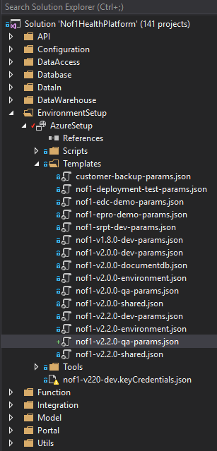

* In the json template you will need to provide the below -

|  |  |
| --- | --- |
| **Key** | **Value** |
| customerIdentifier | Abbreviated name of the customer-{version} for e.g. nof1-v220, nof1-v210 etc. |
| environment | Your deployment environment e.g dev, qa etc |
| Environment number | This field must be incremented to a number that is not yet in use by any other environment. So, if the customer nof1-v220 has 3 environments, and the customer itmi has 2 environments, then our customer foo must have an environmentNumber *no less than 6*. |
| the VM admin password | Use Keepass to generate one |
| name the SQL Elastic Pool | *customerIdentifier-version-***sql** pool e.g nof1-v220-sql-pool |
| SQL Server Name | **nof1health**- *customerIdentifier-version-***sql**  e. g. nof1health-nof1-v220-sql |
| SQL Server Admin Password | Use Keepass to generate one |
| database password for the Nof1db | Use Keepass to generate one |
| database password for the DNN | Use Keepass to generate one |
| database password for the Datawarehouse | Use Keepass to generate one |
| database password for the Log databases | Use Keepass to generate one |

**Note** : The generated password must be 20 characters long, using upper-case letters, lower-case letters, and digits

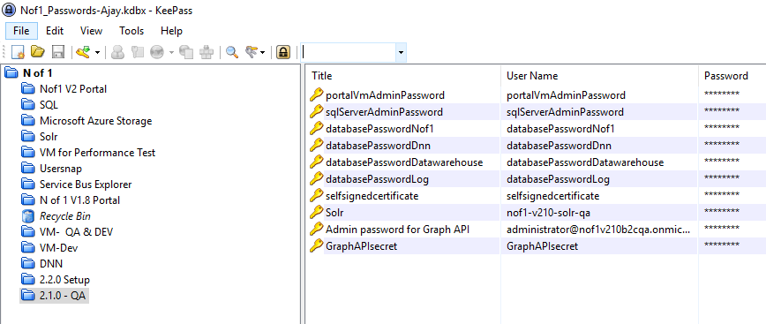

After Setting the parameters in the client specific template, you’re ready to run the deployment script.

* 1. **Create environment file and shared environment file**

The list of languages supported by each user may be different. For example, **User** **A** might want to support English and Spanish, while **User** **B** might want to support German and Italian.

* Navigate to the *localDirectoryToSolution***\Nof1HealthPlatform\EnvironmentSetup\AzureSetupDirectory**.
* Copy the previous environment file and shared environment file and name them as *customerIdentifier*-**environment-json** and *customerIdentifier*-**shared.json**

For e.g. nof1-v2.2.0-environment.json

For e.g. nof1-v2.2.0-shared.json

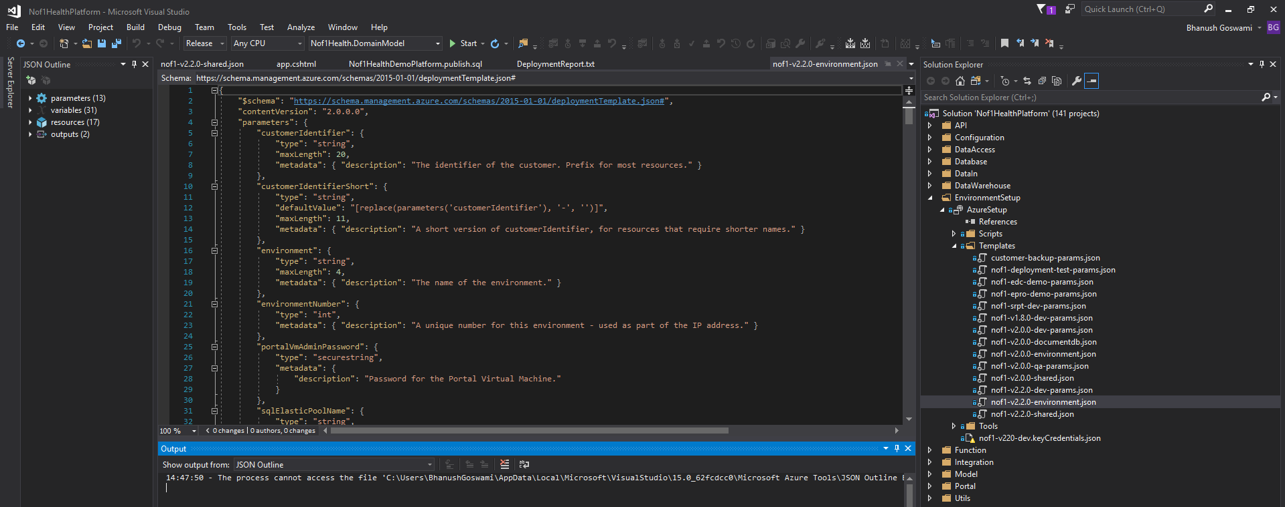

* In the shared json file find the below piece of code

|  |
| --- |
| **shared.json** |
| "resources": [  {  "name": "AllowAllWindowsAzureIps",  "type": "firewallrules",  "location": "[resourceGroup().location]",  "apiVersion": "2014-04-01-preview",  "dependsOn": [  "[concat('Microsoft.Sql/servers/', parameters('sqlServerName'))]"  ],  "properties": {  "startIpAddress": "0.0.0.0",  "endIpAddress": "0.0.0.0"  }  },  {  "type": "Microsoft.Sql/servers/firewallrules",  "name": "[concat(parameters('sqlServerName'),'/firewallrules')]",  "apiVersion": "2014-04-01-preview",  "dependsOn": [  "[concat('Microsoft.Sql/servers/', parameters('sqlServerName'))]"  ],  "properties": {  "startIpAddress": "**124.124.111.177**",  "endIpAddress": "**124.124.111.177**"  }  },.  Change “124.124.111.177” to reflect your IP      "resources": [  {  "name": "AllowAllWindowsAzureIps",  "type": "firewallrules",  "location": "[resourceGroup().location]",  "apiVersion": "2014-04-01-preview",  "dependsOn": [  "[concat('Microsoft.Sql/servers/', parameters('sqlServerName'))]"  ],  "properties": {  "startIpAddress": "0.0.0.0",  "endIpAddress": "0.0.0.0"  }  },  {  "type": "Microsoft.Sql/servers/firewallrules",  "name": "[concat(parameters('sqlServerName'),'/firewallrules')]",  "apiVersion": "2014-04-01-preview",  "dependsOn": [  "[concat('Microsoft.Sql/servers/', parameters('sqlServerName'))]"  ],  "properties": {  "startIpAddress": "124.234.92.177",  "endIpAddress": "124.234.92.177"  }  },. |

Replace the s**tartIpAddress** and the **endIPAddress** values with your IP address. You are now ready to deploy the template.

* 1. **Create Azure Environment**
* Search for the **PowerShell** in search tab and right click on **Windows PowerShell** application in the search list and select **Run as Administrator**.

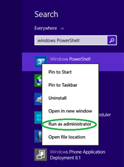

* In the PowerShell window, Copy/paste the below PowerShell command and hit return.

|  |
| --- |
| **PowerShell script to Set Execution Policy to Unrestricted** |
| **Set-ExecutionPolicy Unrestricted** |

* You will be prompted to update the execution policy change, key in **Y** and hit return.

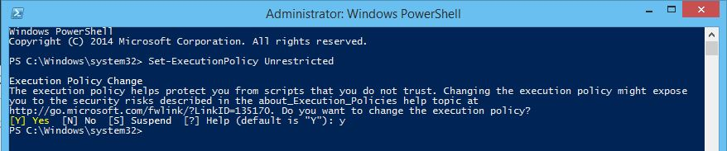

* In the PowerShell window, Copy/paste the below PowerShell command and hit return.

|  |
| --- |
| **PowerShell script to login to Azure** |
| **Login-AzureRmAccount** |

* You will be prompted to sign in to an Azure account. Enter in your credentials and sign.

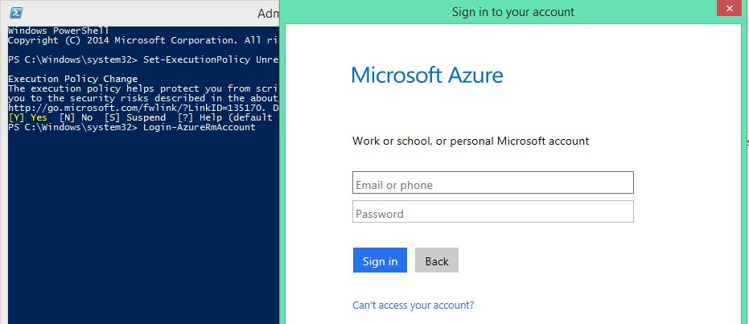

* Give the below command to get the list of all subscriptions attached to your email

|  |
| --- |
| **PowerShell script to list all subscriptions** |
| **Get-AzureRmSubscription** |

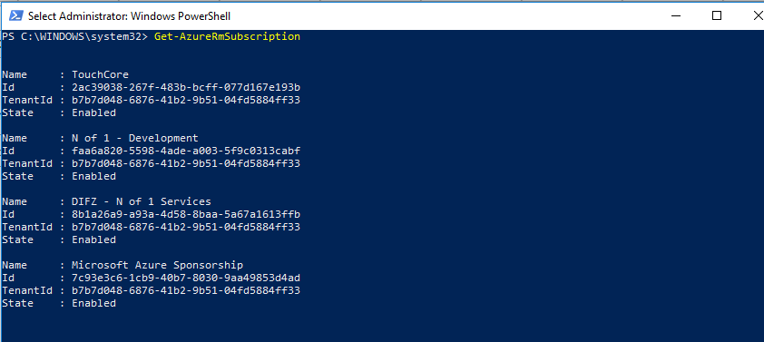

* Ensure that your subscription name appears. Enter the below command after you’ve replaced the *subscriptionName* with your subscription name and hit enter.

|  |
| --- |
| **PowerShell script to set your subscription** |
| **Set-AzureRmContext** -**SubscriptionName** “*subscriptionName”* |

**Note:** The subscription name depends on which subscription you’re using. You can check the azure portal for any other subscriptions that you want to use.

* Change directory to the Nof1HealthPlatform Solution by replacing the directory to the solution and copying, then pasting the following text into PowerShell and hitting enter.

|  |
| --- |
| **Command to switch to scripts directory in Powershell** |
| **cd *localDirectoryToSolution*\Nof1HealthPlatform\EnvironmentSetup\AzureSetup\Scripts** |

* If changes have been made, substitute the Template File address and Template Parameters File address (this is where you pass the client specific params file) to the below command. Put the location of your choice. For e.g. East US 2 After editing, copy and paste the following and hit enter.

|  |
| --- |
| **Command to deploy a new environment in Azure** |
| **.\Deploy-AzureResourceGroup.ps1 -ResourceGroupLocation *location* -TemplateFile ..\Templates*customerIdentifier-version-environment*.json -**TemplateParametersFile **..\Templates*customerIdentifier-version-environment-*params*.*json** |

For e. g.

|  |
| --- |
| **Example script to deploy a new environment in Azure** |
| **.\Deploy-AzureResourceGroup.ps1 -ResourceGroupLocation "East US 2" -TemplateFile ..\Templates\nof1-v2.0.0-environment.json -TemplateParametersFile ..\Templates\nof1-v2.2.0-dev-params.json** |

* Press Enter to start the deployment

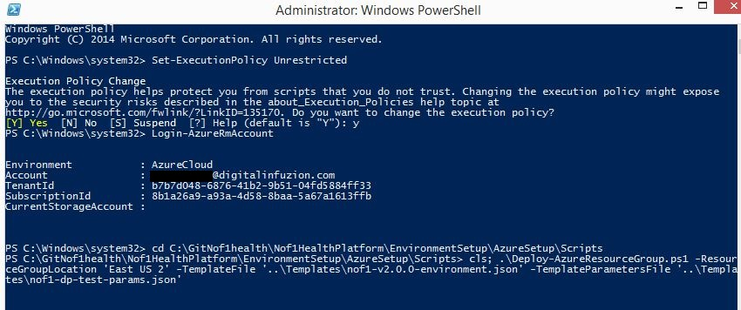

* Wait for the deployment to finish. This may take 15 to 20 minutes. You will see the following happening while the deployment is in progress:

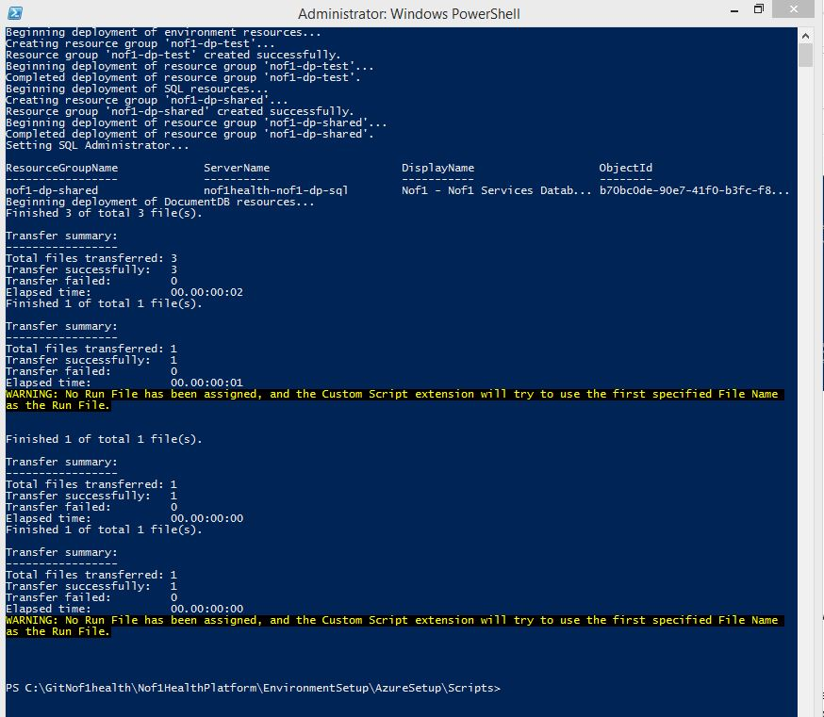

Once the deployment has finished a new command line will appear waiting for your next command. You will also see two resource groups (an environment VM resource group and a shared DB resource group). The VM resource group contains:

* VM
* Load balancer
* Network interface
* Public IP address
* Virtual network
* 2 storage accounts
* 2 App Services and Plan
* Key vault
* Notification hubs

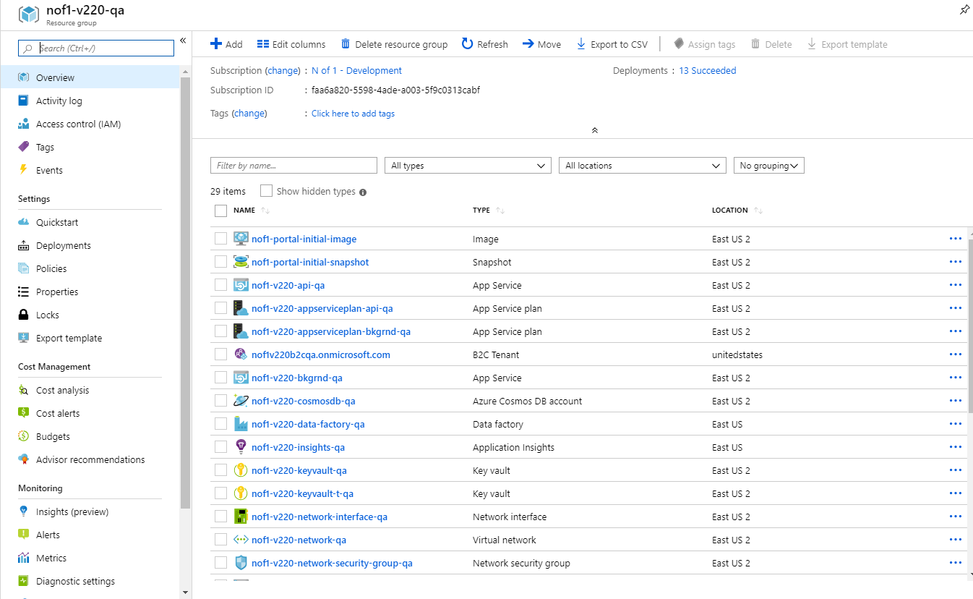

While the shared DB resource group contains:

* An elastic pool
* 4 SQL databases (portal, dnn and data warehouse and log)
* SQL server
* At this point you have the VM and DB environments have been deployed and are ready for configuration.
* Check that you can connect to the virtual machine through remote desktop connection

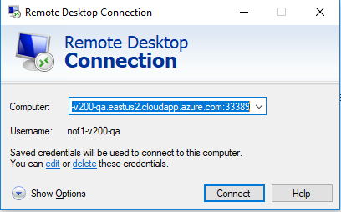

* If you successfully accessed the virtual machine the deployment was successful.

Generate Self-Signed Certificate

* Open a PowerShell prompt and navigate to the *localDirectoryToSolution* **\Nof1HealthPlatform\EnvironmentSetup\AzureSetup\Scripts**

Execute this command:

|  |
| --- |
| **Command to create the self-signed certificate** |
| **.\Create-Nof1ApplicationSelfSignedCertificate.ps1 -CustomerIdentifier “**customerIdentifier-version-environment” |

* This command will prompt you to enter a certificate password. Generate a password from the **Keepass**. Keep this password safe. You will need it to install the certificate.

**Note:** The generated password must be 20 characters long, using upper-case letters, lower-case letters, and digits

* This command will generate two files: *customerIdentifier-version-environment*.pfx and *customerIdentifier-version-environment*.**keyCredentials.json**. The PFX file is the actual certificate.

**Note:** In future steps, you will upload this certificate to the N of 1 platform (API and virtual machine(s)), using the password you supplied during step 2. The JSON file is used to configure the Azure AD Application to access Keyvault.

Setup B2C

* 1. **Setup CORS on the storage container**
* Ensure that you are logged in to the Azure Portal.
* Navigate to **Storage accounts** >> *storageAccountName* and find the CORS setting under **BLOB SERVICE.**

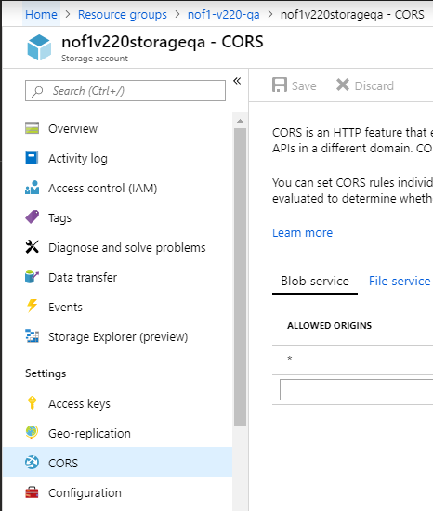

* On the blade that pops-up click on **Add** and setup the following values.

|  |  |
| --- | --- |
| **CORS Setting** | **Value** |
| Allowed Origins | * |
| Allowed Verbs | GET, OPTIONS |
| Allowed Headers | * |
| Exposed Headers | * |
| Max Age | 200 |

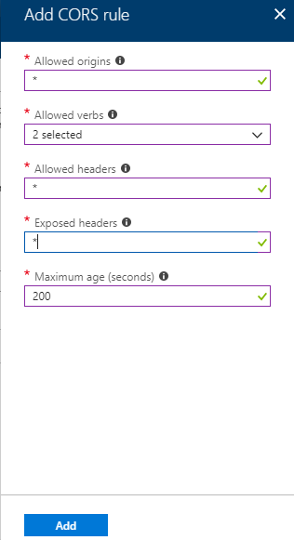

* 1. **Create azureadb2c container and upload B2C templates**
* On the same storage blade, select blobs.
* Click on Container and create a container named **azureadb2c**. Set public access level to **Container (anonymous read access for containers and blobs).**

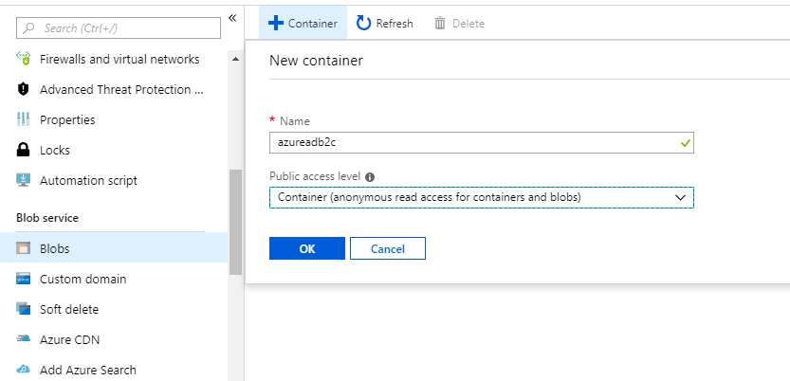

* Once the container is created, upload the templates using the below command. You will need to copy the files on your local machine from any previous installation or you may contact the configuration manager for the same.

|  |
| --- |
| **PowerShell Command to Upload Templates to Container** |
| **.\upload-blobs.ps1** **-subscriptionName** “*subscriptionName”* **-resourceGroupName** *resourceGroupName* -storageAccount *storageAccountName* -**blobContainerName** **azureadb2c** -location “*location”* -**folderToUpload** "Your Path to the container folder on your machine" |

* An example

|  |
| --- |
| **PowerShell Command to Upload Templates to Container** |
| **.\upload-blobs.ps1 -subscriptionName “**N of 1 - Development***”* -resourceGroupName resourceGroupName -storageAccount nof1v210storagedev -blobContainerName azureadb2c -location “*location”* -folderToUpload "C:\Users\bhanushg\Desktop\Deployment\210\azureadb2c-container"** |

* Open the storage account in storage explorer and find **sign-up.css** and **sign-up.html** from the sign-up folder.

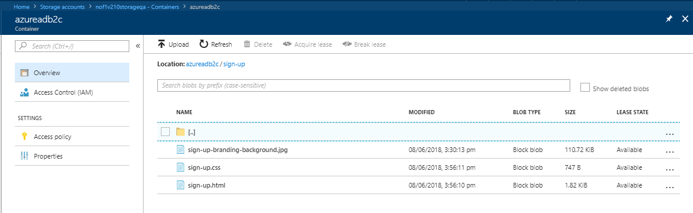

* Edit the **sign-up.html** from the sign-up folder to reflect your customerIdentifier and environment. For e.g.

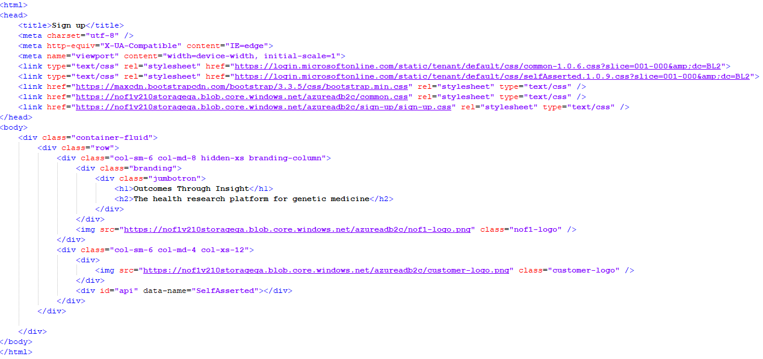

* 1. **Create B2C tenant**
* **Login to Portal -> Click New -> Search for Azure Active Directory B2C**. Below window will pop up:

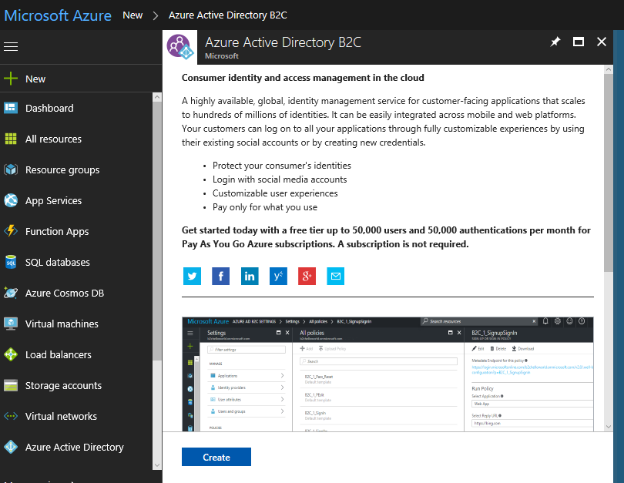

* Click on “Create”. It will provide two options

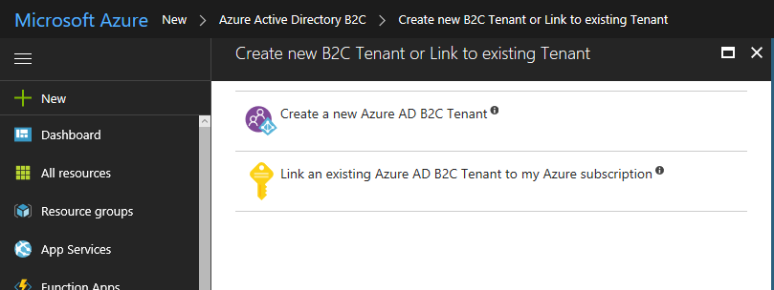

* Select **Create a new Azure AD B2C Tenant**
* Choose the first option and set the following:

|  |  |
| --- | --- |
| **Tenant Setting** | **Value** |
| Organization name | *customerIdentifier-version-***b2c**-*environment* |
| Initial Domain same | *customerIdentifier***b2c***environment* |

**Note** - It won’t accept any special character.

* Click on **Create**.

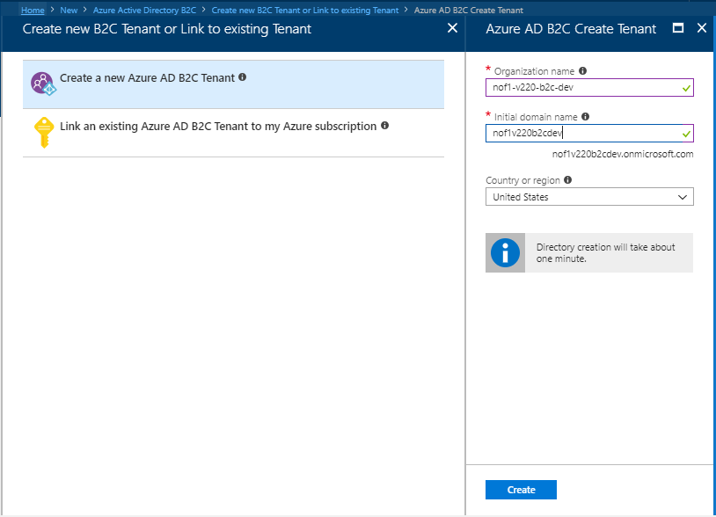

* Once directory is created, click on **Link an existing Azure AD B2C Tenant to my Azure subscription.**
* Click on create after selecting your **Azure AD B2C tenant**, you just created, **Subscription** and **Resource group.**

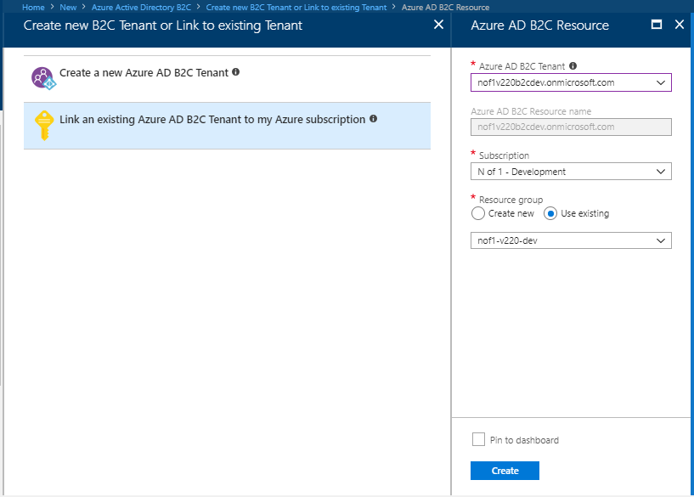

* Logout and Login to the Portal.
* Click on the area which shows your email address on the right-hand side top corner of your Azure page. Switch to the B2C tenant you just created from the list of **Azure Active Directories.**

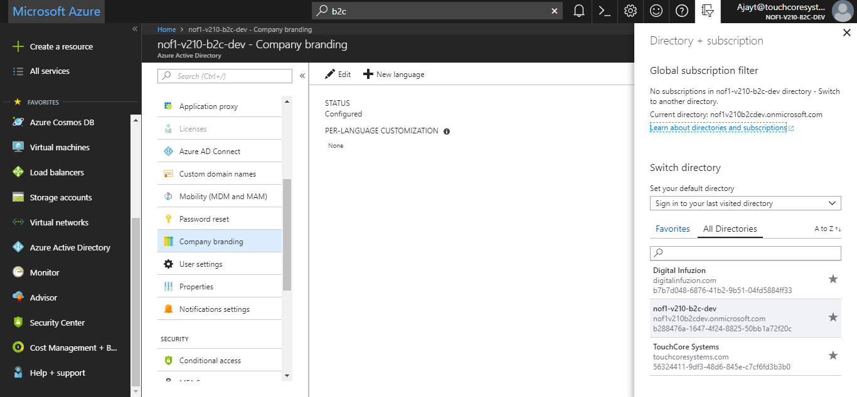

* Click on **Azure Active Directory**.

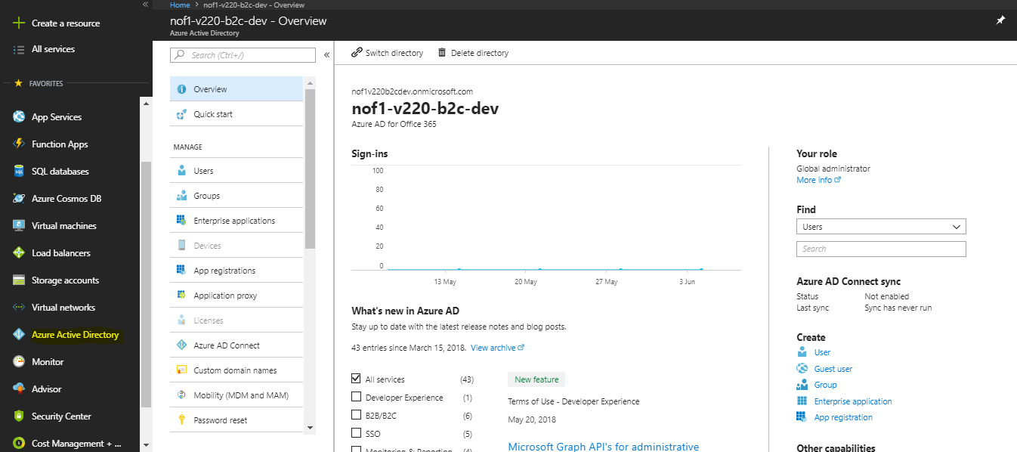

* Click on **App Registrations.**

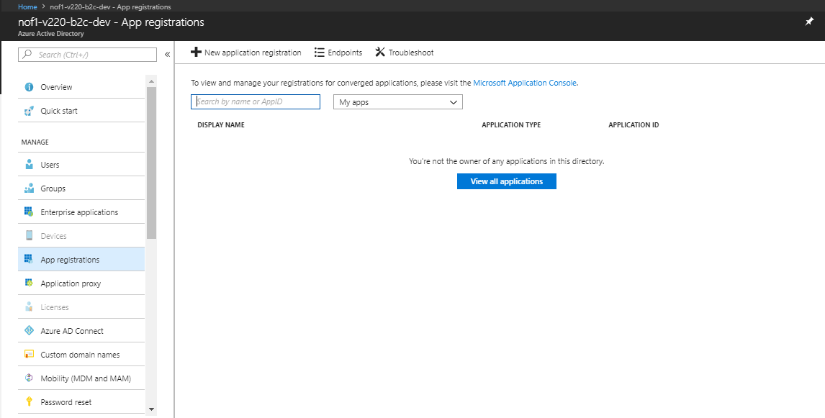

* Click on **New Application Registration** and register an app with the following entries.

|  |  |
| --- | --- |
| **App Settings** | **Value** |
| Name | PortalApp |
| Application Type | Web app/ API |
| Sign-on URL | [https://*customeridentifier*-*version*-api-*environment*.azurewebsites.net/](https://customeridentifier-version-api-environment.azurewebsites.net/) |

* Note down the **APP ID**.
  1. **Create and configure Portal application**
* Type **B2C** in the search bar and then under services click on **Azure AD B2C**.

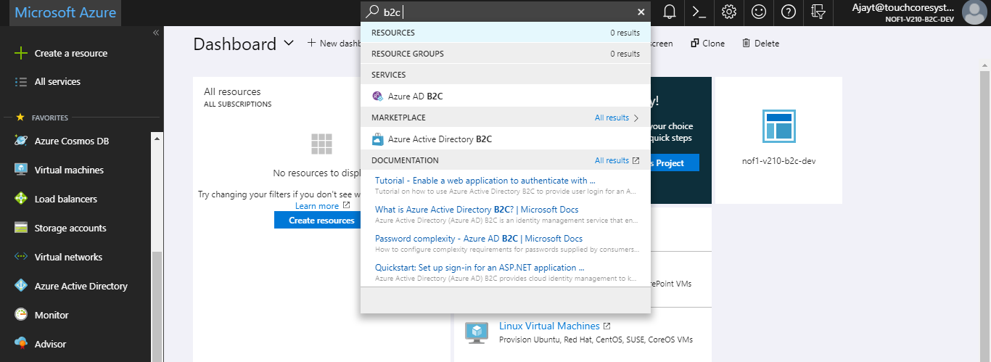

* The B2C configuration window will Open.

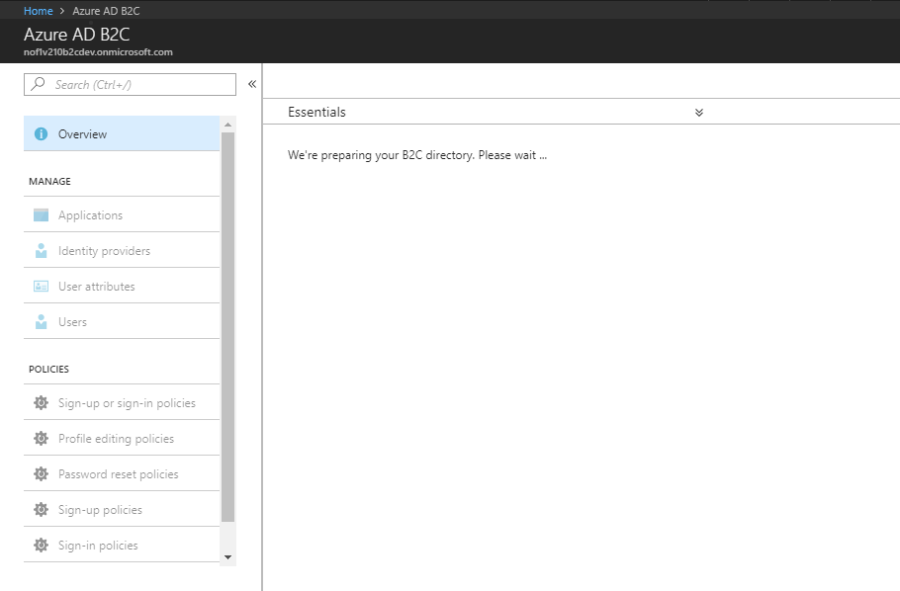

* Select the B2C tenant. Navigate to the Application tab.

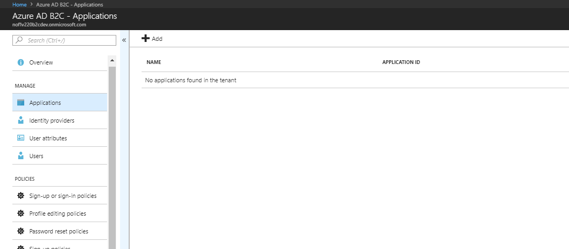

* Click on ADD and in the screen that pops-up, enter the following -

|  |  |
| --- | --- |
| **App Settings** | **Value** |
| Name | N of 1 Portal |
| Include web app / web API | Yes |
| Allow implicit flow | Yes |
| Reply URL | [https://*customerIdentifier-version-environment*.nof1health.com/OnAzureAdLogin.aspx](https://customerIdentifier-version-environment.nof1health.com/OnAzureAdLogin.aspx)  [https://*customerIdentifier-version-environment*.nof1health.com/OnAzureAdESignature.aspx](https://customerIdentifier-version-environment.nof1health.com/OnAzureAdESignature.aspx)  [https://*customerIdentifier-version-environment*.nof1health.com/OnAzureAdSignUp.aspx](https://customerIdentifier-version-environment.nof1health.com/OnAzureAdSignUp.aspx) |
| App ID URI | nof1-portal |
| Include native client | Yes |

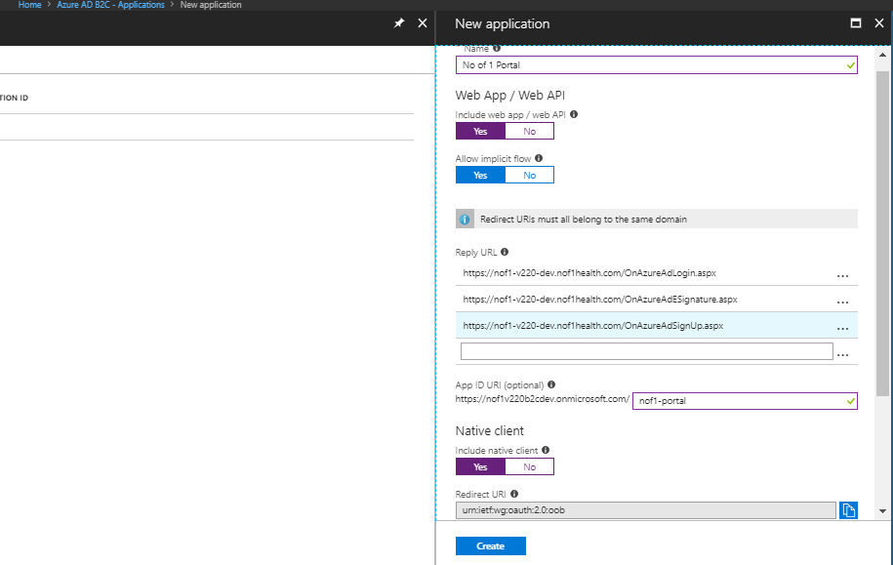

* Note the **Application ID** mentioned against the Application and keep it for future steps.

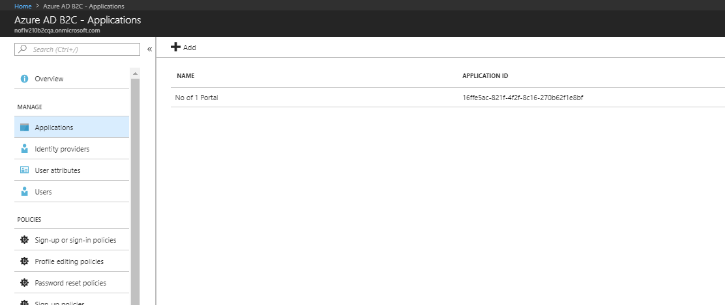

* Once the Application is created, select the App and navigate to the **Keys** tab and click on **Generate Key**. Create a key and Save it. Copy the key for future reference.

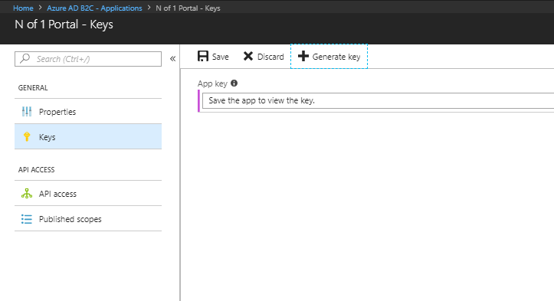

* Click on Add and then select the **N of 1 Portal** API. Keep the default scope and press **OK**. Keep the default scope and press **OK**.

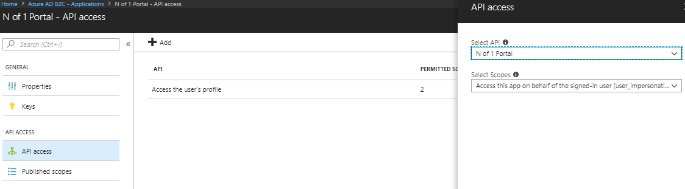

* In the same application, click on **Access the user’s profile** and select the default scopes and save.

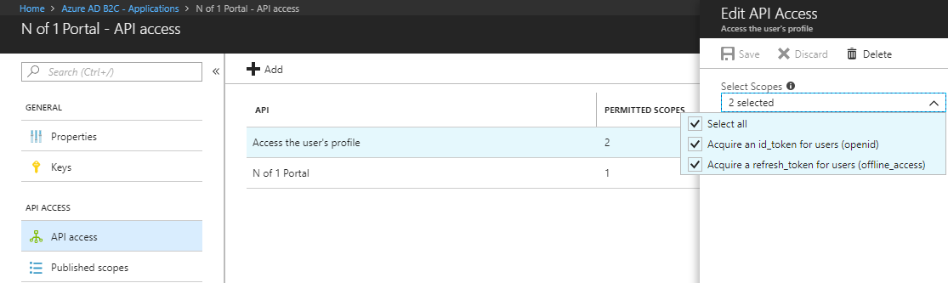

* Navigate to **Published scopes** and ensure it is set to the following

|  |  |
| --- | --- |
| **App Settings** | **Value** |
| SCOPE | user_impersonation |
| DESCRIPTION | Access this app on behalf of the signed-in user |
| FULL SCOPE VALUE | https://*customerIdentifier[version]*v210**b2c***environment*.onmicrosoft.com/nof1-portal/user_impersonation |

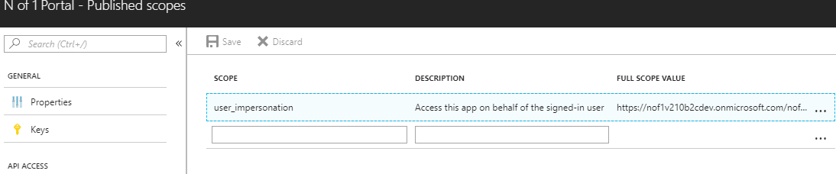

* 1. **Configure Identity Providers**
* Navigate **Identity providers** tab in the Main Menu and click on **Add.**
* Configure the below and press **OK.**

|  |  |
| --- | --- |
| **Identity Provider Settings** | **Value** |
| Name | N of 1 identity Provider |
| Identity Provider | **Microsoft Account** |

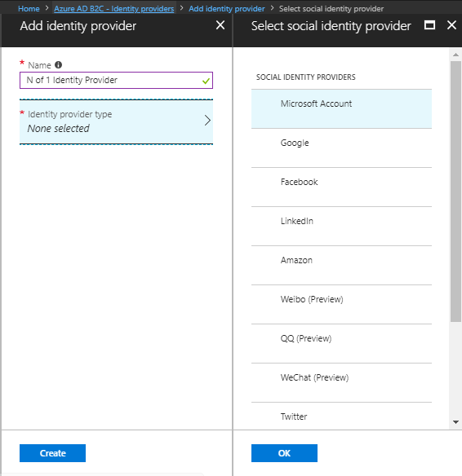

* A new field **Set up this identity provider** appears. Fill in the following details and press **OK.**

|  |  |
| --- | --- |
| **Social identity provider Settings** | **Value** |
| Client ID | The Application ID copied in step 5.4 |
| Secret | The Key Created in Step 5.4 |

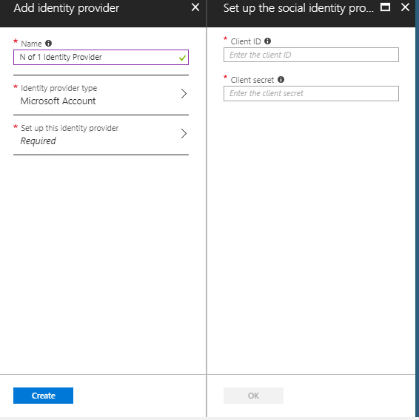

* Click on the **Create** button.

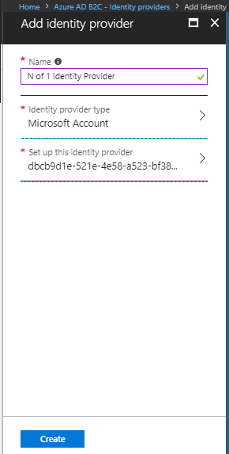

* Your Identity Provider is now setup.
  1. **Configure Sign-up policy**
* Navigate the main menu and click on **Sign-up policies** and click on **Add.**

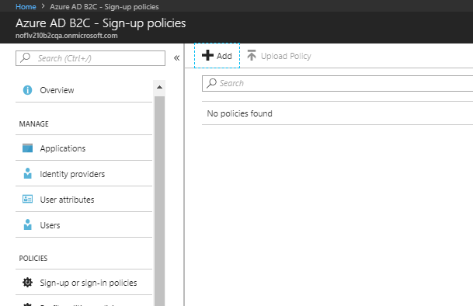

* A new blade opens.

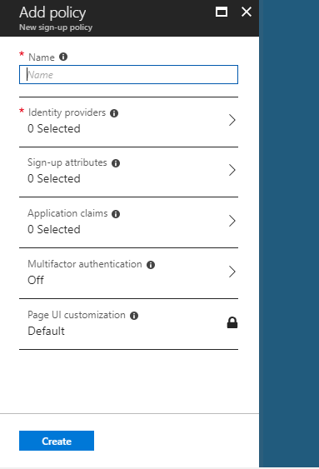

* Put the following details.

|  |  |
| --- | --- |
| **B2C Sign-up Policy Settings** | **Value** |
| Name | B2C_1_*customeridentifier*-*environment*-signup |

* In the Identity Providers select **Email signup**.

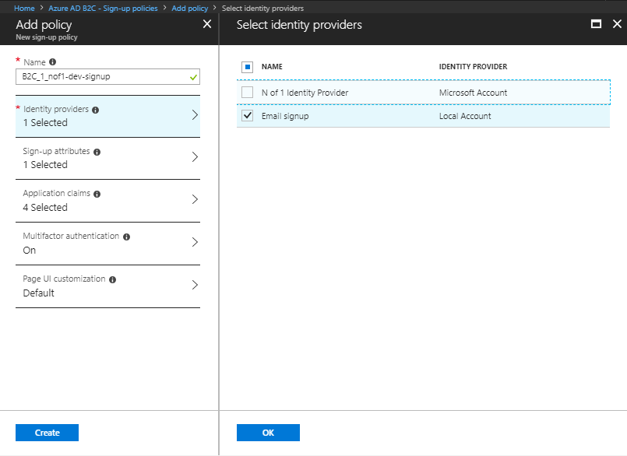

* In the **Sign-up attributes** please select **Email Address.**

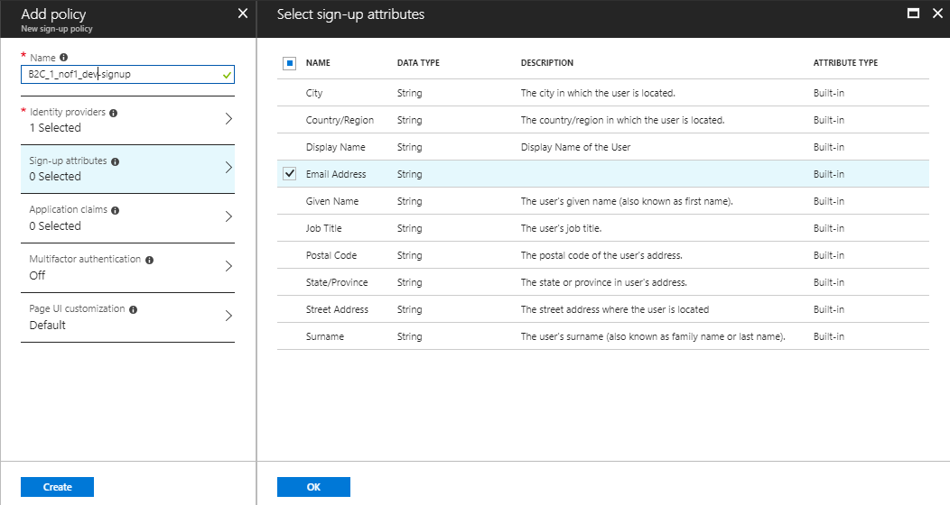

* In the Application claims blade select **Email Addresses**, **Identity Provider**, **User is new**, **User’s Object ID.**

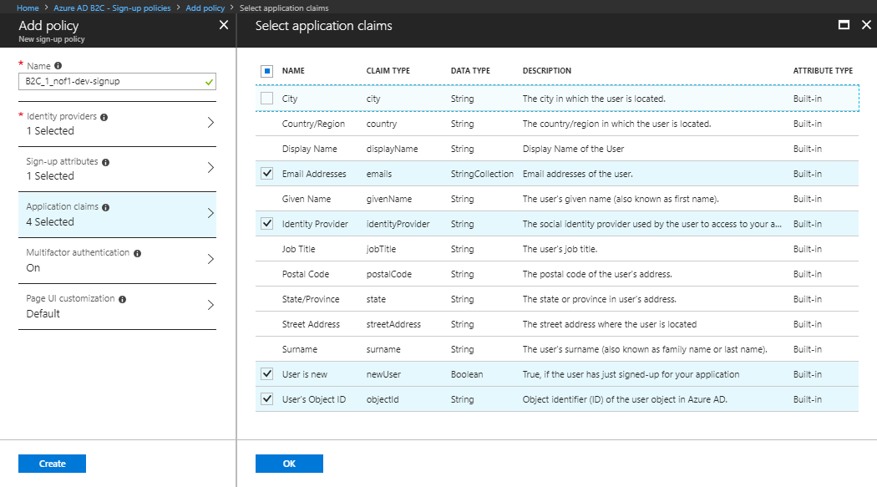

* In the **Multifactor authentication** blade, turn the state to **On.**

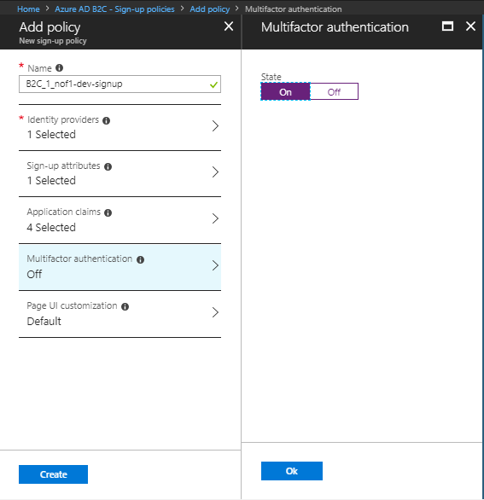

* Click on the **Page UI customization** blade. Select **Local Account sign-up page** and set **Use custom page** to **Yes** and then put the following URL.

<https://customerIndentifier[version]storage[environment].blob.core.windows.net/azureadb2c/sign-up/sign-up.html>.

* Click other values as default and click **OK** for all the Page UI customization blades.

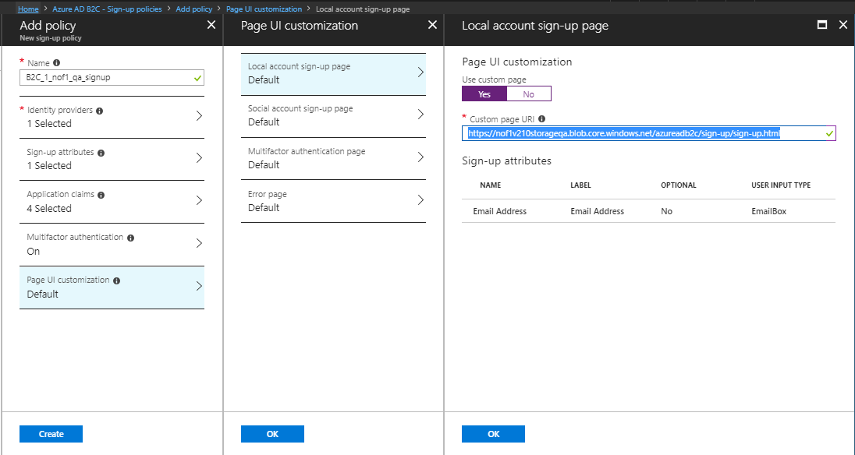

* Click on **Create** and wait for the policy to be created.
* Once the policy is created, click on the policy.

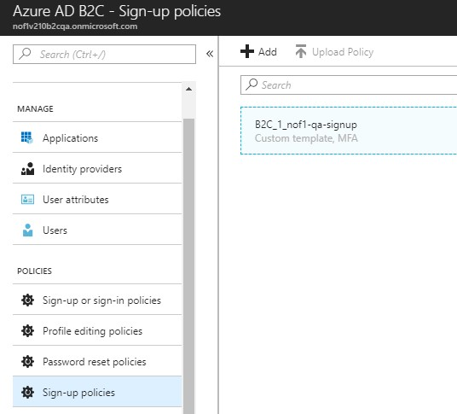

* On the next screen click on **Run now.**

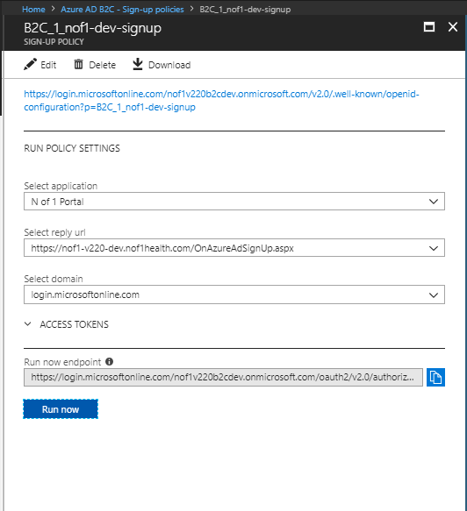

* Clicking on **Run Now** will take you a login page. Complete the Registration Process for the super user email you have created in Gmail. If you have not created an email in Gmail, you may do that by browsing to **http://www.gmail.com**. You will have to go through multi-factor authentication.
* The user will get added to the list of users in the B2C tenant.

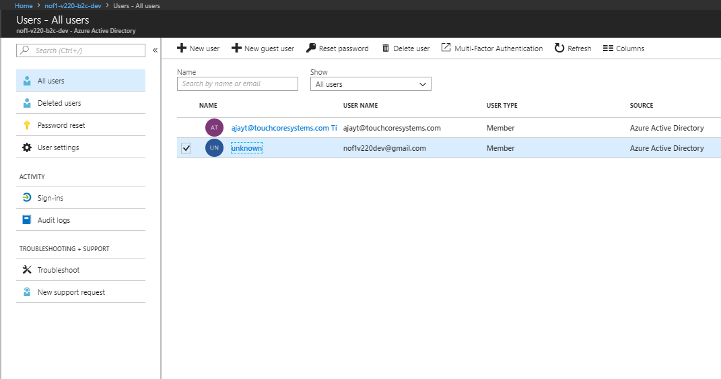

* Get the **Object ID** via the Users blade in the tenant active directory. This object ID is used to create the **Person** in Database as a Super-User.

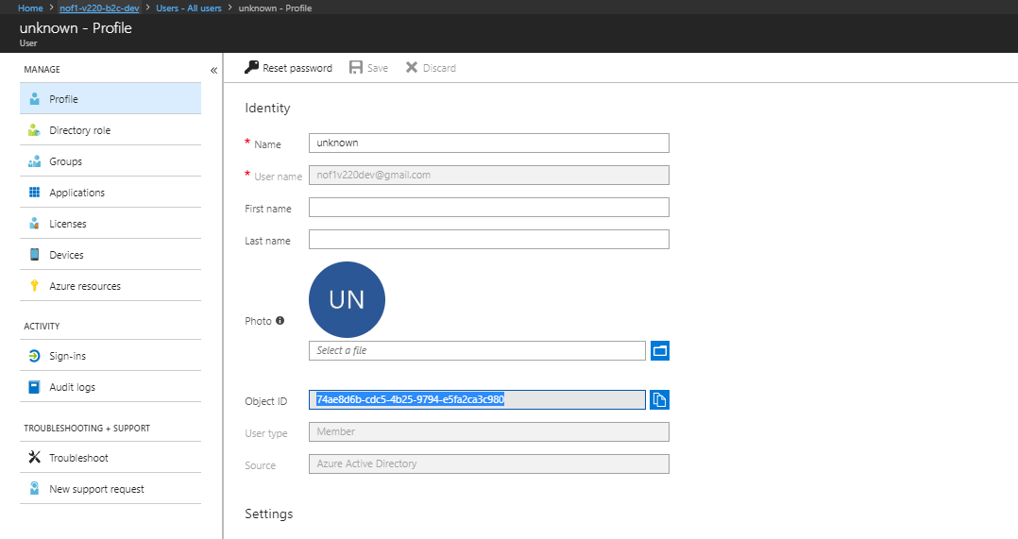

* The sign-up process is not finished yet. In the sign-up policy you created, click on **Edit.**

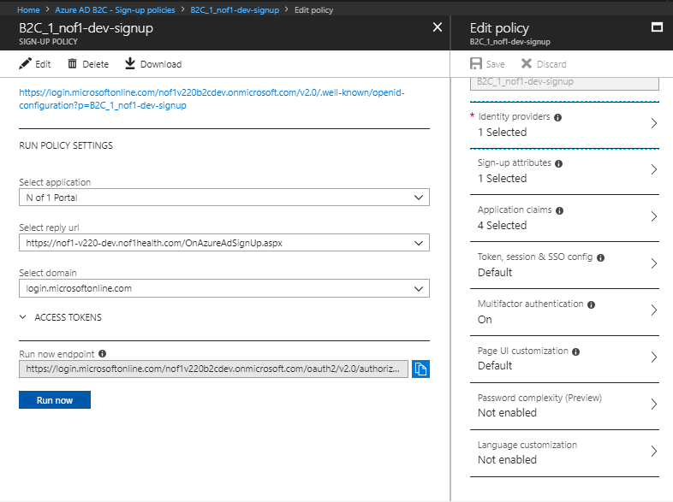

* Go to the **Token, session and SSO config** blade. Change the following settings and keep other settings as they are.

|  |  |
| --- | --- |
| **B2C Sign-up Policy Settings** | **Value** |
| Web app session lifetime (minutes) | 15 |
| Web app session timeout | Absolute |
| Issuer (iss ) claim | https://<domain>/tfp/XXXX-1020-XXXXX-XXXXXX-XXXX//**B2C_1_***customeridentifier-environment*-signup**/v2.2/** |

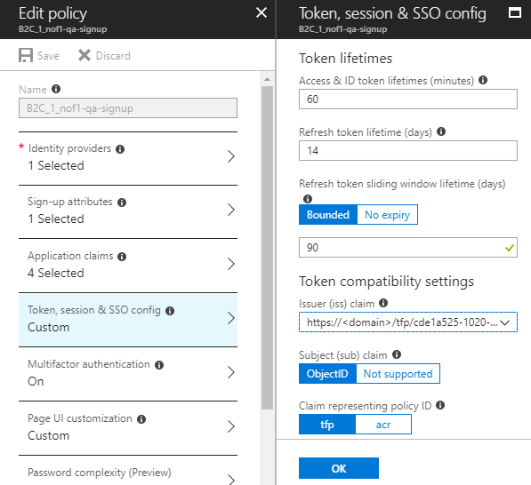

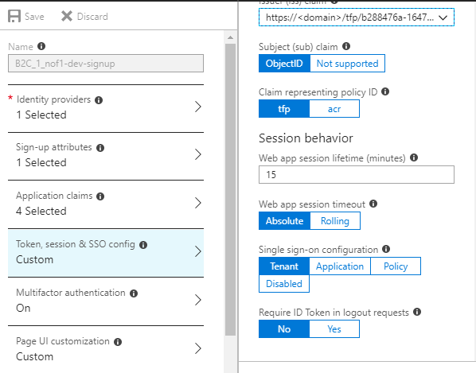

* Go to the **Password complexity(Preview)** blade and select **Strong(Default)** and Press **OK**

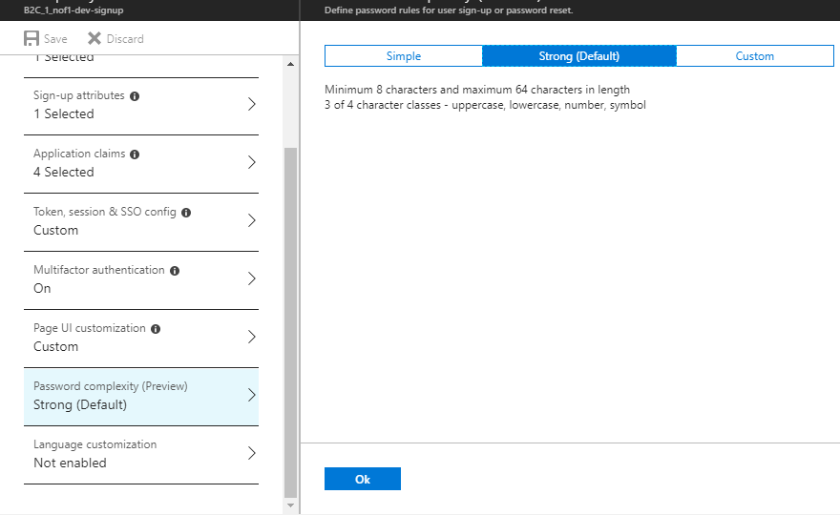

* Click on **Enable** **Language Customization**.

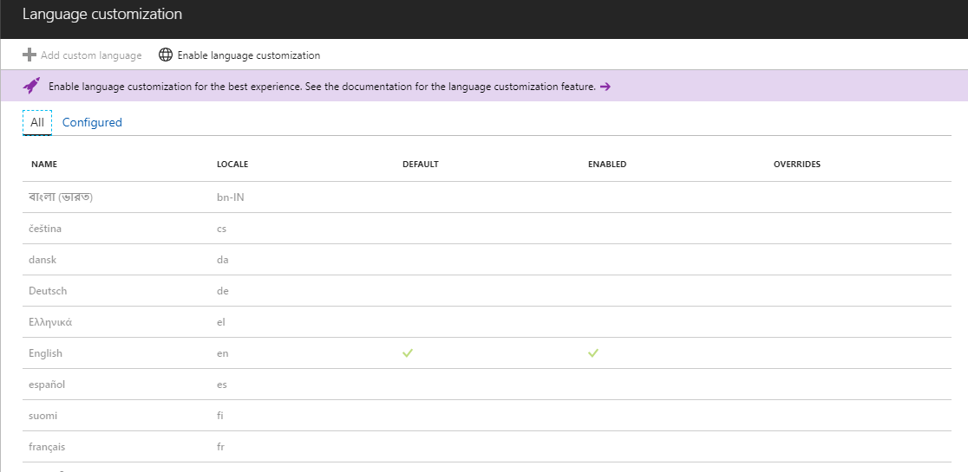

* 1. **Configure Sign-in Policy**
* In the B2C account click on Sign-in policies and click on **Add.**

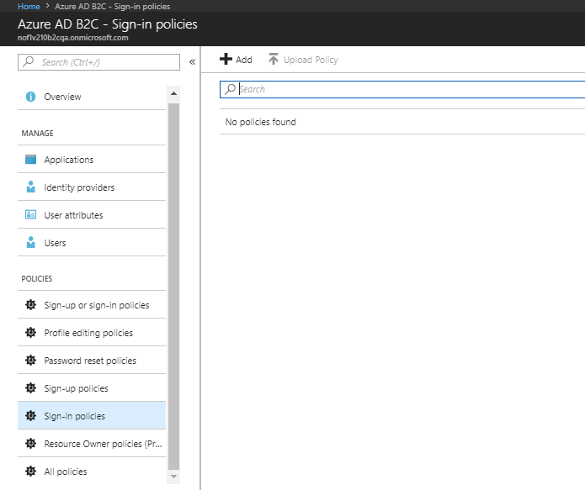

* In the blade that appears put the following.

|  |  |
| --- | --- |
| **B2C Sign-in Policy Settings** | **Value** |
| Name | B2C_1_*customeridentifier*-*environment*-signin |

* Under Identity Providers select **Local Account Sign-in** and press **OK.**

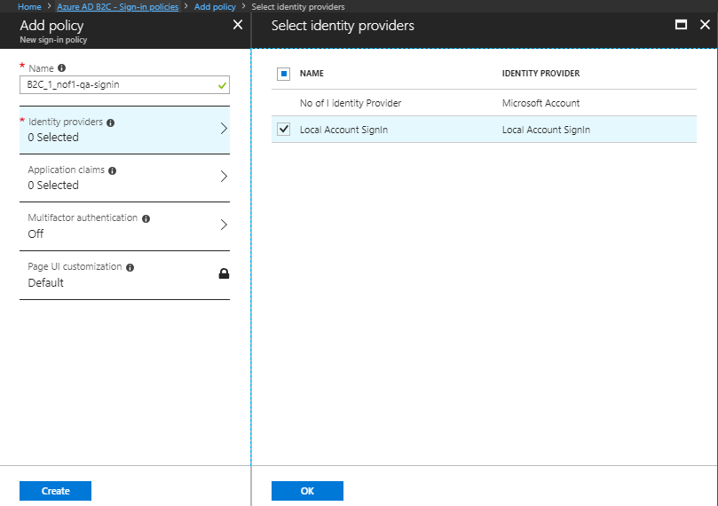

* Under Application claims select **Email addresses, Identity Provider** and **User’s Object ID.**

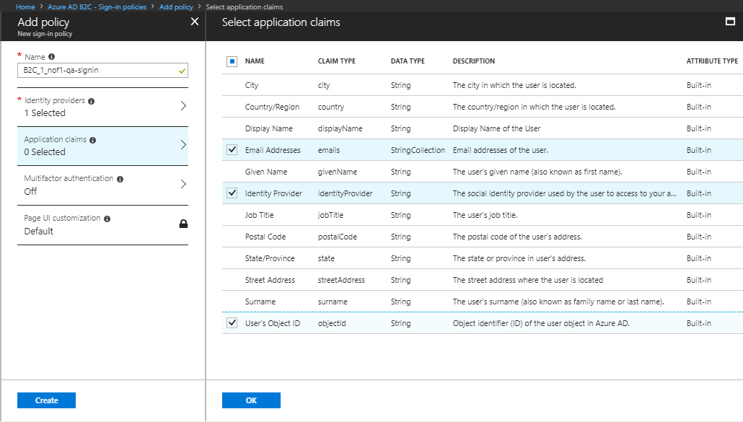

* Keep the **Multi-factor authentication** setting **Off.**
* Keep the **Page UI Customization** settings as they are and then click on **Create.**
* Click on the **Sign-in** policy just created and click on **Edit.**

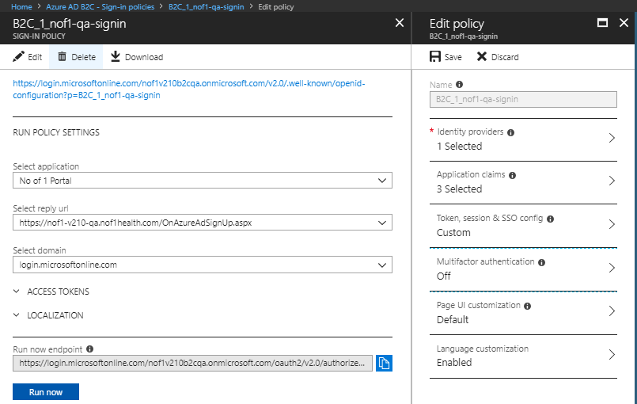

* Select the **Token, session & SSO config** and set the following values. Keep other settings as they are.

|  |  |
| --- | --- |
| **B2C Sign-in Policy Settings** | **Value** |
| Refresh token lifetime (days) | 1 |
| Refresh token sliding window lifetime (days) | 1 |
| Web App Session lifetime | 60 |
| Issuer (iss) claim | https://<domain>/tfp/XXXX-1020-XXXXX-XXXXXX-XXXX//**B2C_1_***customeridentifier-environment*-signup**/v2.0/** |

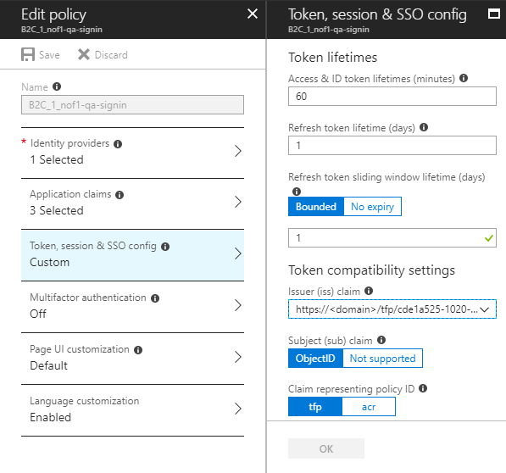

* Now click on the **Language customization** blade and **Enable Language Customization**.

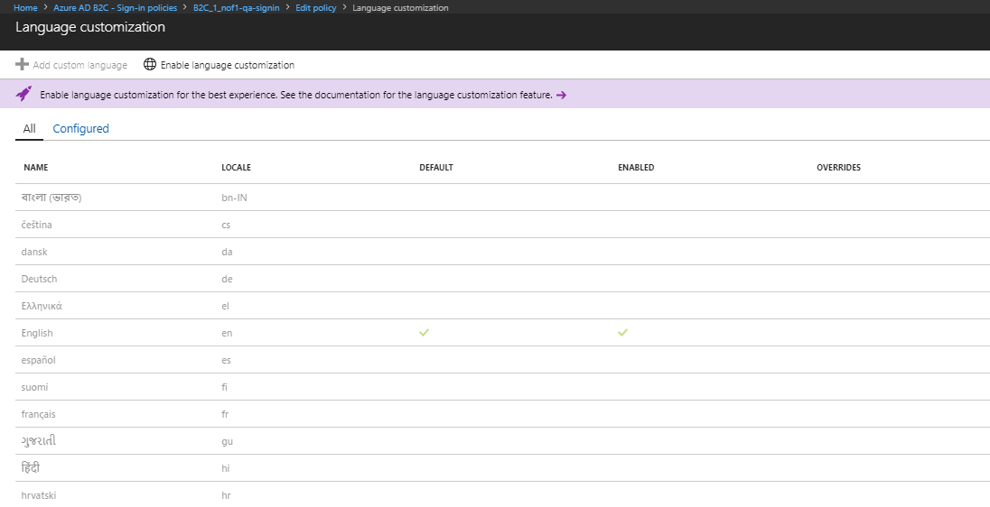

* On the page that appears enable the language **Deutsch**.

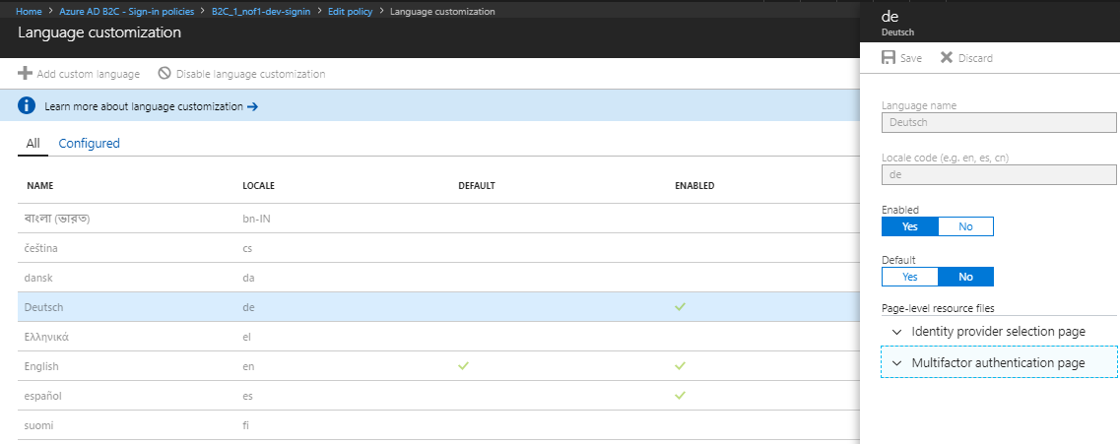

* Enable the language **español**.

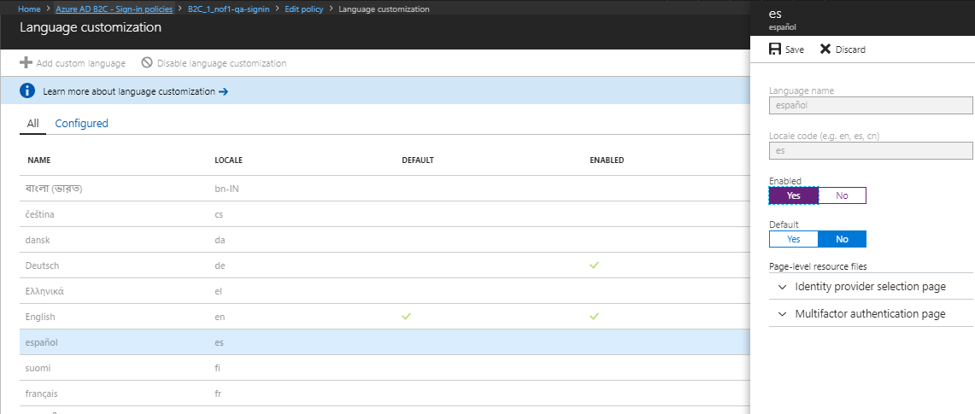

* 1. **Set Password Reset Policy**
* Click on the **Password reset policies** blade.

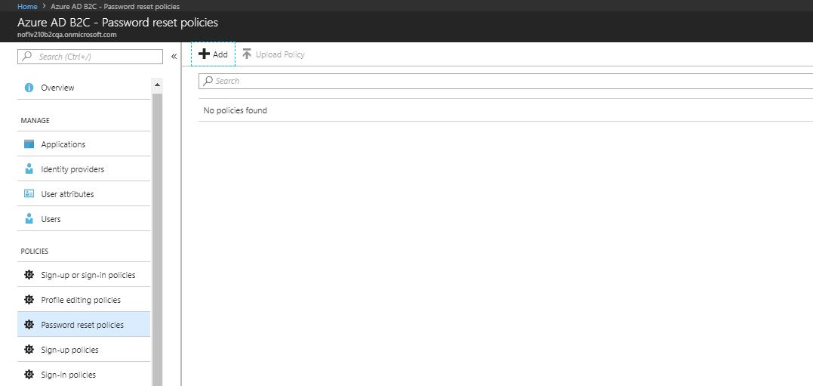

* Select **Add**. On the screen that appears put the following.

|  |  |
| --- | --- |
| **B2C Reset Policy Settings** | **Value** |
| Name | B2C_1_*customeridentifier*-*environment*-reset |

* In the **Identity providers** blade select **Reset password using email address** and click **OK**.

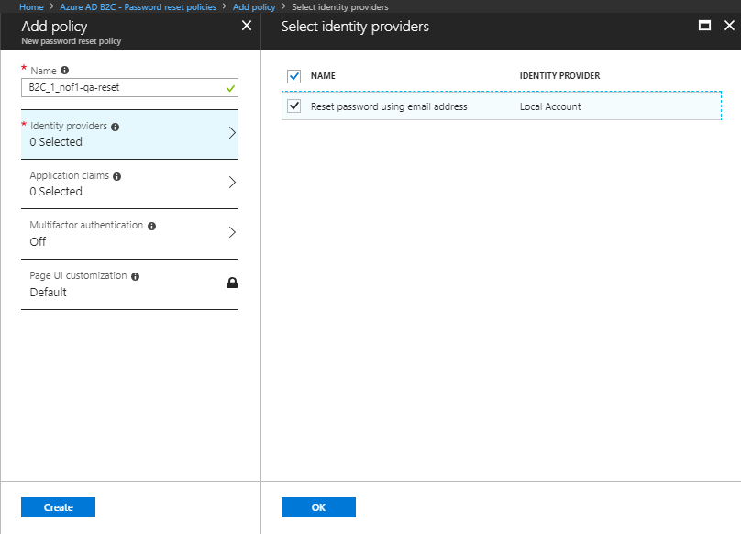

* In the Application claims windows select **Email Addresses** and **User’s Object ID.**

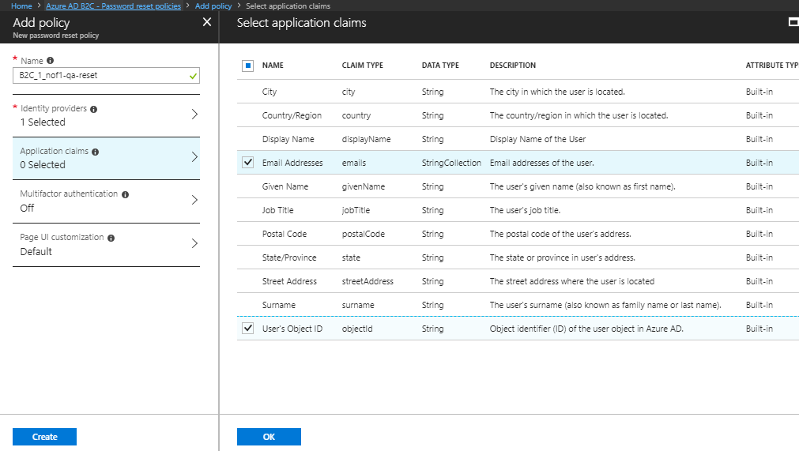

* On the **multifactor authentication** blade set the state to **ON**.

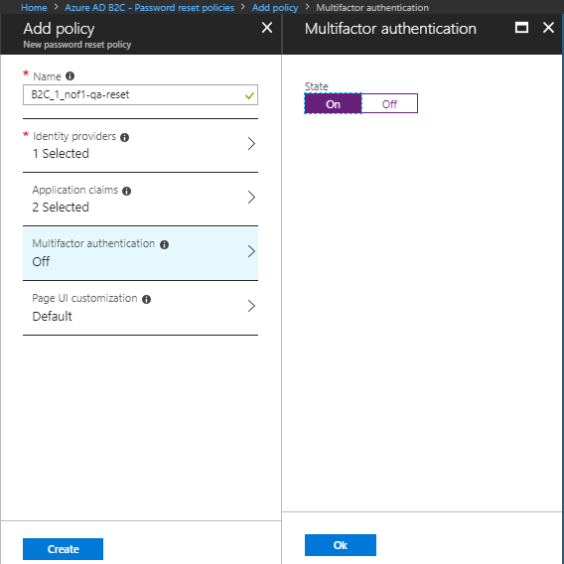

* Select the Page customization blade and set **Use custom page** to **Yes** and **custom page URI** to

[https://*customeridentifier[version]*v210storage*environment*.blob.core.windows.net/azureadb2c/selfasserted.htm](https://customeridentifier[version]v210storageenvironment.blob.core.windows.net/azureadb2c/selfasserted.htm)

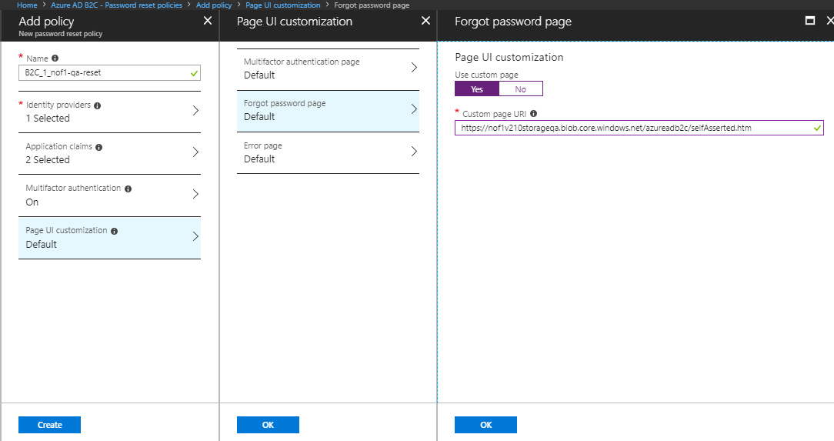

* Click on **Create.**
* Once the policy is created, select it.

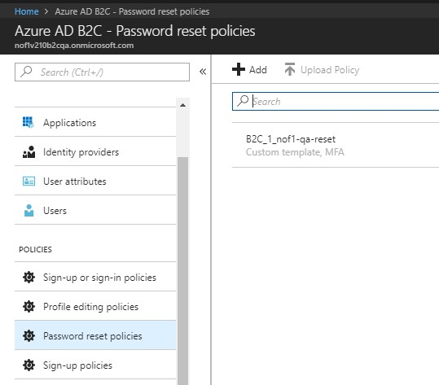

* Click on **Edit**.

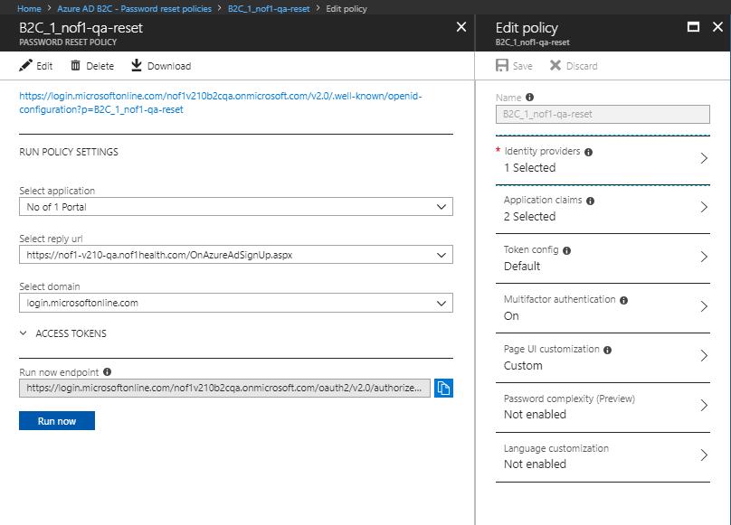

* Click on the **Language Customization** blade and **Enable Language Customization.**

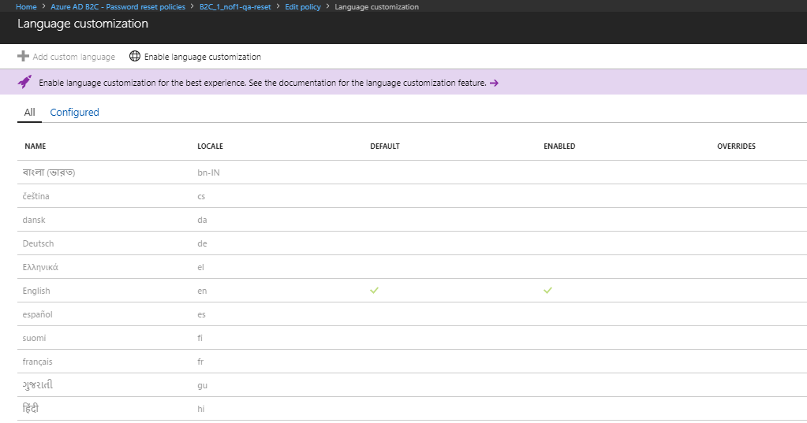

* Enable **Deustche** and **español** languages.

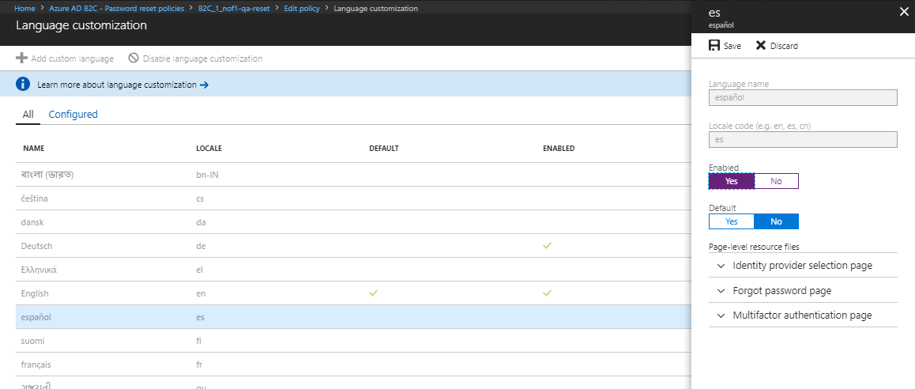

* Remove overrides from the English language.

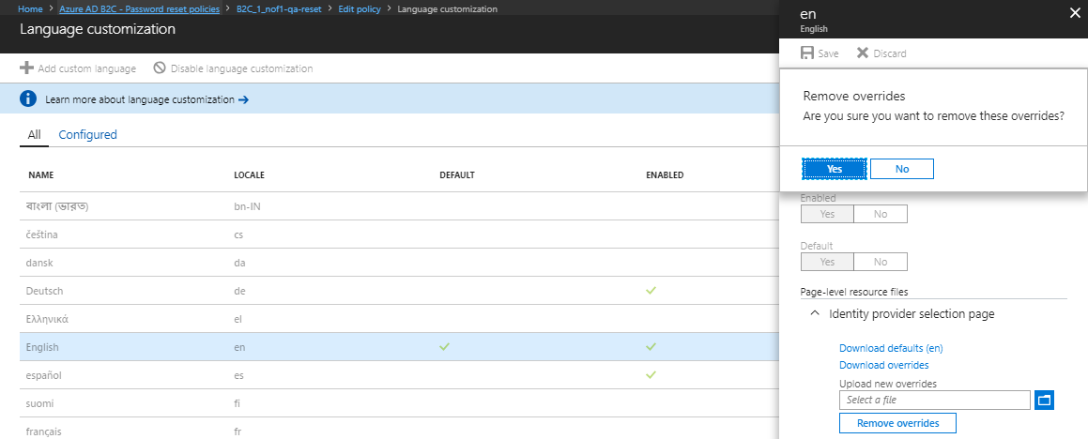

* 1. **Set-up e-signature policy**
* In the B2C account blade, click on **Sign-up and Sign-in policies** and then click **Add.**

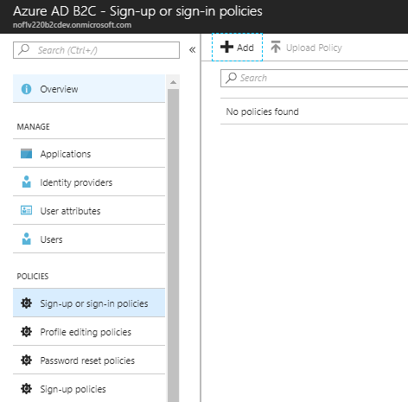

|  |  |
| --- | --- |
| **B2C esignature Policy Settings** | **Value** |
| Name | B2C_1_esignature |

* In the **Identity** **providers** blade select **Email signup.**

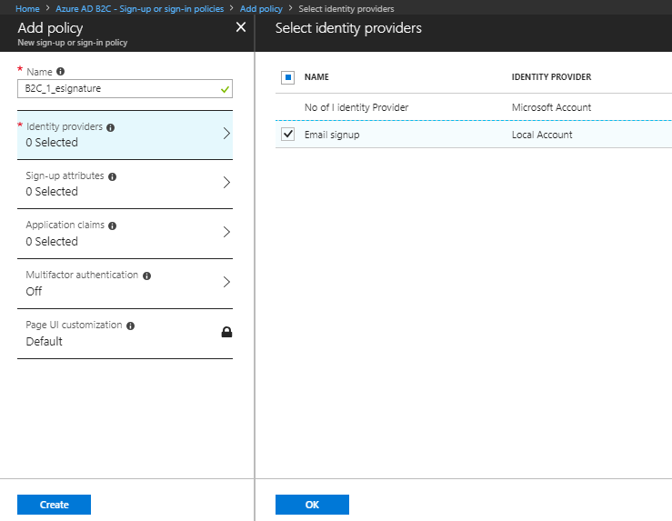

* Skip the **Sign-up attributes** blade.
* In the Application claims blade select **Email Addresses, Identity Provider, User’s Object ID.**

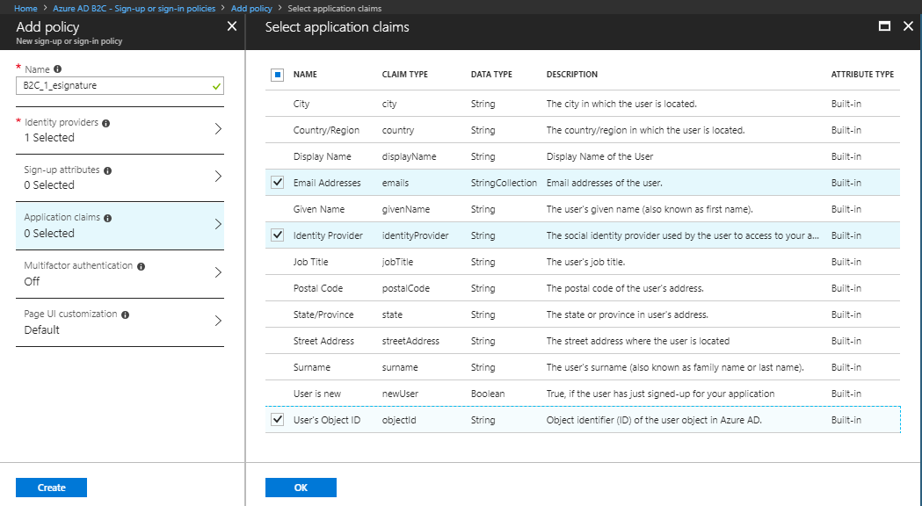

* Skip the Multifactor Authentication blade.
* Select Page UI Customization. Click on **Unified sign-up or sign page**. Set Use **Custom page** to **Yes** and put the Custom page URI value as

[https://*customerIdentifier[version]***storage***[environment]*.blob.core.windows.net/azureadb2c/esignature/esignature.html](https://customerIdentifier[version]storage[environment].blob.core.windows.net/azureadb2c/esignature/esignature.html)

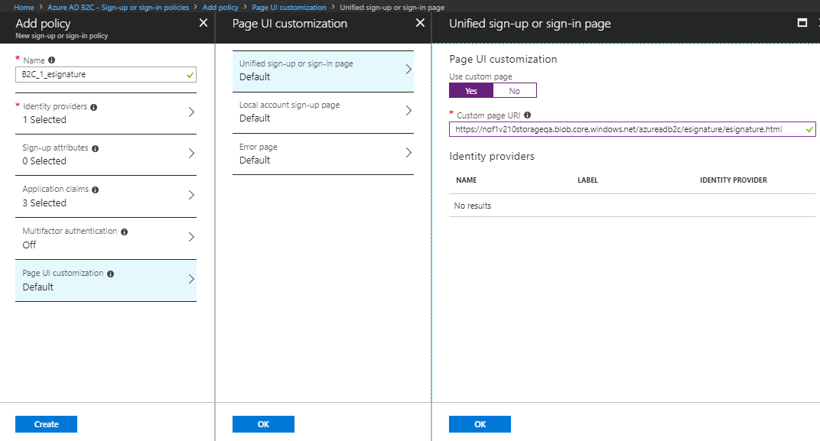

* Click on **Create**.
* Once the e-signature policy is created, click on the policy.

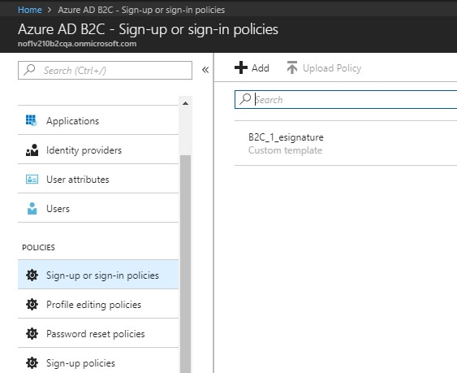

* Click on **Edit** and set the following in **Token, session and SSO config** tab.

|  |  |
| --- | --- |
| **B2C Sign-in Policy Settings** | **Value** |
| Refresh token lifetime (days) | 1 |
| Refresh token sliding window lifetime (days) | 1 |
| Web App Session lifetime | 15 |
| Issuer (iss) claim | https://<domain>/tfp/XXXX-1020-XXXXX-XXXXXX-XXXX//B2C_1_nof1-esignature/v2.0/ |
| Web app session timeout | Absolute |
| Single sign-on configuration | Disabled |

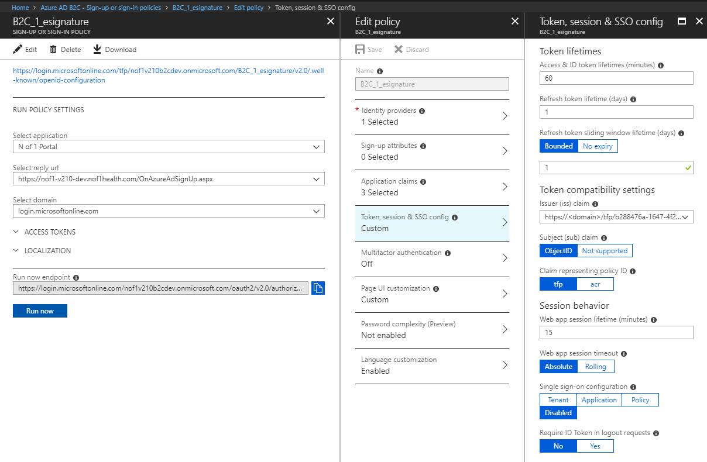

* Click on **Save.**
* Click on the **Language customization** blade.

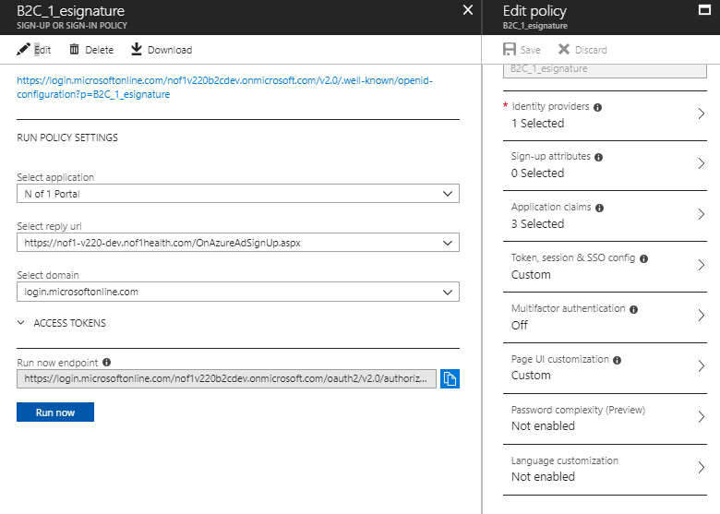

* On the **Language customization** blade, click on **Enable language customization**.

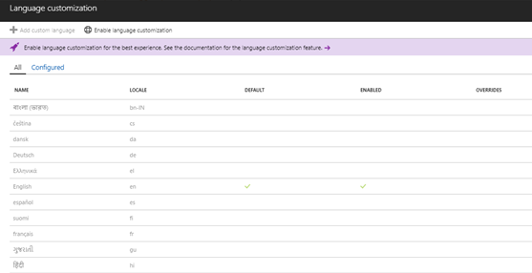

* Enable the **Deustch** language and save and then enable the language español and click **Save.**



* Once saved, the language settings should look like this.

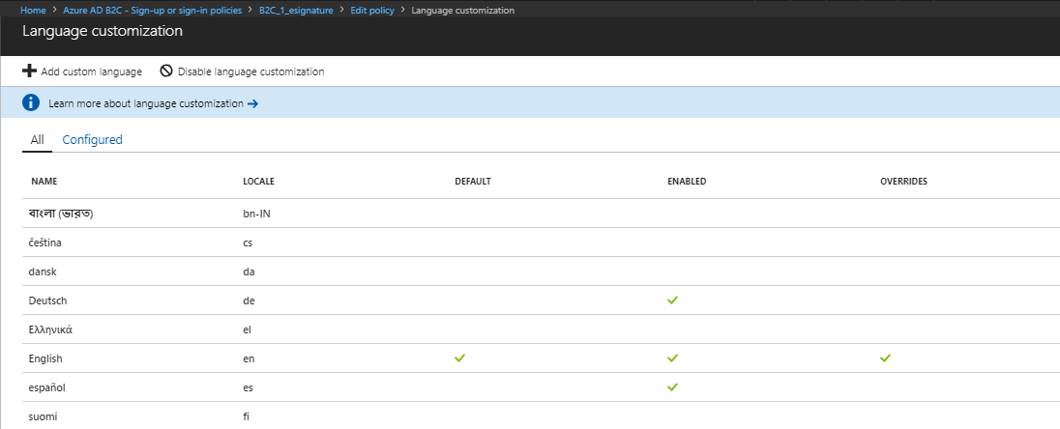

* 1. **Company branding**
* Navigate to the Azure AD B2C **Azure Active Directory** and click on **Company branding**.
* Click on **Configure**.

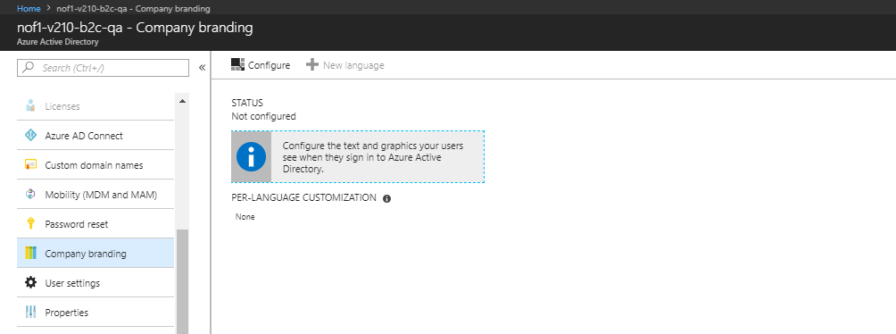

* Upload the **Sign-in page background image, the Banner logo and the Square logo image**.
* Set the **Option to remain signed in** to **Yes.**

|  |  |
| --- | --- |
| **Company branding settings** | **Value** |
| User name hint | [someone@gmail.com](mailto:someone@gmail.com) |
| Sign-in text | Need help? or For more information about  N of 1 Health Research and ePRO Platform,  Contact Us - nof1@digitalinfuzion.com.  © 2018 Digital Infuzion, Inc. digitalinfuzion.com |
| Option to remain signed-in | Yes |

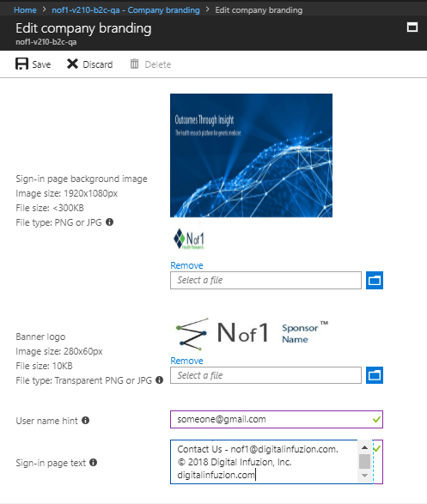

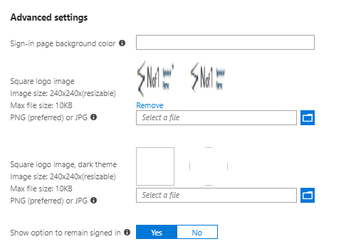

* Click on **Save**.
* Click on **New Language**.

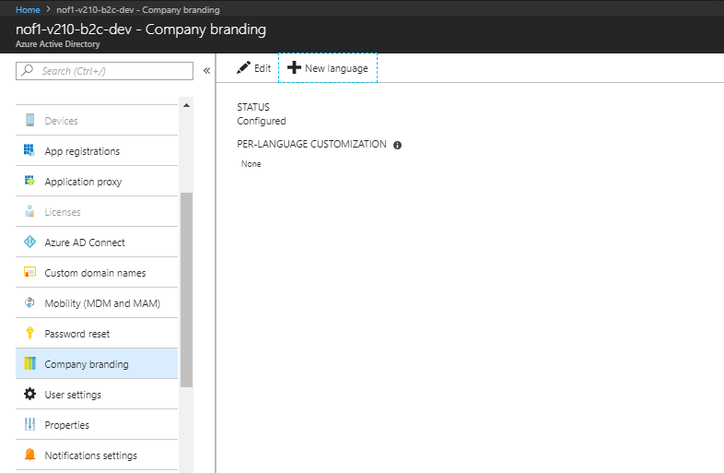

* Select **Deustch** ( Deutschland ).

|  |  |
| --- | --- |
| **Company branding settings** | **Value** |
| User name hint | [someone@gmail.com](mailto:someone@gmail.com) |
| Sign-in text | Brauchen Sie Hilfe? oder weitere Informationen über N of 1 Health Research and EPRO Platform, Kontaktieren Sie uns - nof1@digitalinfuzion.com. |
| Option to remain signed-in | Yes |

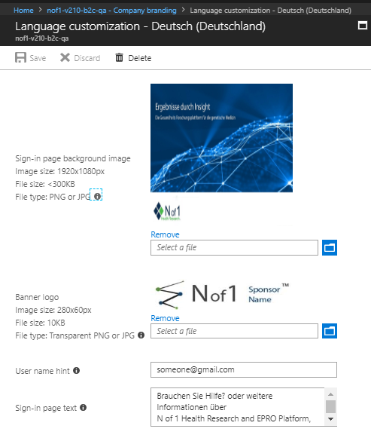

* Repeat the above steps for the Spanish language.

|  |  |
| --- | --- |
| **Company branding settings** | **Value** |
| User name hint | [someone@gmail.com](mailto:someone@gmail.com) |
| Sign-in text | ¿Necesita ayuda? o para obtener más información sobre N of 1 Health Research and ePRO Platform, Contáctenos - nof1@digitalinfuzion.com.   © 2018 digital Infuzion, Inc. digitalinfuzion.com |
| Option to remain signed-in | Yes |

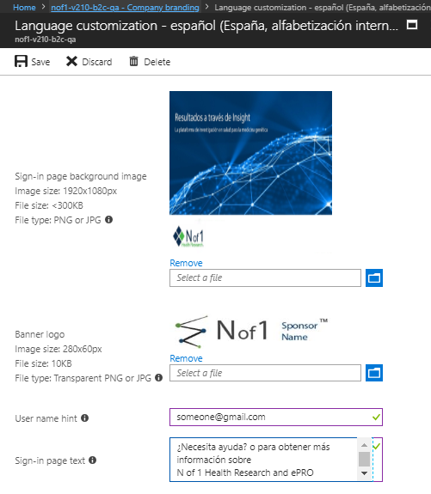

* 1. **Set Self-Service Password Reset Policy**
* Click on the Azure Active Directory tenant and Select **Password Reset** Menu. 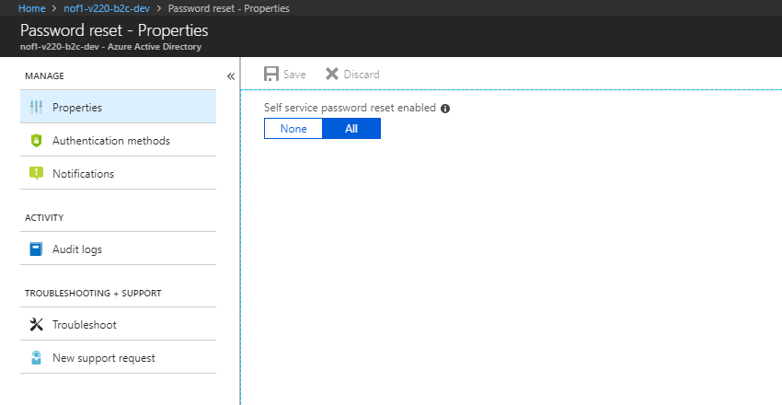

Platform and Datawarehouse Database Deployment

* 1. **Take backup of existing database**
* Connect to N of 1 database in SQL Server Management studio.
* Under **Databases** -> **System Databases** -> Select **master**. Right click and select New Query. Use the following command to create the backup. QA environment is used as an example.

|  |
| --- |
| **PowerShell script to auto-translate single language** |
| **CREATE DATABASE [*customerShortIdentifier-version*-nof1-*environment*-backup] AS COPY OF [*customerShortIdentifier-version*-nof1-*environment*]** |

Make sure you include the name of the original database. It will take a few minutes for the backup database to be created.

* 1. **Get the latest version of your database project**
* Open the solution in Visual Studio in SQL Server Management studio.
* Navigate to **Source Control>> Get Latest Version** (Recursive )

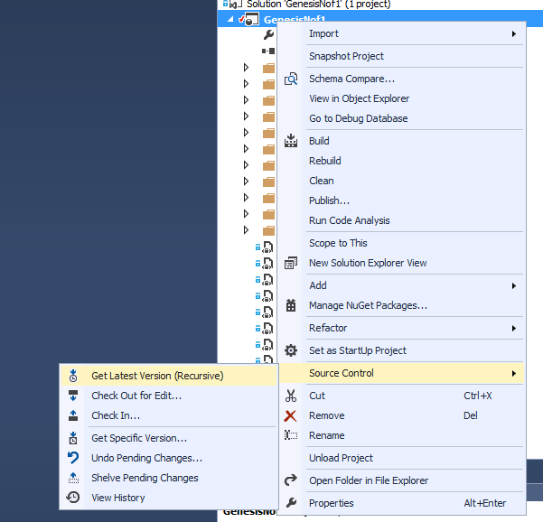

|  |
| --- |
| **PowerShell script to auto-translate single language** |
| **CREATE DATABASE [*customerShortIdentifier-version*-nof1-*environment*-20180711] AS COPY OF [*customerShortIdentifier-version*-nof1-*environment*]** |

**Note**: Make sure you include the name of the original database. It will take a few minutes for the backup to be created.

* 1. **Steps for doing first time deployment**
* Right click on *localDirectoryToSolution*\Nof1HealthPlatform\Database\Nof1HealthPlatformDatabase project and select Publish.
* Select appropriate publish profile for your environment and click Publish Select Publish option

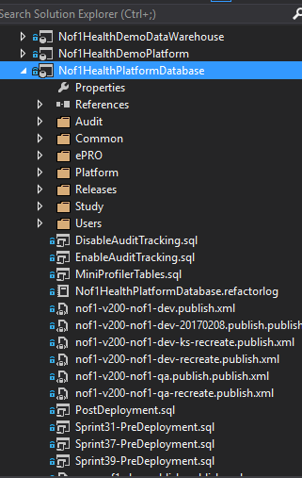

* On the next screen click on the **Edit** button next to the **Target Database** Settings.

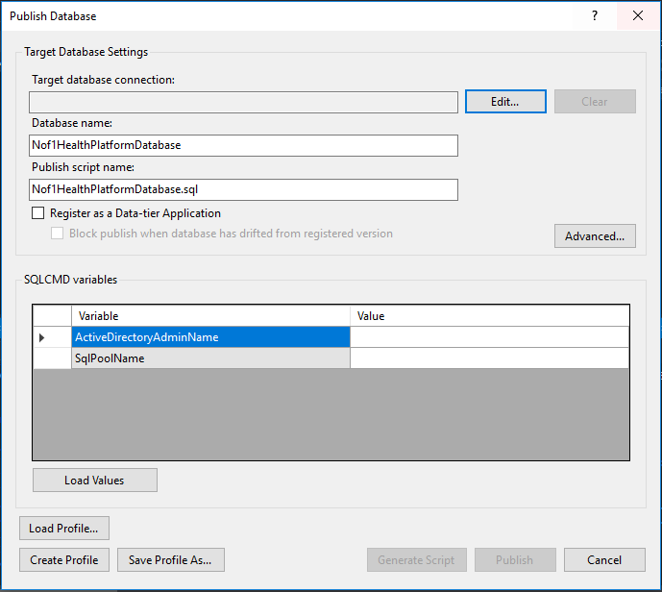

* On the next screen add the database server name, username and password and click on **OK**.

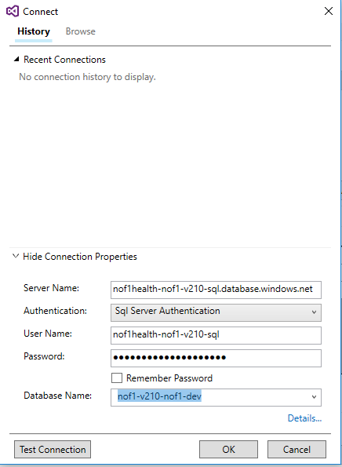

* Once you click **OK** it will go back to the previous screen. Click on **Load Profile** and load any previous profile and click on the **Open** button.

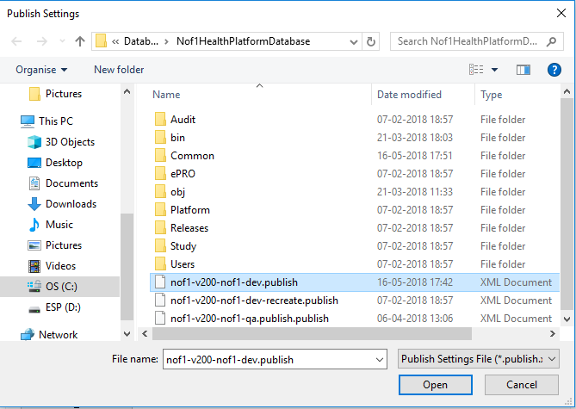

* Click on **Load Values**. It will show the below screen.

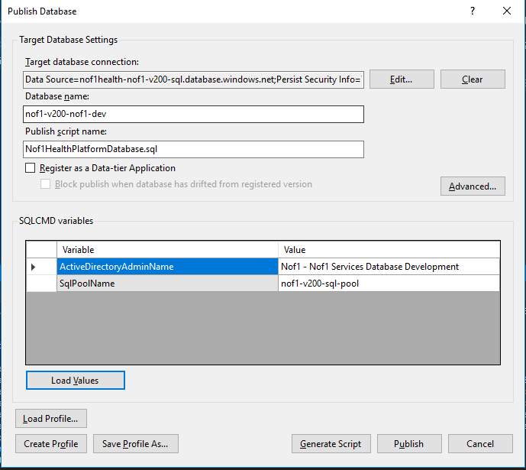

* Change the **SQL Pool** Name to reflect your pool name.

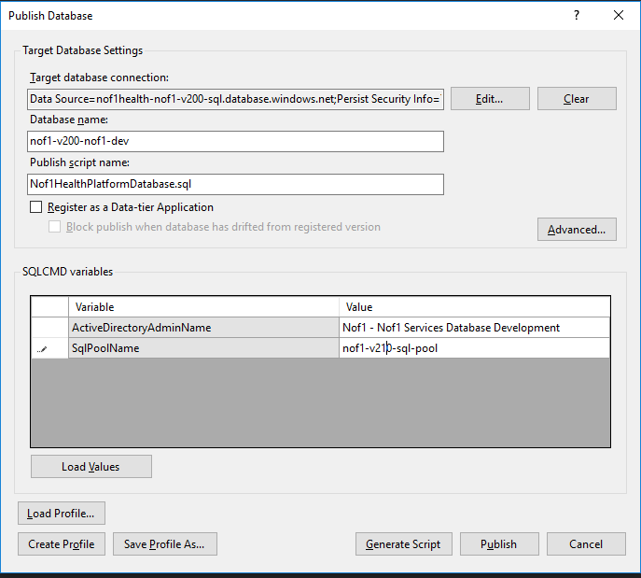

* Click on Publish and monitor the task to ensure it completes.
* Repeat the above steps for below databases

Nof1HealthDemoPlatform

Nof1HealthDataWarehouse

Nof1HealthDemoDataWarehouse

* After testing is done cleanup database backup.

**Note** : The username for all the above databases user remains the same i.e. of1health-nof1-v210-sql. The password is the server password.

Solr Setup

* On your machine create a folder and copy all the Solr related files from any existing deployment.
* Create the yaml configuration file. Use the below template and update the following.



|  |  |
| --- | --- |
| **Solr Setup Settings** | **Value** |
| Username | solr-*customerIdentifier-version*-*environment* |
| Ports | Choose a unique port for your new Docker instance. Each customer gets a block of 10 ports for their various environments (dev, qa, etc) |
| volumes folders | Replace existing environment values with your *customerIdentifier-version*-*environment* values |

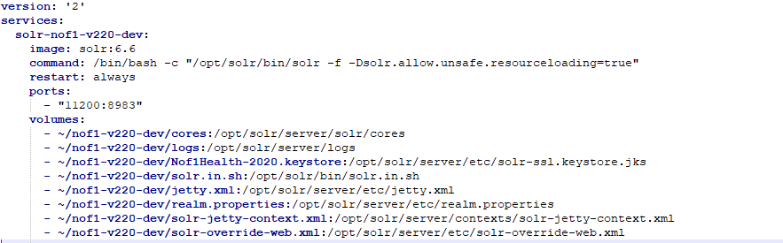

* Update **realm.properties** file with proper username and password. Username would be in the below format. Generate the password from keepass.

*customerIdentifier-version***-solr*-environment***



* Open WinSCP to login to Solr VM. Login using the Solr VM credentials.
* You will see the below screen.

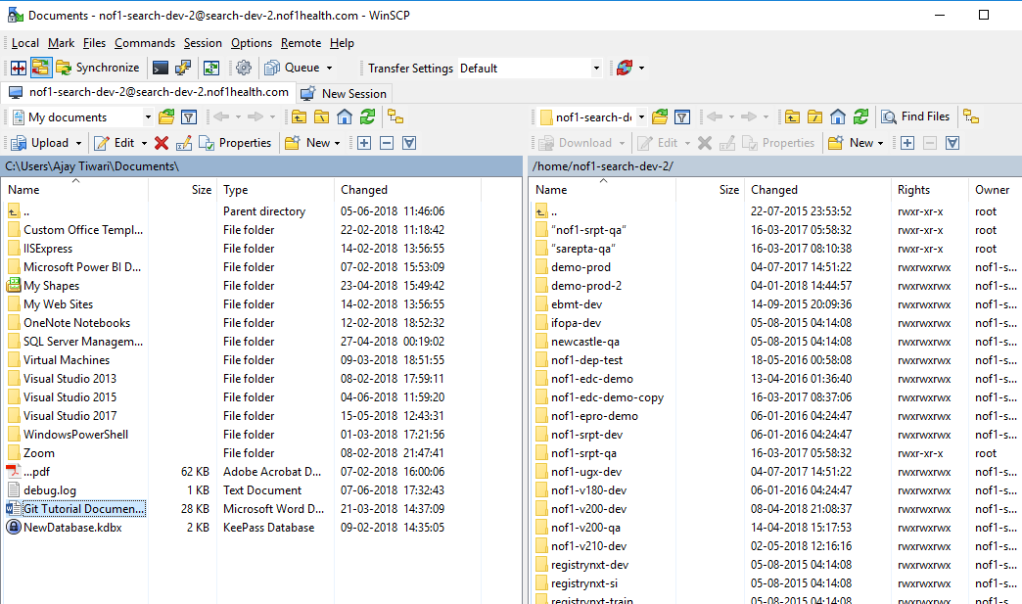

* In the **/home/nof1-search-dev-2** directory, create a new directory for the target environment. Follow the convention used by the other directories.
* The folder name should be of this format.

*customerIdentifier-version-environment*

* Copy contents from your machine to this folder.
* Select all contents of the new directory, right-click and open **Properties**. Ensure/change the group ownership and the owner ownership of the directory to **nof1-search-dev-2** as mentioned below.

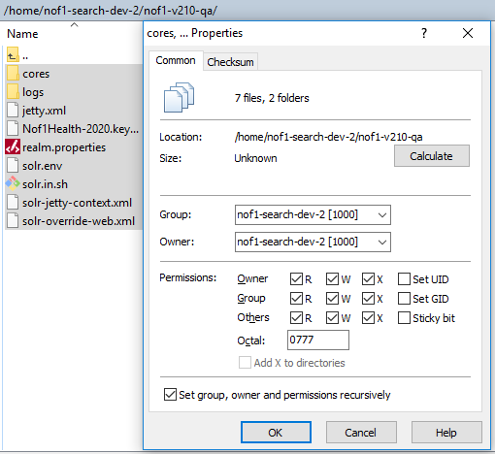

* Double-Click on the cores folder. The below window will open.

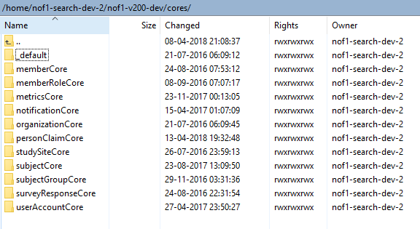

* Select all folders and right click on the selection and open **Properties**. Ensure/Change the Octal value to **0777**. **Check the Set group, owner and permissions recursively** setting and press **OK**.

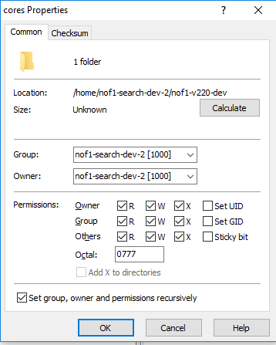

* Now upload your local yaml file into the root **/home/nof1-search-dev-2** directory.

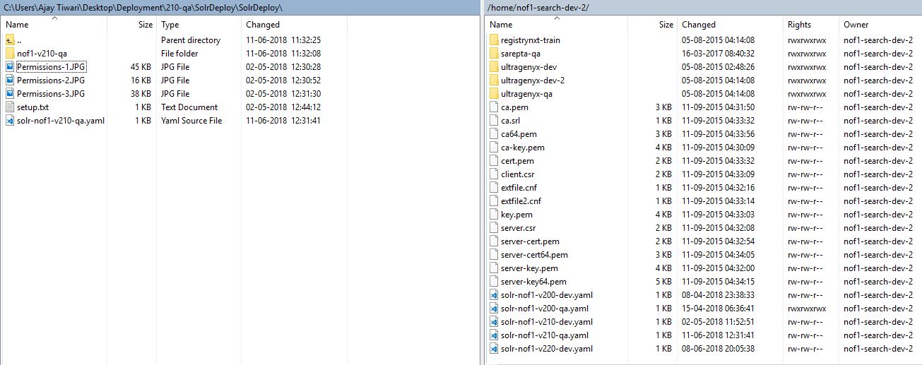

* Upload your **realm.properties** file into the folder you have created for your environment.

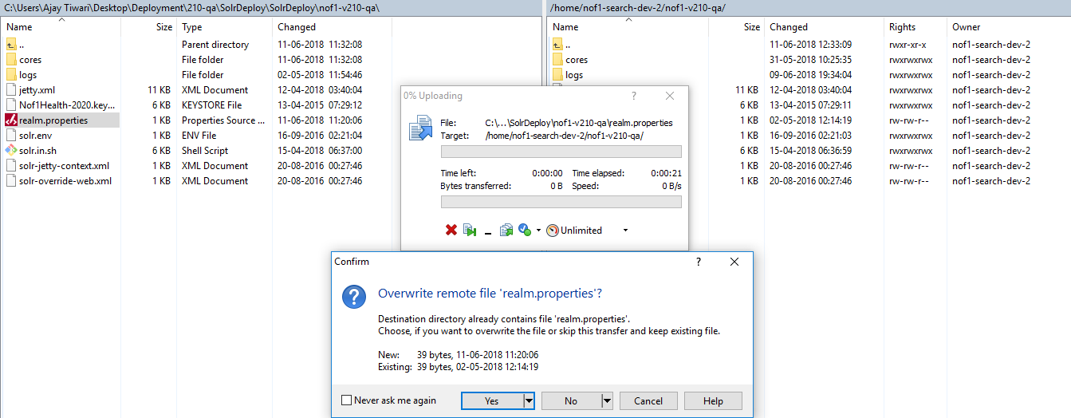

* Connect to the VM using an SSH terminal, such as PuTTY.

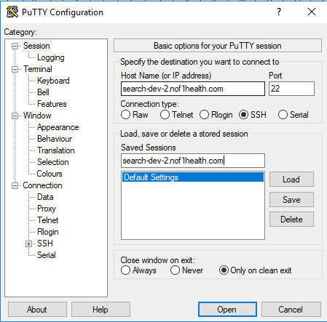

* Click on Open. Put the Solr VM **username** and **password** on the prompt.

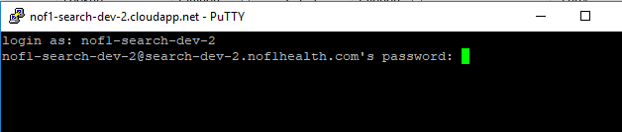

* Run the command

|  |
| --- |
| **Linux Docker command to deploy Solr Container** |
| **docker-compose --file ./<your-yaml-file> up -d** |

For example

|  |
| --- |
| **Example Linux Docker command to deploy Solr Container** |
| **docker-compose --file ./solr-nof1-v210-dev.yaml up -d** |



* Verify the newly created docker container is running by giving the docker ps -a command

|  |
| --- |
| **Linux Docker command to check if the container is running** |
| **docker ps -a** |



* Now login to the Azure Portal and find the VM with the name **nof1-search-dev-2**. Goto the VM’s Endpoints blade and then click on **Add.**

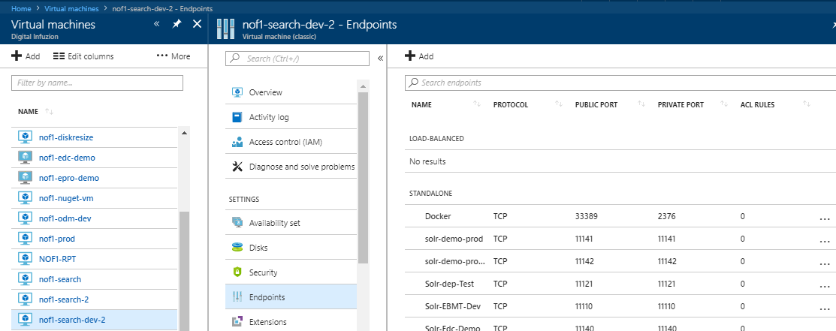

* Put the following values in the windows that appears:

|  |  |
| --- | --- |
| **Solr Server Azure Endpoint Settings** | **Value** |
| Name | Solr-*version-customerIdentifier* |
| Protocol | TCP |
| Public port | The port number you have selected for your environment |
| Private port | The port number you have selected for your environment |
| Floating IP address | Disabled |

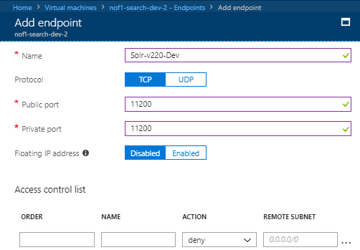

* Click on **OK** to save the endpoint.
* Now you are done the Solr service setup and open the browser and type the below URL.

https:// search-dev-2.nof1health.com:*solrportnumber*/solr/

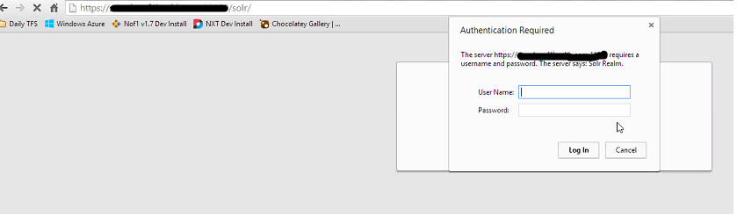

* It will prompt you User Name and Password. Use the username and password you put in the ream.properties file.
* Once filled press the Login button. You will see the dashboard page.

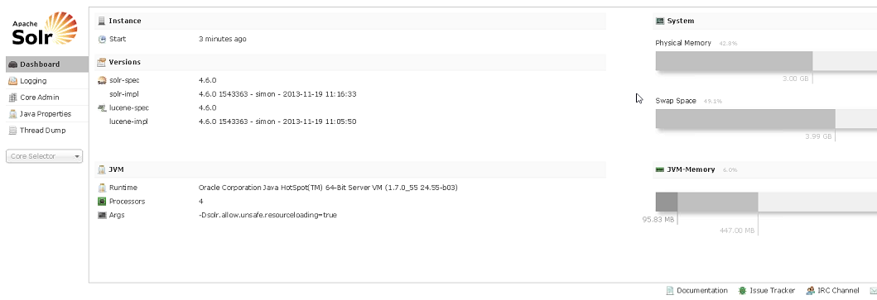

* The Solr service setup is now complete.
  1. **Refresh Solr indexes.**
* Login to the website and get the bearer token from the browser.

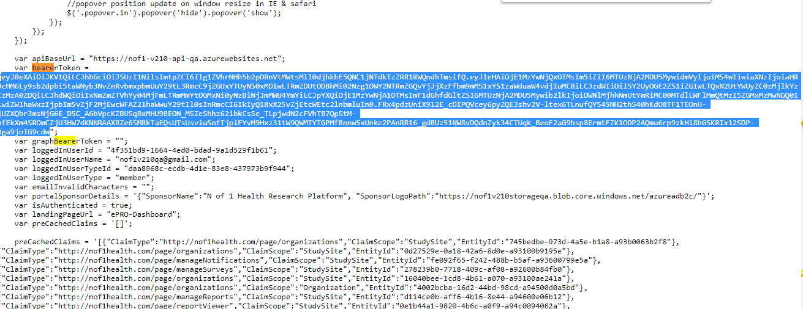

* Run POST calls on the following

https:// *customerIdentifer-version*-**api**-*environment.***azurewebsites.net***/search/completeReindex*

https:// *customerIdentifer-version*-**api**-*environment.***azurewebsites.net** */notification/search/index/all*

https:// *customerIdentifer-version*-**api**-*environment.***azurewebsites.net***/organization/search/index/all*

https:// *customerIdentifer-version*-**api**-*environment.***azurewebsites.net***/userAccount/search/index/all*

https:// *customerIdentifer-version*-**api**-*environment.***azurewebsites.net***/survey/response/search/index/all*

* Run GET calls on the following

https://nof1-v210-api-dev.azurewebsites.net/personnel/claim/cache/refresh

* 1. Update solr core

Whenever we update .xml file on solr core we have to reload that core by loging to solr admin console to refresh the changes on solr.

Setup and Deploy WebAPI and Webjobs

* 1. **Create the background App Service**
* In your subscription navigate to **App Services >> Add.**

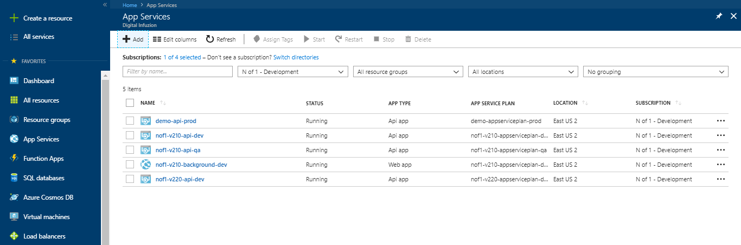

* Search for WebApp in the list and select **Web App**.

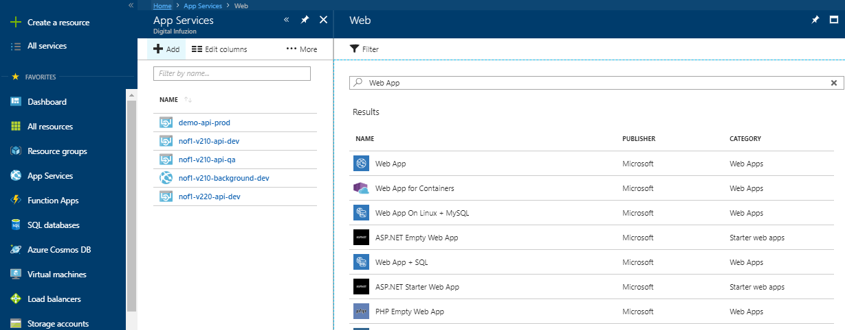

* Click on **Create.**

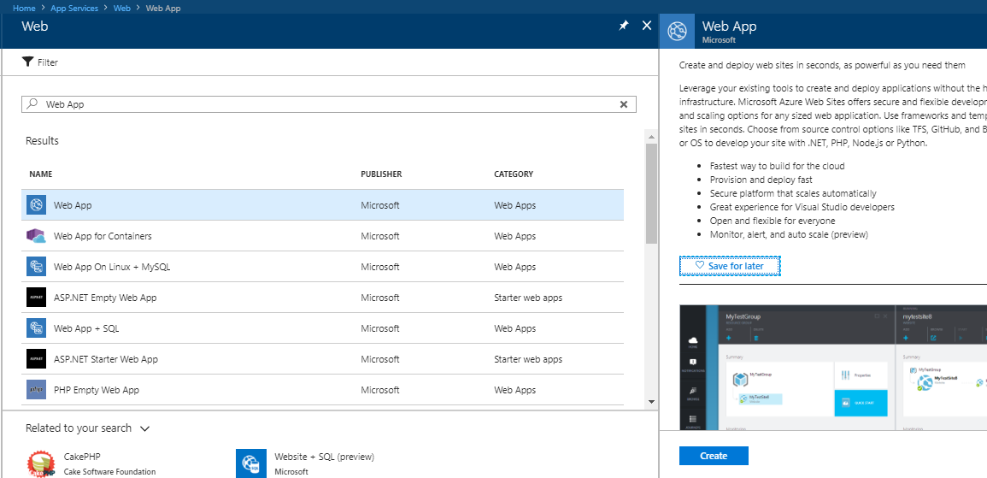

* On the next screen put the following.

|  |  |
| --- | --- |
| **Background API Settings** | **Value** |
| App Name | *CustomerIdentifer-version*-**background**-*environment* |
| Subscription | Absolute |
| Resource group | Use the Environment specific resource group created in step 3. |
| OS | Windows |
| App Service Plan | *CustomerIdentifer-version*-**appserviceplan**-**background**-*environment* |
| App Insights | off |

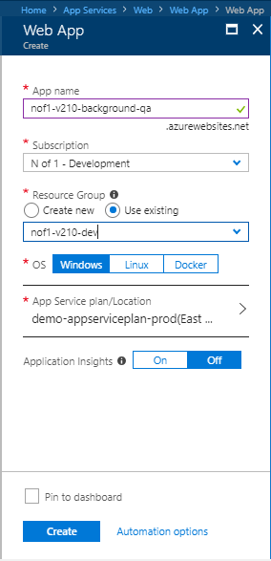

* 1. **Upload Self-signed certificate in the App service and the background App Service**

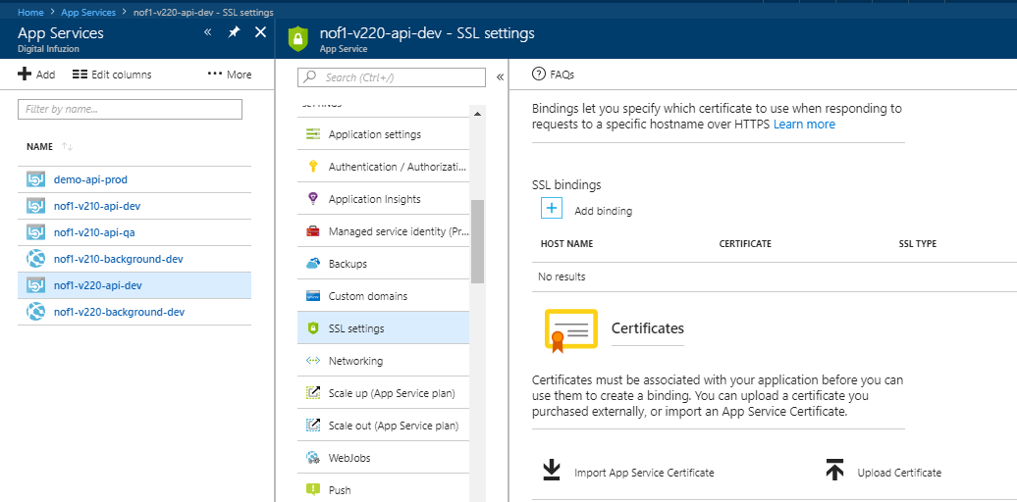

* Click on **Upload Certificate.**

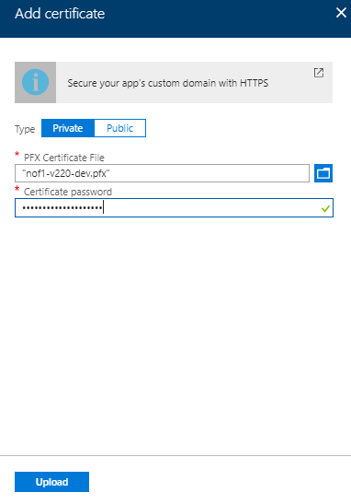

* After uploading the certificate, the certificate will appear in the private certificates section.

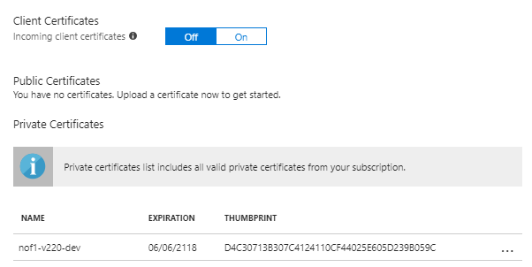

* Copy the certificate thumbprint.
* Now navigate to **Application Settings** and add a setting name **WEBSITE_LOAD_CERTIFICATES** and put the value as **\***. Restart the App service by clicking on **Restart.**

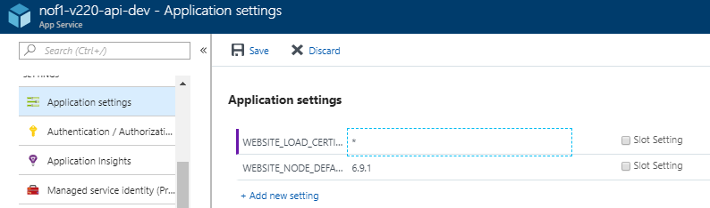

* Do the same for background App Service.
  1. **Deploy BackgroundTaskWebJob**
* In Visual Studio, go to project *localDirectoryToSolution***\API\Nof1Health.BackgroundTaskWebJob**. Open **App.config** file. Update settings under the sections **configuration\appSettings** and **autofac\modules** to point to the resources in your Azure environment. Download the publish profile for the Background App service you created from the Azure portal.
* Right click on the project and select **Publish as Azure WebJob**.

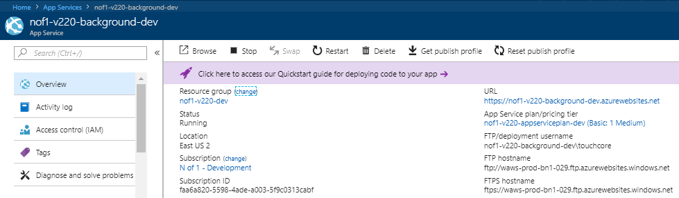

* On the Profile page, click Import and select the downloaded publish profile.

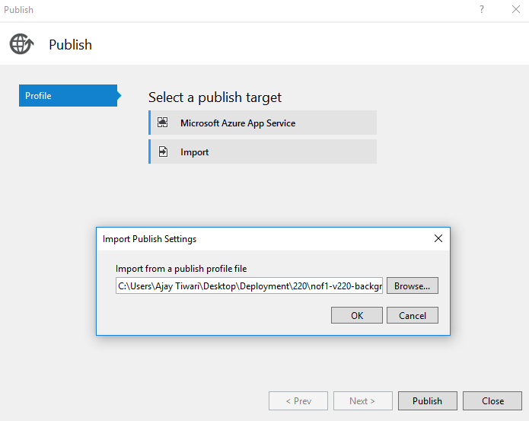

* On the Connection page, validate the connection.

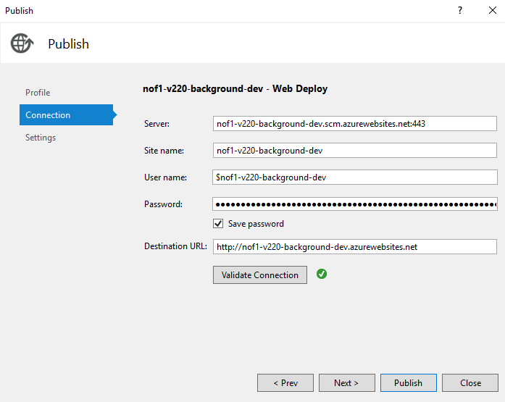

* On success, click **Next**. On Settings page, select **Release-Any CPU** and click **Publish**.

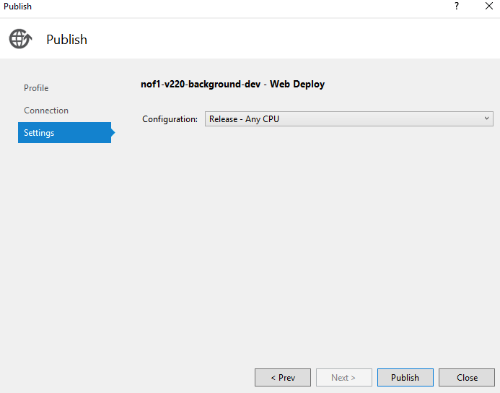

* 1. **Deploy API App service**
* In Visual Studio, go to project *localDirectoryToSolution***\API\Nof1Health.Api**. Open the **Web.config** file. Update settings under the sections **configuration\appSettings** and **autofac\modules** to point to the resources in your Azure environment. Download the publish profile for your app service from the Azure portal by clicking on the **Get publish profile** window.

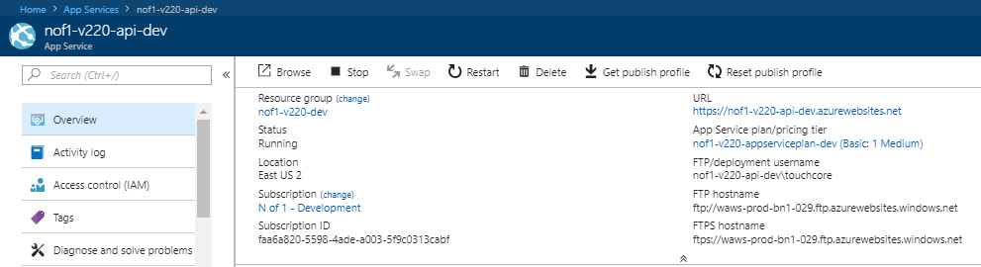

* Right click on the project and select **Publish.**

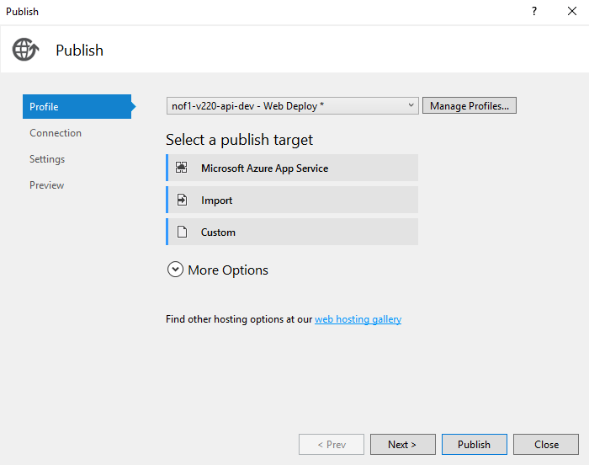

* Select Profile page, click Import and select the downloaded publish profile.

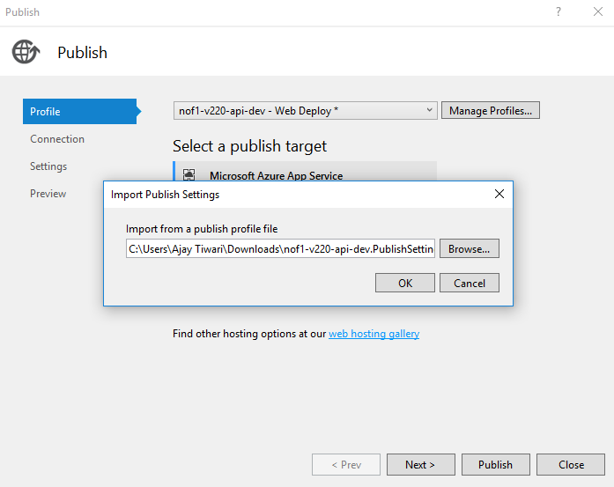

* On the Connection page, validate the connection and ensure it is successful.

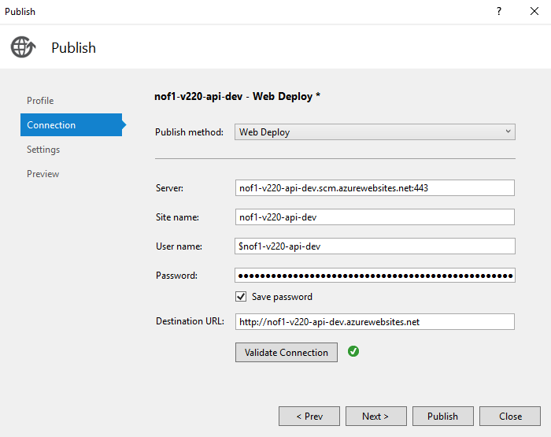

* Click on **Publish.**

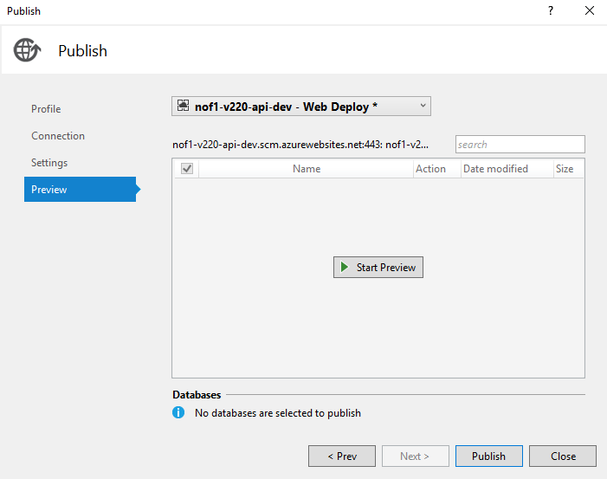

* 1. **Create and Deploy the ServiceBusWebjob**
* In Visual Studio, go to project *localDirectoryToSolution***\API\Nof1Health.ServiceBusWebJob**. Open **App.config** file. Update settings under the sections **configuration\appSettings** and **autofac\modules** to point to the resources in your Azure environment.
* Download the publish profile from your background app service from the Azure portal.
* Right click on the project and select **Publish as Azure WebJob....** and the follow the steps used for the deploying the **BackgroundTaskWebJob**.
* Once the deployment is done, select the background Web app and check if you have the Webjobs running. You will see a notice which says Continuous and scheduled CRON webjobs require ‘**Always on’** to be enabled for your App.

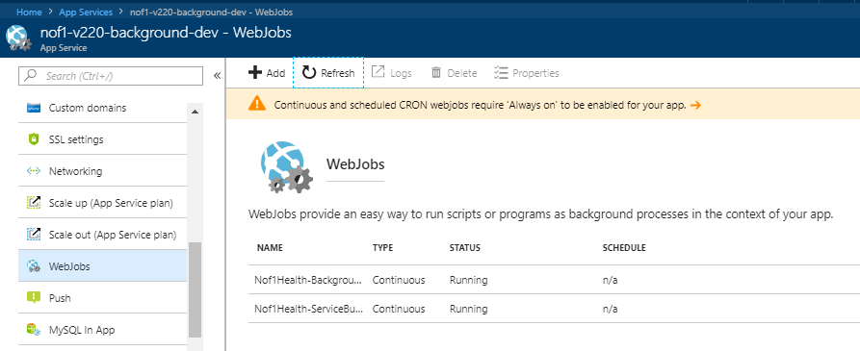

* Click on the notice and on the next screen turn **Always On** to **On**.

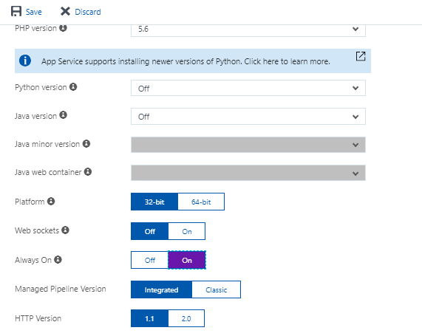

* 1. **Deploy OdmProcessorWebjobs**
* Select the project *localDirectoryToSolution***\DataIn\Nof1Health.DataIn.OdmProcessorWebJob** and right click on it. Open **App.config** file. Update settings under the section **autofac\modules** to point to the resources in your Azure environment.
* Download the publish profile for your *customerIdentifier-version*-**background**-*environment* app service from the Azure portal.
* Right click on the project and select **Publish as Azure WebJob...**. and the follow the steps used for the deploying the BackgroundTaskWebJob.
* Turn **Always On** to **On** as mentioned in the previous step.

Add templates in the Storage Container

* We need to upload the templates required by the Notifications system.
* Go to the environment specific storage **account -> blobs -> container**. Create new container named **templates**. Set public access level set to **Private (no anonymous access)**.

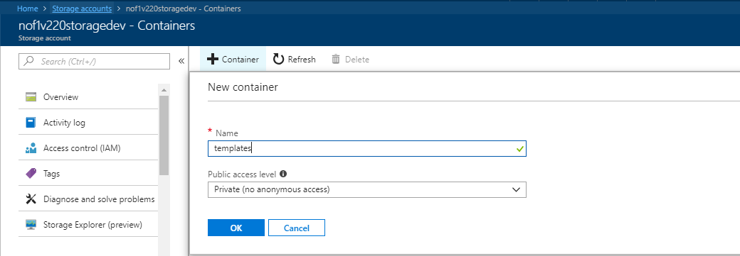

* Open **PowerShell** and navigate to the *localDirectoryToSolution* **\Nof1HealthPlatform\EnvironmentSetup\AzureSetup\Scripts** directory run the following command to upload all the required templates to blob storage.

|  |
| --- |
| **Powershell Script to Upload Templates to the environment** |
| **.\upload-blobs.ps1 -subscriptionName “*subscriptionName”* -resourceGroupName *resourceGroupName* -storageAccount *storageAccountName* -blobContainerName templates -location “*location”* -folderToUpload "*pathToTemplatesFolder*”** |

|  |
| --- |
| **Example powershell Script to Upload Templates to the environment** |
| **.\upload-blobs.ps1 -subscriptionName "N of 1 - Development" -resourceGroupName nof1-v220-dev -storageAccount nof1v220storagedev -blobContainerName templates -location "East US 2" -folderToUpload "C:\Projects\V2\Nof1HealthPlatform\Integration\Nof1Health.Integration.AzureServiceBus\Message\Notification\Templates"** |

Deploy Batch Pool Account

We begin by Setup CORS on the shared storage account, created during environment creation, so that we can upload the dotNetFramework-4.6.1-offline.exe required by the batch pool nodes.

* Navigate to the shared storage account pertaining to your environment.

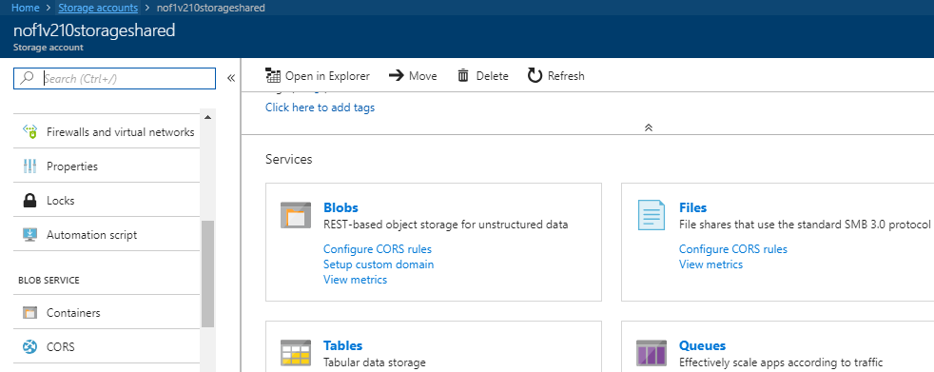

* Goto **CORS** 🡪 Click on **Add**. Setup the Following values.
* On the blade that pops-up click on Add and setup the following values.

|  |  |
| --- | --- |
| **CORS Setting** | **Value** |
| Allowed Origins | * |
| Allowed Verbs | GET, OPTIONS |
| Allowed Headers | * |
| Exposed Headers | * |
| Max Age | 200 |



* Click on **Add.**

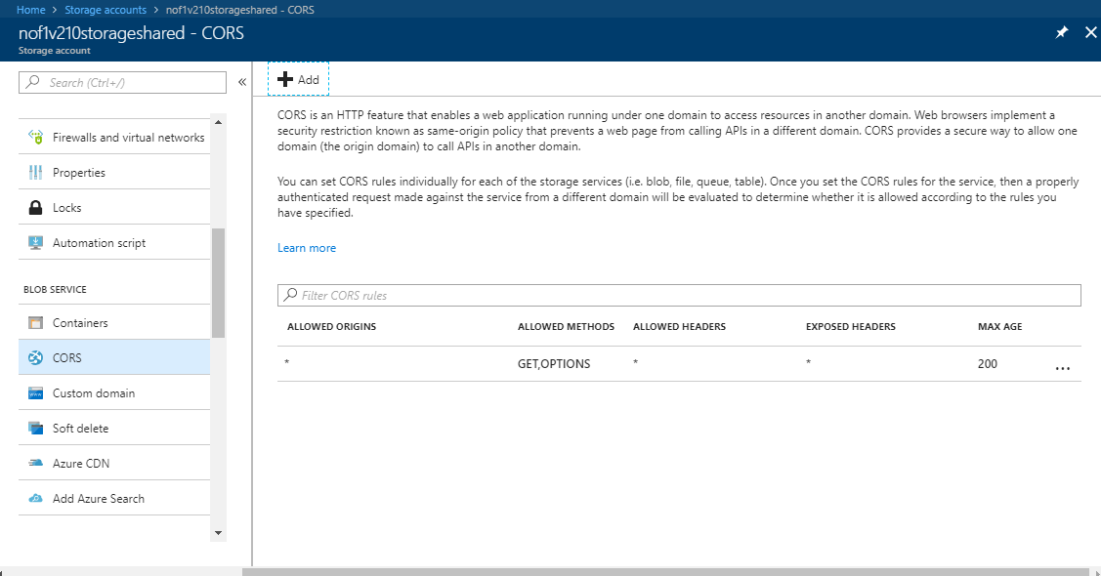

* Create a container named - **data-factory-custom-activity**.
* Here is where we will upload the **dotNetFramework-4.6.1-offline.exe**. You will need to download this file from a storage account from any previous deployment.

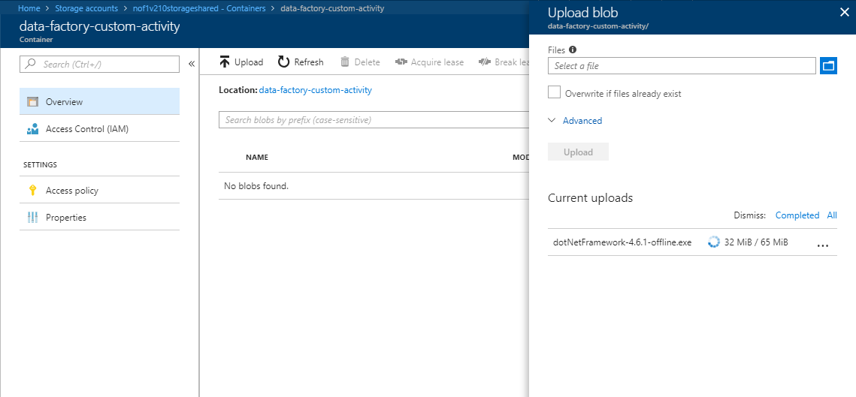

* Now navigate to the batch account. If the batch account is not created, create one in the shared storage.
* In the batch account, click on **Pools**.
* In the Pools screen click on **Add Pool** and put in the following details

|  |  |
| --- | --- |
| **Pool Settings** | **Value** |
| Pool ID | datain-pool-qa |
| Image Type | Marketplace ( Linux/Windows ) |
| Publisher | MicrosoftWindowsServer |
| Offer | WindowsServer |
| Sku | 2012-R2-Datacenter |

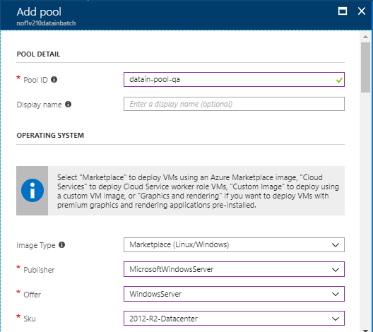

* Set Node Size to **Standard A1 ( 1 Cores, 1.8 GB )**

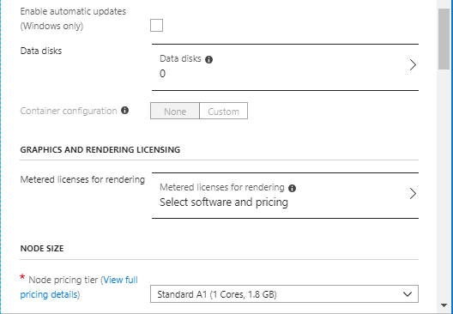

* Under **SCALE** set the following.

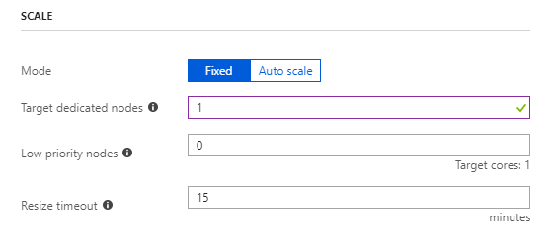

* Enable Start Task. Set the **Max task retry count** to 3. In the Command line put

%AZ_BATCH_NODE_STARTUP_DIR%\dotnetinstall\dotNetFramework-4.6.1-offline.exe

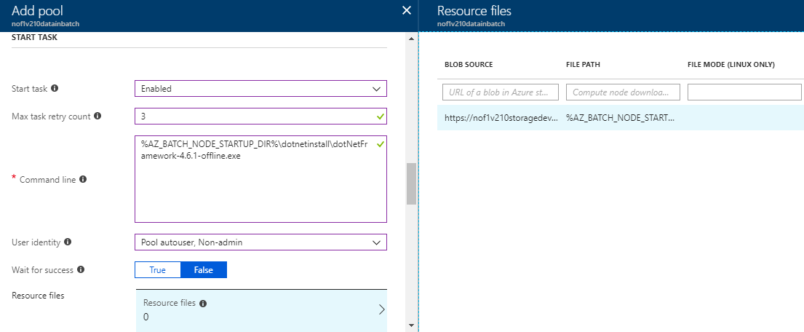

* Click on **Resource Files** and put the following details.

|  |  |
| --- | --- |
| **Pool Settings ( Resource files )** | **Value** |
| blob Source | https://*customeridentifier[version]****s*torage***[environnment]*.blob.core.windows.net/data-factory-custom-activity/dotNetFramework-4.6.1-offline.exe |
| FILE PATH | %AZ_BATCH_NODE_STARTUP_DIR%\dotnetinstall\dotNetFramework-4.6.1-offline.exe |
| FILE MODE | blank |

* Now in **OPTIONAL SETTINGS** click on **CERTIFICATES** and upload the certificate.
* Select **Start Task, Task, Remote User** in visibility.

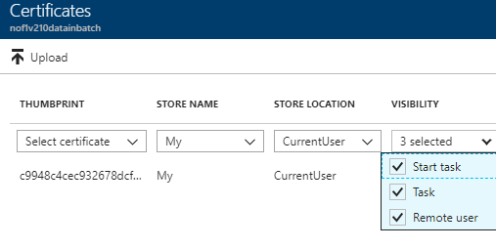

* Press enter to save.

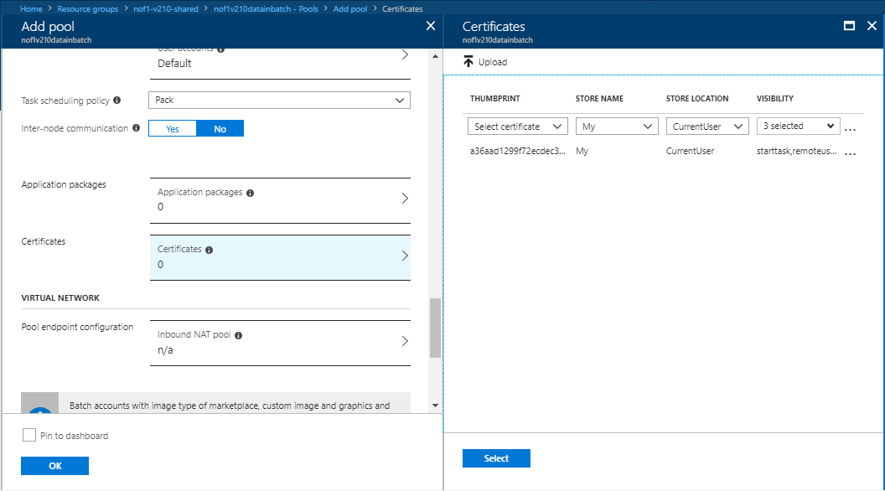

* Press **OK** and start monitoring the Start Task. It will give a succeeded message once the task runs successfully.
* Your batch account is setup with 1 node.

Setup Cosmosdb

* In the Powershell window, run the below script. Change the ResourceGroupName and the Cosmosdb name to match your environment name.

|  |
| --- |
| **Powershell Script to create Cosmosdb environment** |
| **$locations = @(@{"locationName"= *location*; "failoverPriority"=0}, @{"locationName"="Central US"; "failoverPriority"=1})**  **$iprangefilter = ""**  **$consistencyPolicy = @{"defaultConsistencyLevel"="Session"}**  **$CosmosDBProperties = @{"databaseAccountOfferType"="Standard"; "locations"=$locations; "consistencyPolicy"=$consistencyPolicy; "ipRangeFilter"=$iprangefilter}**  **New-AzureRmResource -ResourceType "Microsoft.DocumentDb/databaseAccounts" -ApiVersion "2015-04-08" -ResourceGroupName *customerIdentifier-version-environment* -Location *location* -Name *customerIdentifier-version*-cosmosdb-*environment* -Properties $CosmosDBProperties** |

* Login to portal and select your account. Click on **Add Collection**.

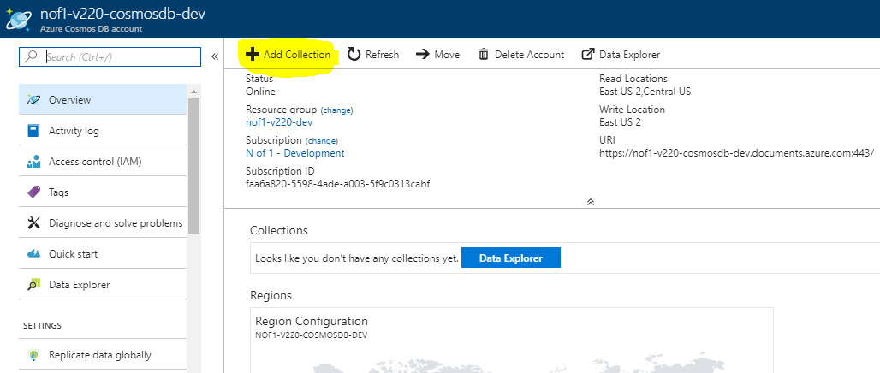

* The below screen will appear:

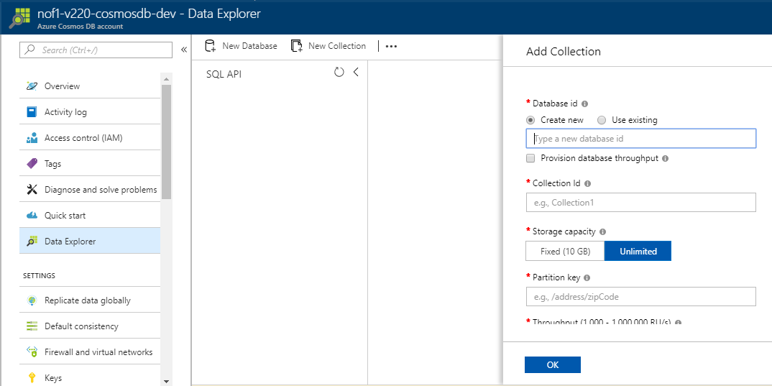

* Delete any existing databases that exist and create a new collection named “collection” as below and press **OK**.

|  |  |
| --- | --- |
| **CosmosDB collection database settings** | **Value** |
| Database id | *customerIdentifier-version*- documents |
| Collection id | collection |
| Storage capacity | unlimited |
| Partition key | /partitionKey (This is case sensitive) |
| Throughput | 1000 RU/s |

* Click on **New collection** again.

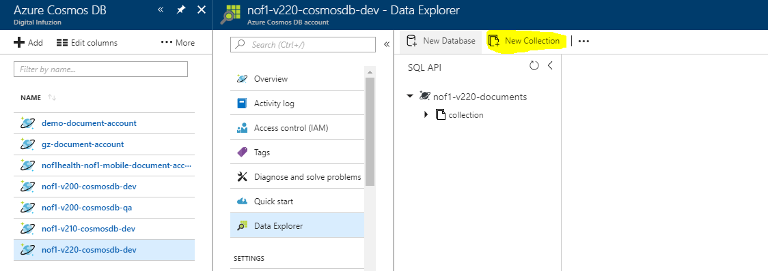

|  |  |
| --- | --- |
| **CosmosDB phi database settings** | **Value** |
| Database id | Select existing |
| Collection id | phi |
| Storage capacity | Fixed (10 GB) |
| Throughput | 400 RU/s |

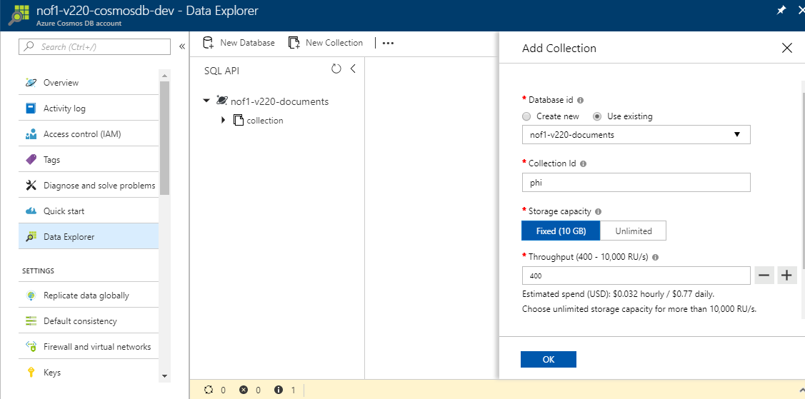

* The CosmosDB is now setup.

Create Study Build

* 1. **Extract SDS for each study and version**
* Log into Rave using the credentials provided to you.
* Choose **Architect** from the main menu.

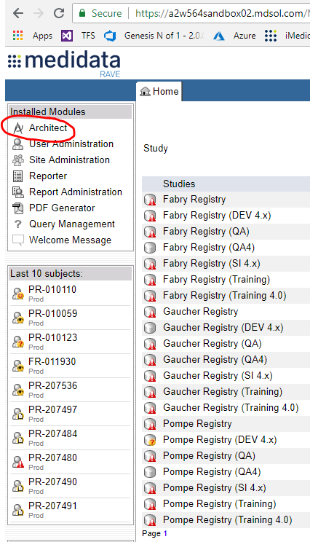

* Amongst the list that appears, select the study you want configure.

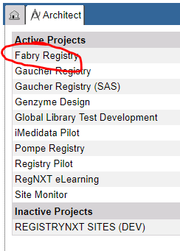

* Pick the CRF Version

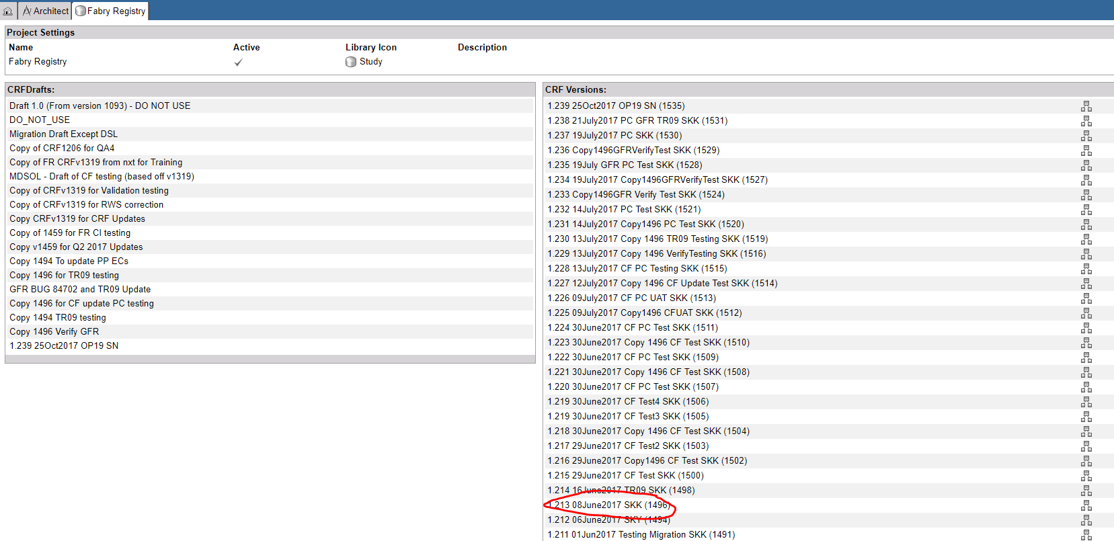

* Download the SDS

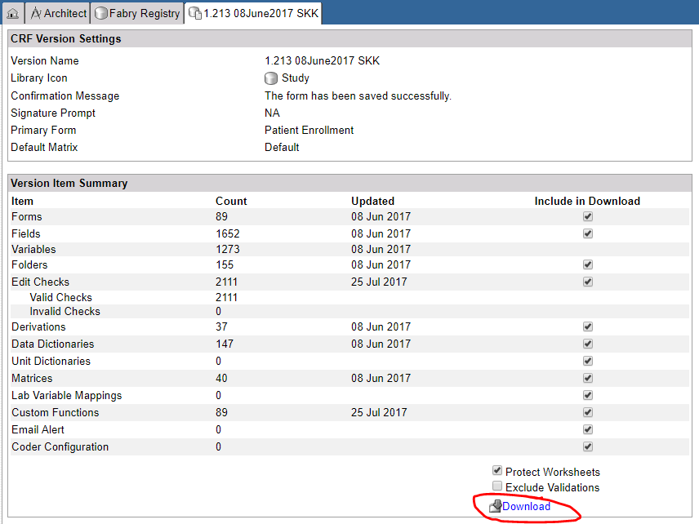

* Save the file. Right click on the downloaded file. At least note where it is downloaded.

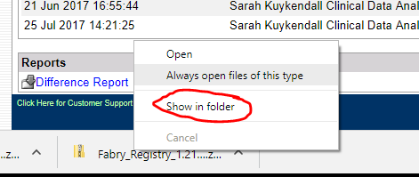

* For example: <https://a2w564sandbox02.mdsol.com/RaveWebServices/metadata/studies/Fabry%20Registry/versions/1496>
* Save the study build ODM file by right clicking on the web page, choose Save as…, name the file (studyname_version).



* Upload the file to the raw folder in container datawarehouse-studybuild container in the the blob storage.

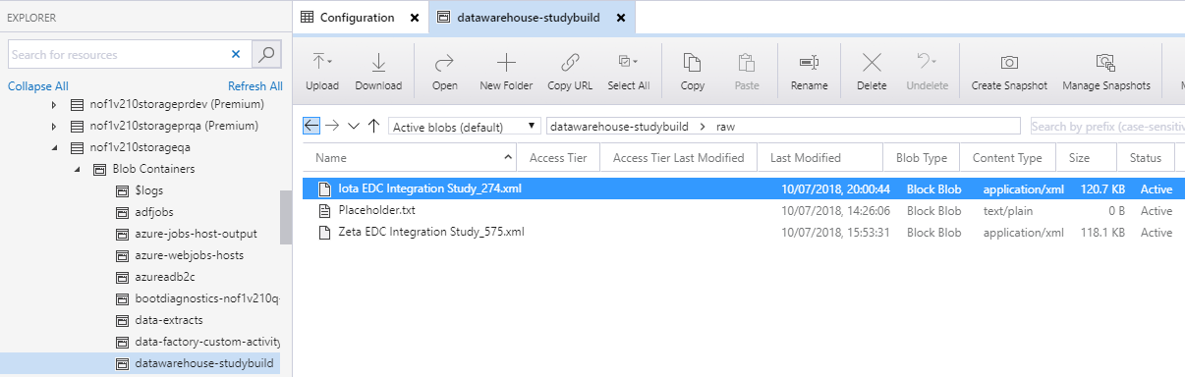

* 1. **Convert the SDS spreadsheet to JSON**
* Open the zip file from any previous installation.
* Copy the SDS spreadsheet in the folder.
* Open and save the SDS spreadsheet as an Excel Workbook.
* Open and Edit and change the storage connection string in the UploadSDS.bat file

An Example:

|  |
| --- |
| **Changing the code in the storage connection string in the SDS file** |
| ConvertStudyBuildExcelToJson "path to the xlsx file" "DefaultEndpointsProtocol=https;AccountName=demostorageprod;AccountKey=JLYUiTuGpVCur5rsgUARWirIluDzTqOpNH36DaHGj0l9nEMU8EVhomCSYedHec8CEyfYJwL7xeRPrGA+OGcnPw==;EndpointSuffix=core.windows.net" "datawarehouse-studybuild/sds" 1> UploadSDS.log |

* Save the batch file
* Close the spreadsheet.
* Run the batch file.
* Check the results.
  1. Fix the study build ODM file
* Edit Nof1Health.Integration.MedidataRave.Test\TestDownloader.cs MakeReadyAsync. The line 906 should be read

var fOid = new XAttribute("FormOID", form.OID);

* Run test unit TestMakeReadyAsync.
  1. **Create the item level ODM files**
* Open the file Nof1HealthUtilities.CreateOdmItemFiles
* Update the command line arguments on the Properties page
* Run the program

Deploy Data-factory

* Navigate to *localDirectoryToSolution***\DataWarehouse\Nof1Health.DataWarehouse.DataFactory**
* Create a configuration file for deployment. The file should follow the below convention *customerIdentifier-version-environment*.**config.json.**

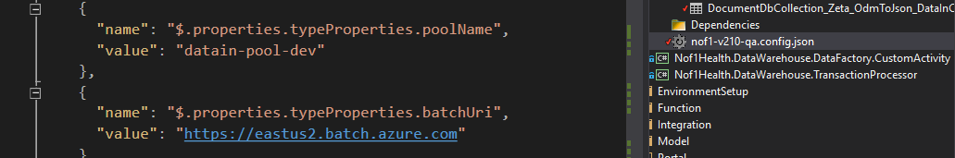

* Change all the connection strings and study related entries in the file.

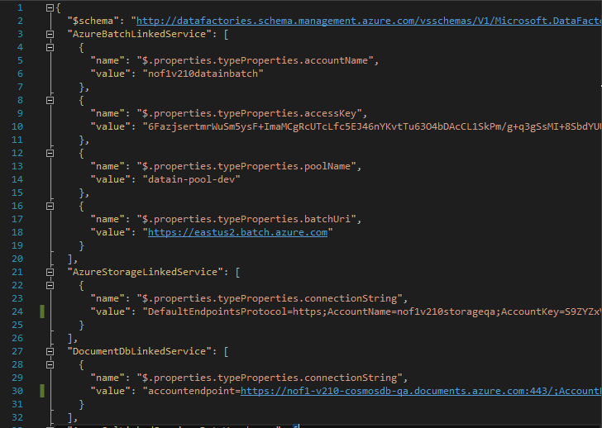

* Under the **Nof1Health.DataWarehouse.DataFactory** project click on the **Tables** folder.
* Create json files pertaining to the edc study you want to run the DataFactory job for. You may copy the existing json files or change existing studies.

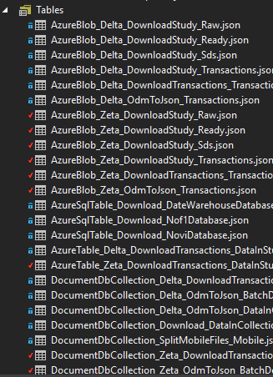

* Edit these tables to reflect the correct study names.

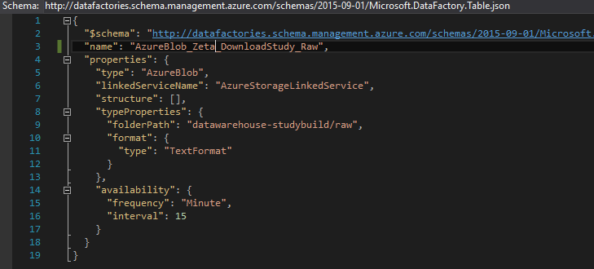

* Open *edcStudyName*Edc**TransactionPipeline.json**. Update the **start** date-time in the pipeline in the specified format.

Note : - Check the time in UTC and put the time as UTC – 15 minutes in addition to the date

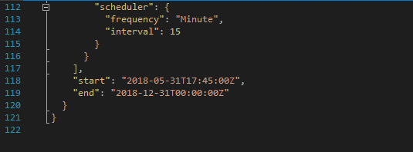

* Open NoviSurveyTransactionPipeline.json .Update **start** and **end** time in the pipeline in the specified format.



* Build the project **Nof1Health.DataWarehouse.DataFactory** in debug mode.
* Open project **Nof1Health.DataWarehouse.DataFactory** in file explorer
* After successful build, copy all files from *localDirectoryToSolution***\Nof1HealthPlatform\DataWarehouse\Nof1Health.DataWarehouse.DataFactory\bin\Debug\Dependencies** to *localDirectoryToSolution***\Nof1HealthPlatform\DataWarehouse\Nof1Health.DataWarehouse.DataFactory\Dependencies**

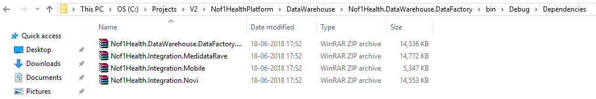

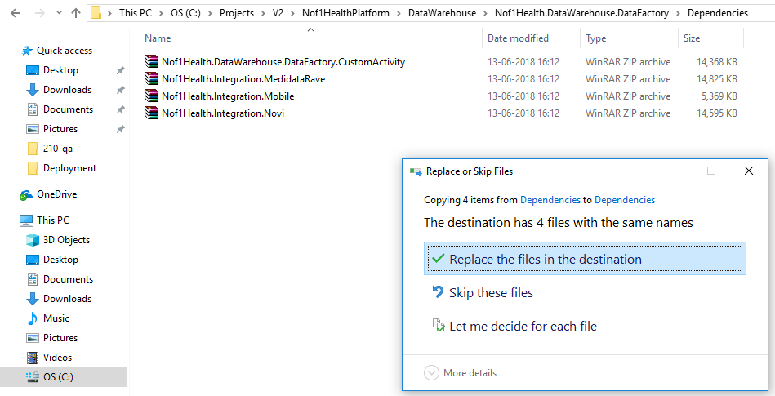

* Open Powershell in Administrator mode.
* Change the directory using the below command.

|  |
| --- |
| **PowerShell script to change to the Datafactory directory** |
| **cd l*ocalDirectoryToSolution*\Nof1HealthPlatform\DataWarehouse\Nof1Health.DataWarehouse.DataFactory** |

* Open the **Publish.ps1** file and make the changes pertaining to your study’s. Also ensure the file configuration file name is changed. For e.g.

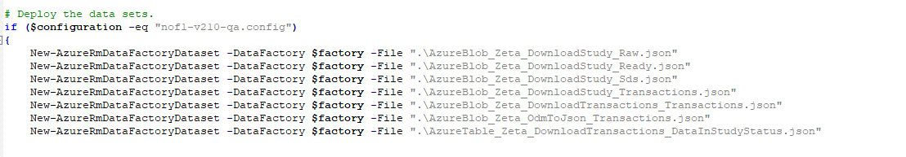

* Run following command in PowerShell:

|  |
| --- |
| **PowerShell script to create a Datafactory Pipeline** |
| **.\Publish.ps1 -subscriptionName “*subscriptionName” -*resourceGroupName *sharedResourceGroupName* -dataFactoryName *customerIdentifier-version-data-factory-environment* -configuration customerIdentifier-version-environment.config** |

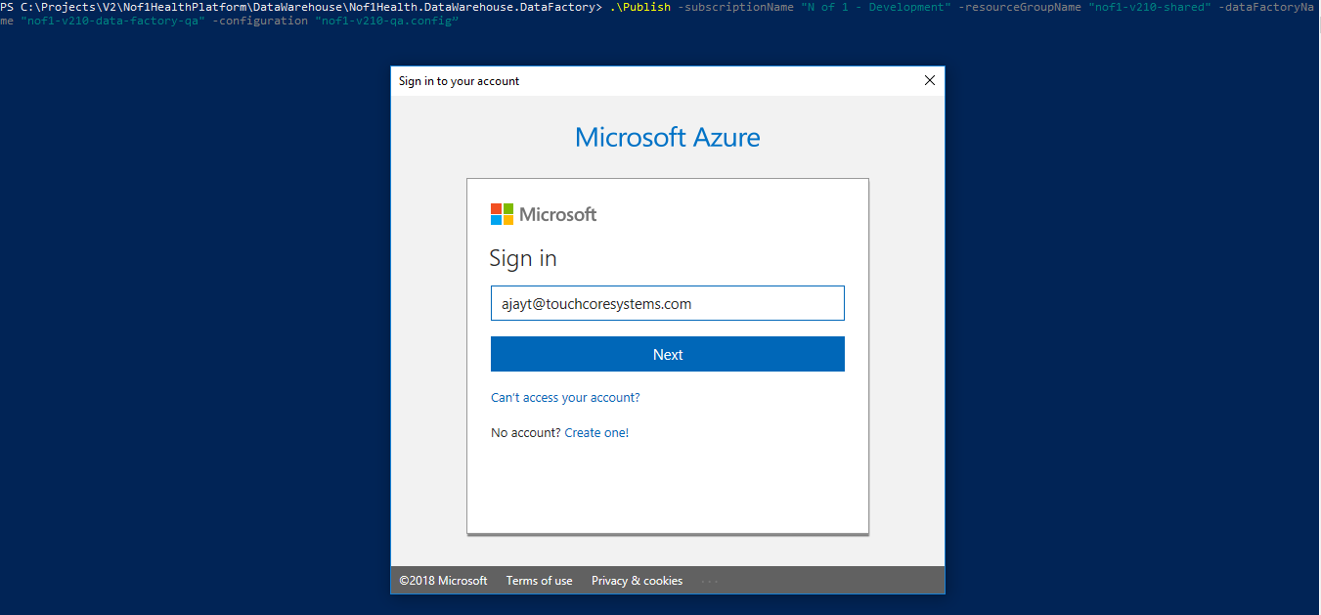

* Login with your Azure credentials.
* Complete the deployment by saying **Y** to delete existing data factory (only happens if it already exists).
* Monitor and ensure that all the pipeline projects succeed.

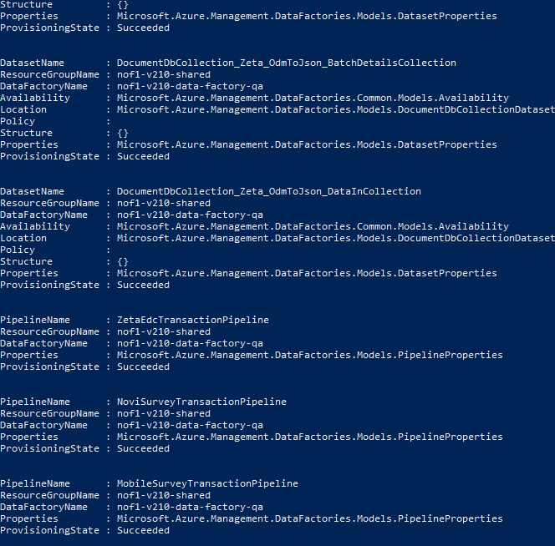

Create Service bus account

* Search for Service bus in Search bar and Click on **Add.**

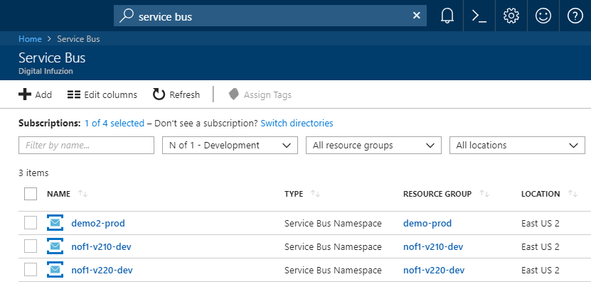

* Put the name as *customerIdentifier-version-environment.*

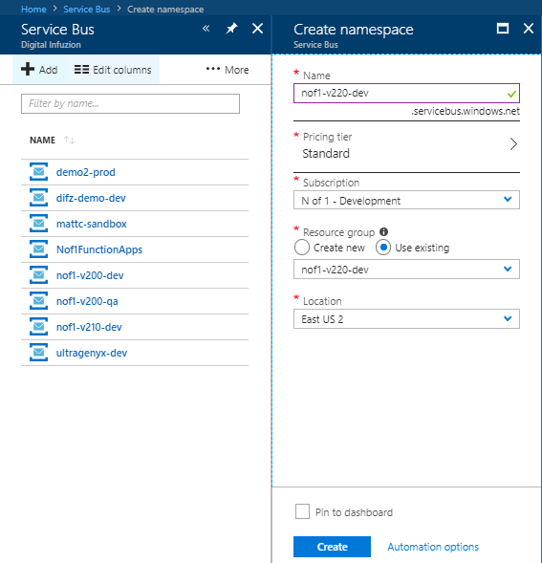

* Copy the **Primary Connection String** and replace it in the Keyvault config file.

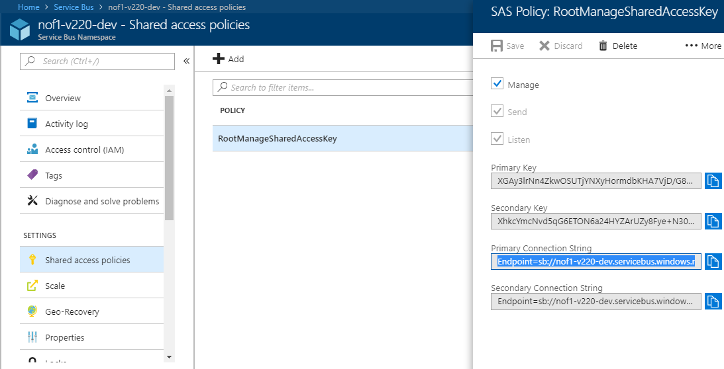

Create Graph API Service Principal

* In the Active directory of the B2C tenant, you need to create an administrator to create the Graph API.
* **Note:** You need to be a global administrator of the B2C tenant to be able to create the Graph API Service Principal. In case you are not able to create the user, ask someone to add you as a new user to the B2C tenant. When someone adds you as a user to the B2C tenant, you will net and email asking for your consent.

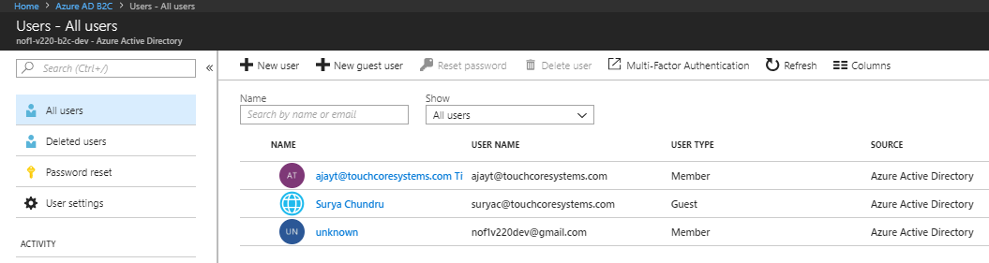

* To create the administrator, click on New User. Put the following

|  |  |
| --- | --- |
| **B2C tenant Active Directory User** | **Value** |
| Name | administrator |
| Username | [administrator@customerIdentifierversion**b2c**environment.onmicrosoft.com](mailto:administrator@customerIdentifierversionb2cenvironment.onmicrosoft.com) |
| Directory Role | Global Administrator |

* Click on Show the password and copy and Save the password.

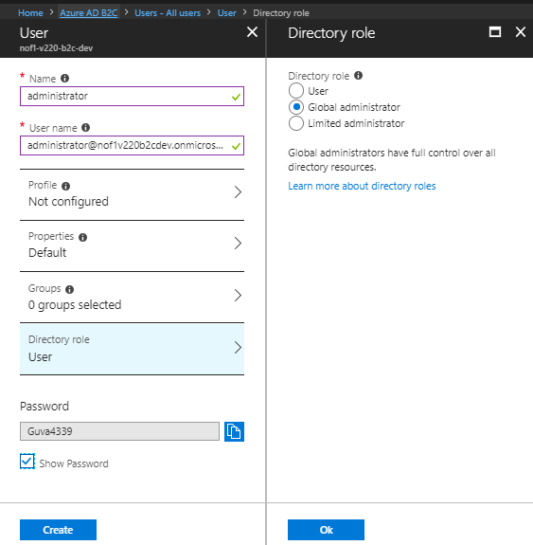

Now Goto Portal.Azure.com

Sign in with administrator (the user created in above step).It will ask you to reset the password.

* 1. Set up for password Reset
* Download the attached .ps1 file and change the AdminUsername and AdminUserPassword values.



* Ensure that you have installed the Module MSOnline. If not install it using the below command in powershell

Install-Module MSOnline

* Run the script and note down the Graph API Principle Id and Graph API secret. This secret needs to be replaced in the code files.

Get the Client Secret (Graph API Secret) from output of Powershell script.

Go to AzureActiveDirectory->Enterprise Applications->Select All Applications-> apply.

Search for Graph API application created through powershell script.

Create and Populate Configuration Table

* Create a json file with Configuration data for your environment. The name of the file should be:

*customerIdentifier-version-environment*-**config-table.json**.

* This file will contain all the Configuration table entries.
* Create the file from the attached file



* Open this json file and change the connection strings, values, entries etc to reflect your environment
* For e. g.

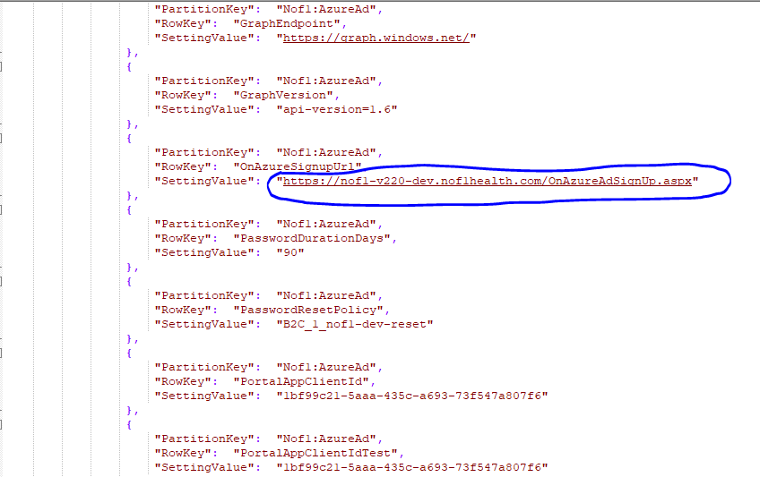

* In the same file, change the ePRO and edc Study names. Replace the three letter codes of the old study name with the three letter codes of the new study name. Replace the full name of the old study name with the new study name.
* For e.g. If the study name was earlier named Beta, and the new study name was Zeta, then the three-letter code BET should be replaced by ZET and the full name BETA should be replaced by ZETA. Please maintain the case sensitivity. So, beta should be replaced by Zeta and Beta should be replaced by Zeta.

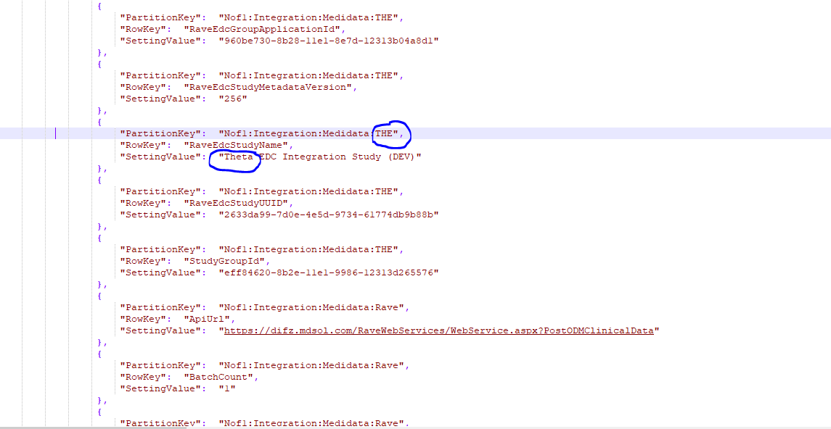

* Ensure you have the module **AzureRmStorageTable** else install it using the below command.

|  |
| --- |
| **PowerShell script to install Azure Storage Modules** |
| **Install-Module AzureRmStorageTable** |

* Open PowerShell and navigate to the directory *localDirectoryToSolution* **\Nof1HealthPlatform\EnvironmentSetup\AzureSetup\Scripts**. Copy any file with the format
* nof1-configuration-table-setup.ps1 to reflect your customer-identifier and then execute the below command.

|  |
| --- |
| **PowerShell script to install Azure Storage Modules** |
| **.\nof1-configuration-table-setup.ps1 -subscriptionName "*subscriptionName*" -resourceGroupName *resourceGroupName* -storageAccount *storageAccountName* -tableName Configuration -location “*location”* -configTableJSONFileName "*configtableJSONFilePath*"** |

* For e.g

.\nof1-configuration-table-setup.ps1 "N of 1 - Development" -resourceGroupName "nof1-v220-dev" -storageAccount "nof1v220storagedev" -tableName "Configuration" -location "East US 2" -configTableJSONFileName "C:\Users\bhanushg\Desktop\Deployment\220\nof1-v220-dev-config.json"

* This will setup the Configuration table in the storage account.

Configure Keyvault and Upload the KeyVault Secrets

* 1. **Register an app in Azure AD for Keyvault and Generate App key**
* From the Main blade click on **Azure Active Directory**. Click on **New App Registrations** and on the next screen enter the following

|  |  |
| --- | --- |
| **Azure AD Application Settings** | **Value** |
| Name | *customerIdentifier-version-environment* |
| Application type | Web App/API |
| URL | https://*customerIdentifier-version-environment*.eastus2.cloudapp.azure.com |

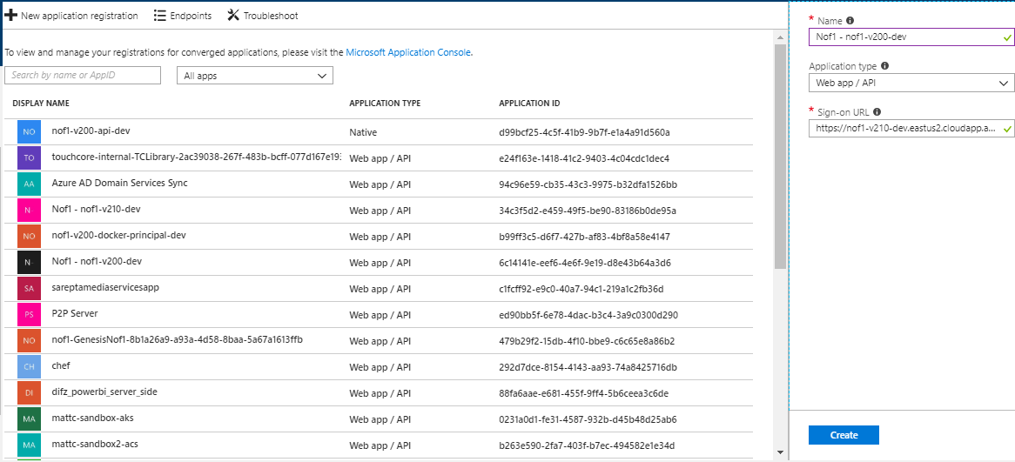

* Click on **Create**.
* Now Goto the **App registrations** tab in the Azure AD account and select the app you just registered.

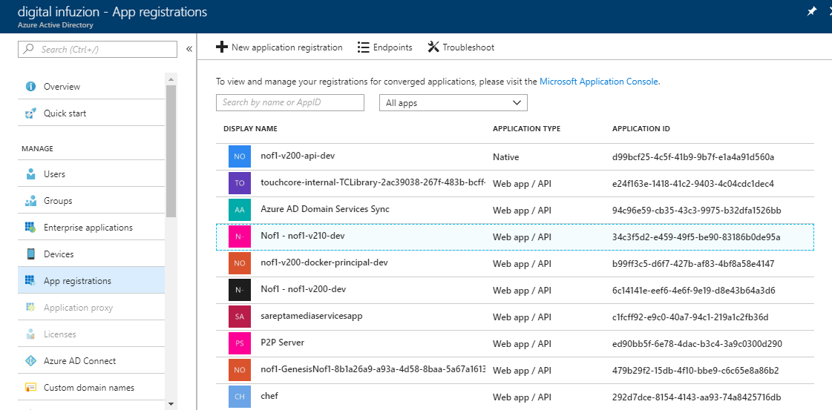

* On the next screen click on **Settings**. A new blade with all the settings will appear.

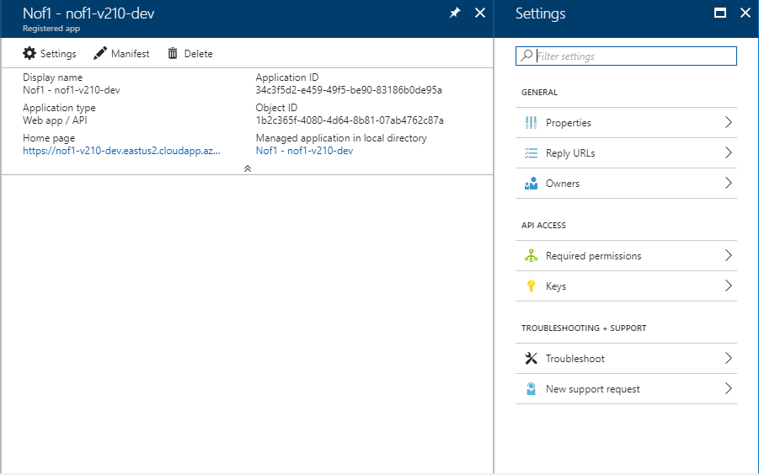

* On the next screen click on **Keys** and then generate a key by putting in a description e.g. **Client secret** and choose the expiration **In 2 years** and then **Save.**
* **Note: This the client ID and Client Secret**

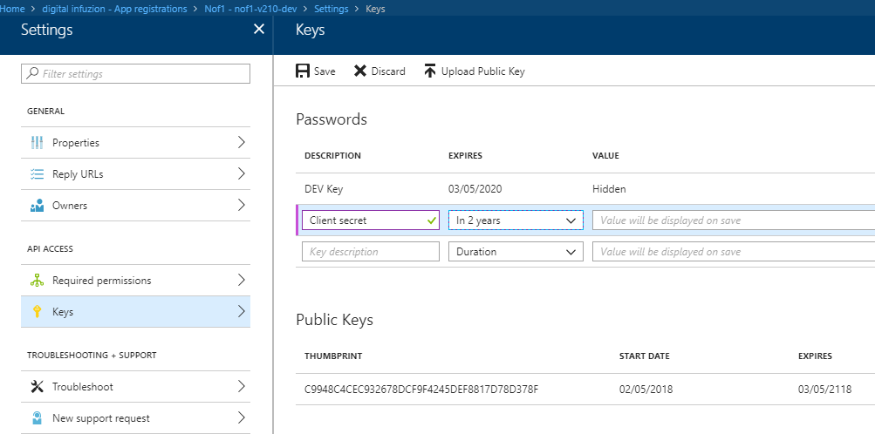

* Copy the key generate for future use. This is the client secret you pass in your configuration files.
  1. **Add default users to the Active Directory Application**
* Select the Active Directory application you just created and click on the **Owners** tab.

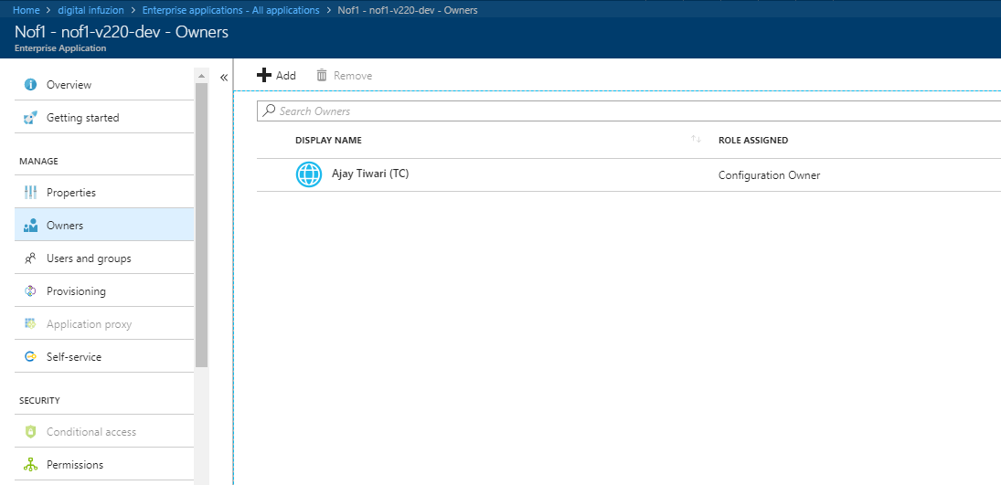

* Click on **Add.** Search and the members to add**.**

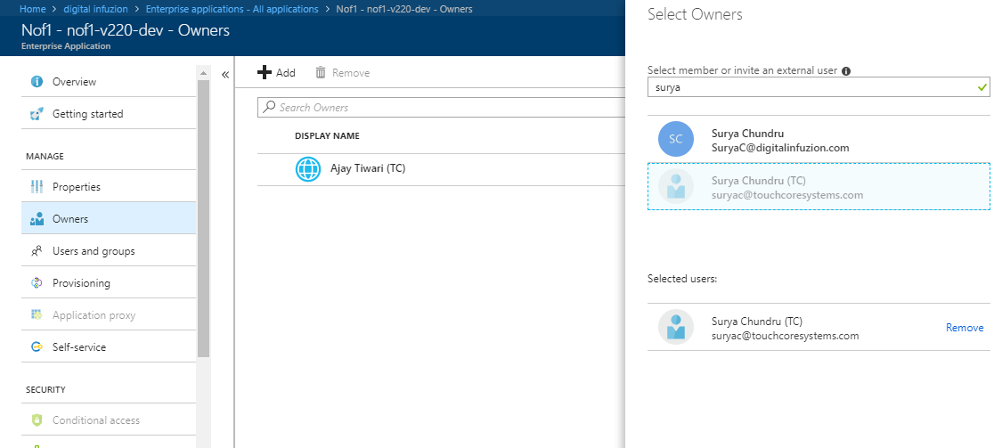

* 1. **Add policies to access the Keyvault**
* Select the Keyvault resource pertaining to your environment
* Navigate to **Access Policies.**
* Click on **Add new**

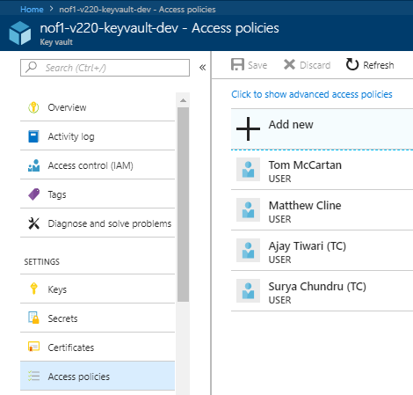

* Select the App you created and give the below permissions.

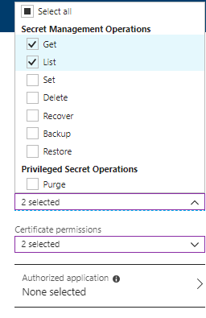

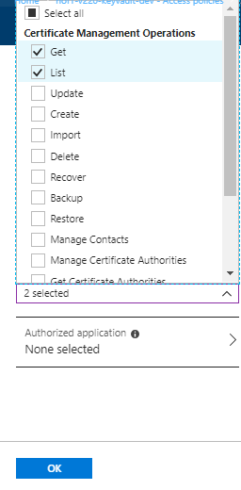

* Click on **OK**. It will take you to the screen where you can save the user.

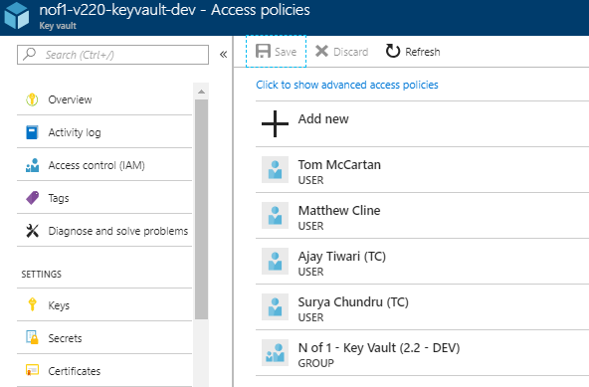

* Click on **Save**.
  1. **Edit the Manifest file in the Application**

The Active Directory application that we created above needs to be updated to use the self-signed certificate to authenticate.

* To do this, an Active Directory administrator will need to edit the manifest of the application.
* Ensure that you are logged in as an Active Directory Administrator.
* In the previous section, one of the outputs of the PowerShell script is a file named *customerIdentifier-version-environment*.**keyCredentials.json**. This file contains a JSON object like below.

|  |
| --- |
| **keyCredentials.json** |
| **{**  **"customKeyIdentifier": "1MNMNHE7MHxBJBEM9EAl5gXSObBZw=",**  **"keyId": "xxxxxx-xxxx-xxx-xxxx-xxxxxxxxxxx",**  **"type": "AsymmetricX509Cert",**  **"usage": "verify",**  **"value": ""**  **}** |

* The entire contents of this file need to be added to the manifest, in the key Credentials array as below.

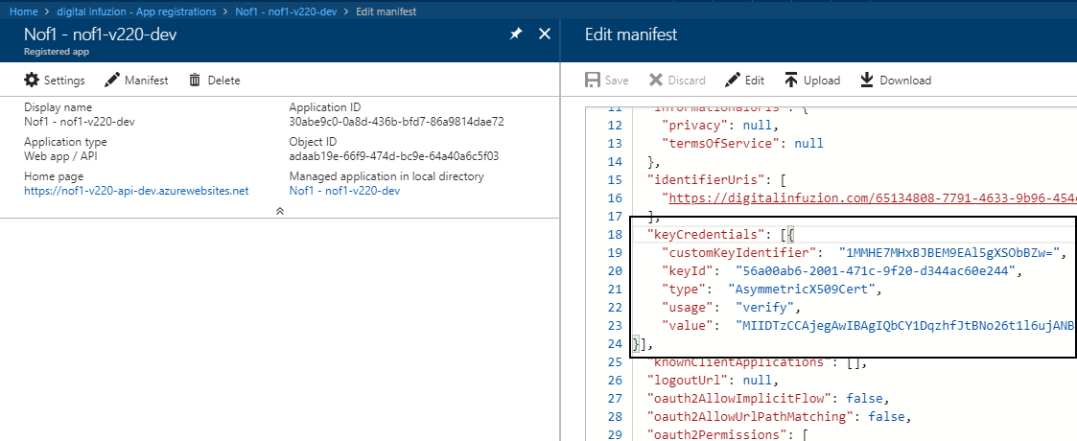

* Once the manifest has been updated, the Active Directory application will now accept the certificate as a valid form of authentication.

**Note:** The generated or obtained certificate must now be installed into all the locations that need to access the Key Vault. Typically, this will include the virtual machine running the portal, and the Azure App Service instance running the Web API. There may be other locations that need to have the certificate installed as well.

* 1. **Create Secrets table in Keyvault**
* Create another json file with all the secrets to be stored in KeyVault for your environment. Follow the format used in the file *customerIdentifier-version-environment*-**keyvault.json**. From the same Scripts directory as above, run the following command.
  1. **Upload the Keyvault secrets**
* Search for the Keyvault resource in the portal and add yourself as the user to be able to access the keyvault secrets by Going to **Access Policies**.

|  |
| --- |
| **Powershell script to upload Secrets to the Keyvault** |
| **.\nof1-key-vault-setup.ps1 -subscriptionName "*subscriptionName*" -resourceGroupName *resourceGroupName* -keyVaultName *keyVaultName* -location “*location”* -keyVaultJSONFileName "*keyVaultJSONFilePath”*** |

|  |
| --- |
| **Example powershell script to upload Secrets to the Keyvault** |
| **C:\Projects\V2\Nof1HealthPlatform\EnvironmentSetup\AzureSetup\Scripts> .\nof1-key-vault-setup.ps1 -subscriptionName "N of 1 - Development" -resourceGroupName "nof1-v210-qa" -keyVaultName "nof1-v220-keyvault-qa" -location "East US 2" -keyVaultJSONFileName "C:\Users\Bhanush Goswami\Desktop\Deployment\220-dev\nof1-v220-qa-key-vault.json"** |

* This will add all the secrets for your environment to the KeyVault.
* Your Setup is now complete.

Setup and Deploy DNN Portal

This step need to follow for New setup or New Env. Like (e.g Nof1-V230-DEV)

The steps below provide the steps necessary to setup the DNN portal and install the modules. Start with the setting up the DNN Portal. The following steps should be performed from the remote desktop connection to the client specific VM.

* 1. **Setup the Virtual Machine**
* Go to the Main Menu and Click on **Virtual Machines.**

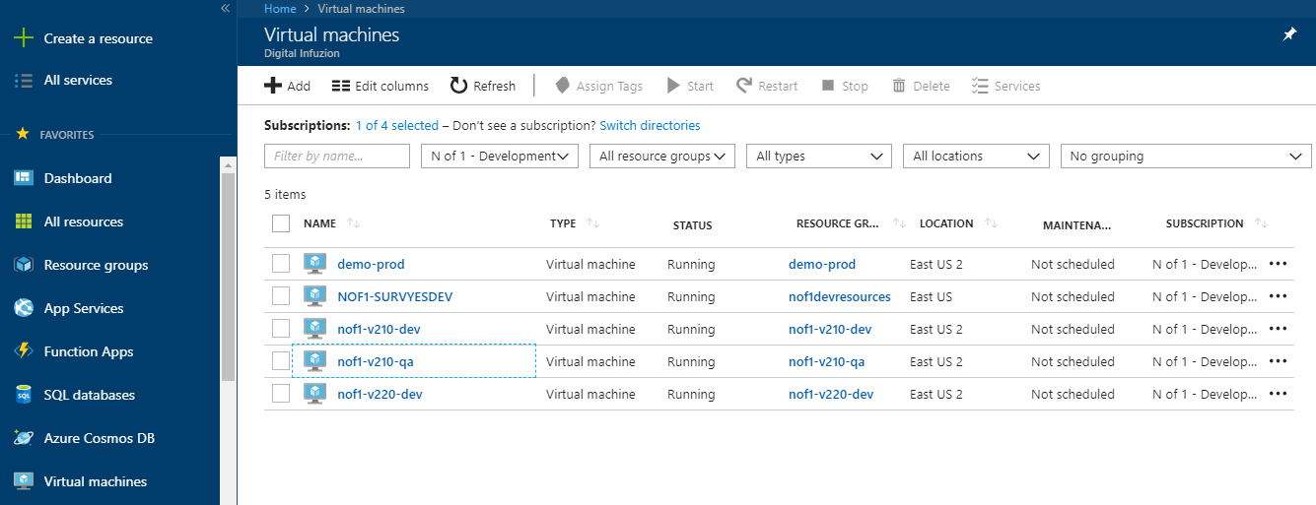

* Click on the virtual machine pertaining to your environment.

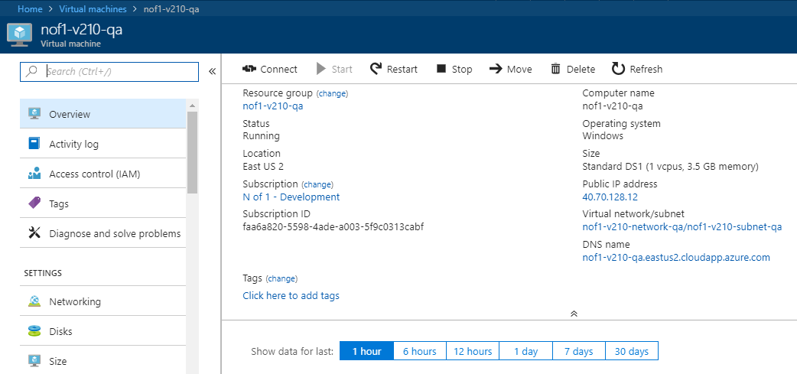

* Click on **Connect**. It will give an option to download the rdp file.

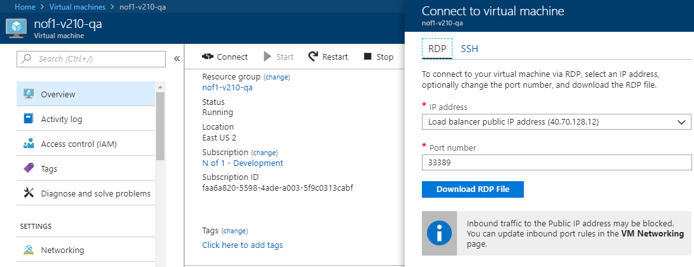

* Download the RPD file and click on it. On the next **Remote Desktop Connection** Pop-up click on.

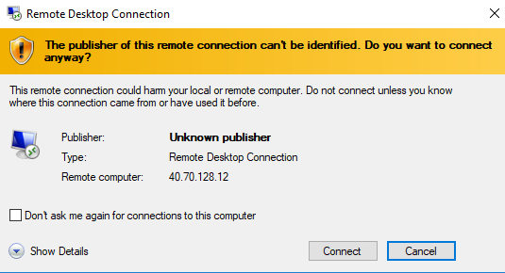

* It will ask you for the VM credentials. Put the VM credentials and click on **OK.**

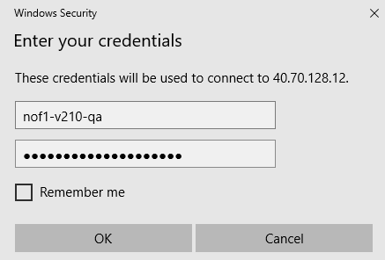

* On the Next screen click on **Yes.**

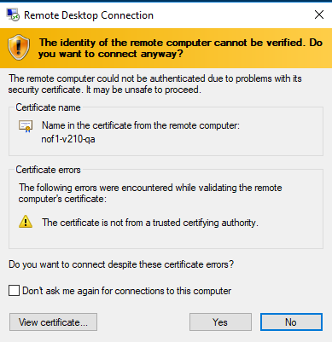

* You will be now logged-in to the machine. The **Server Manager** Dashboard Opens by Default. Click on **Add roles and features.**

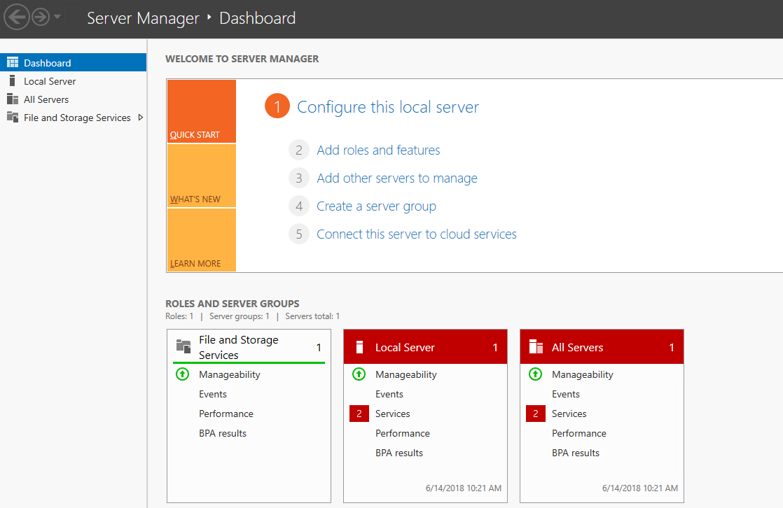

* On the next screen click on **Next.**

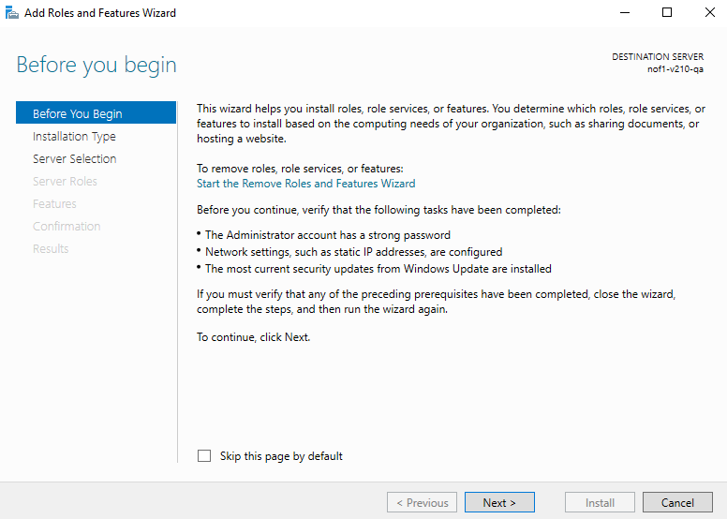

* Select **Role-based or feature-based installation** and click on **Next.**

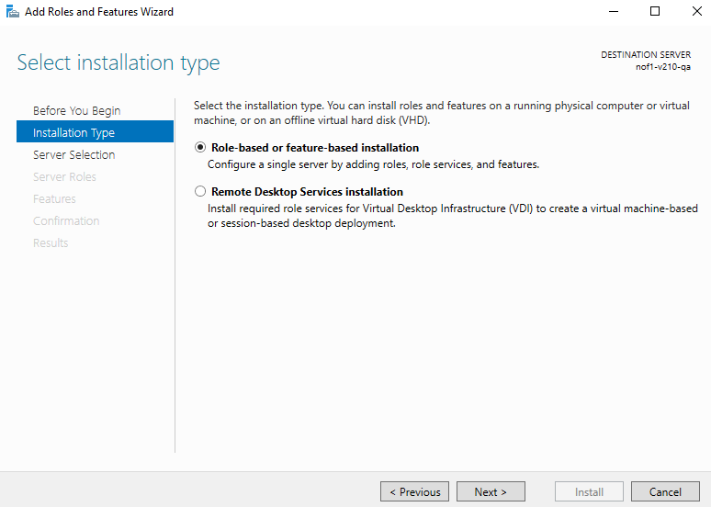

* Select your server name from the list and click on **Next.**

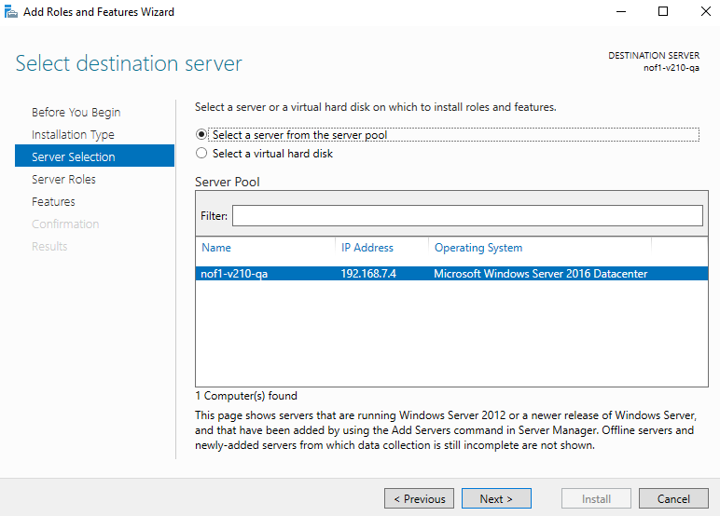

* On the next screen select Web Server ( IIS ) and click on **Next.**

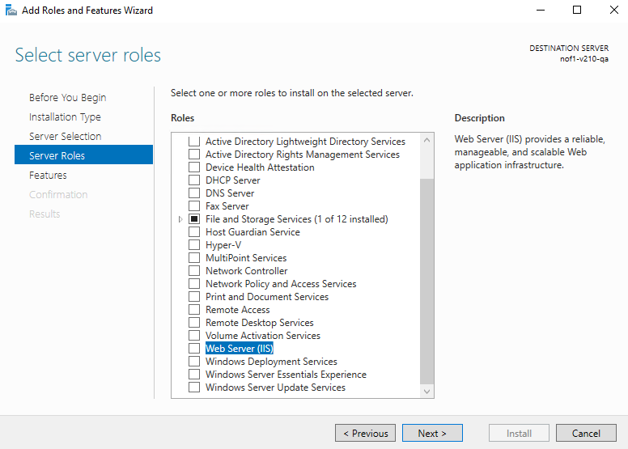

* On the next screen click on **Add features**.

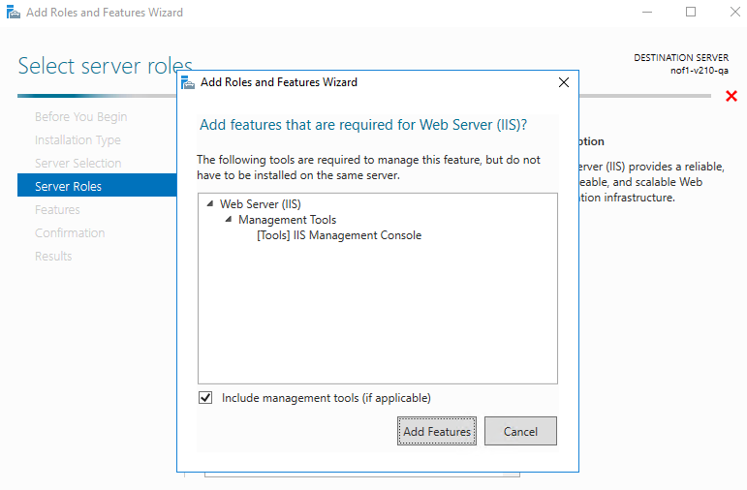

* On the next screen select **Next.**

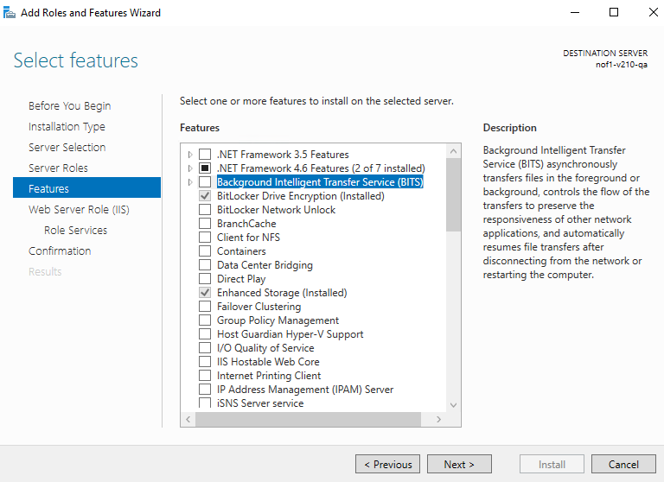

* On the next screen select **Next.**

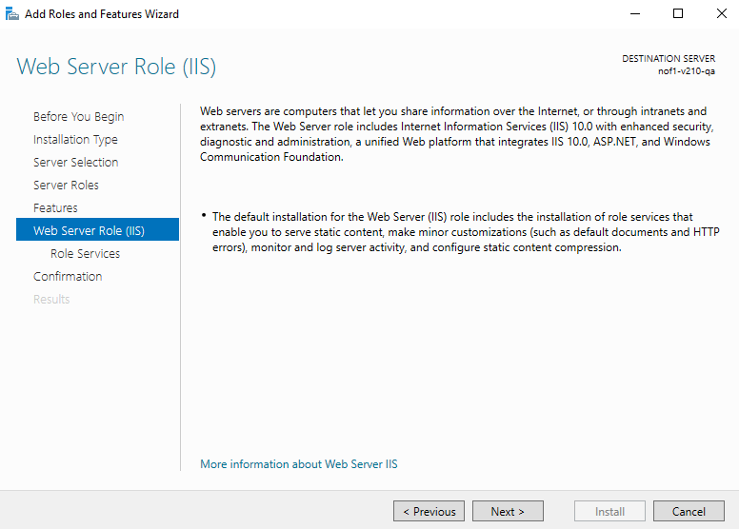

* Ensure the following Services are selected.

|  |  |
| --- | --- |
| **Features** | **Sub-features** |
| Common HTTP Features | Default Document  Directory Browsing  HTTP Errors  Static Content  HTTP Redirection |
| Health and Diagnostics | HTTP Logging  Custom Logging  Logging Tools  Request Monitor  Tracing |
| Performance | Static Content Compression  Dynamic Content Compression |
| Security | Request Filtering  Basic Authentication  IIS Client Certificate Mapping Authentication  IP and Domain Restrictions |
| Application Development | .NET Extensibility 4.6  Application Initialization  ASP.NET 4.6  ISAPI Extensions  ISAPI Filters  WebSocket Protocol |

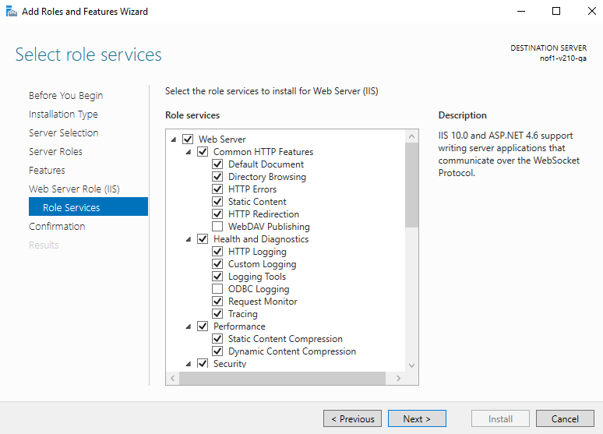

* Click on **Next.**
* On the next screen click on **Install.**

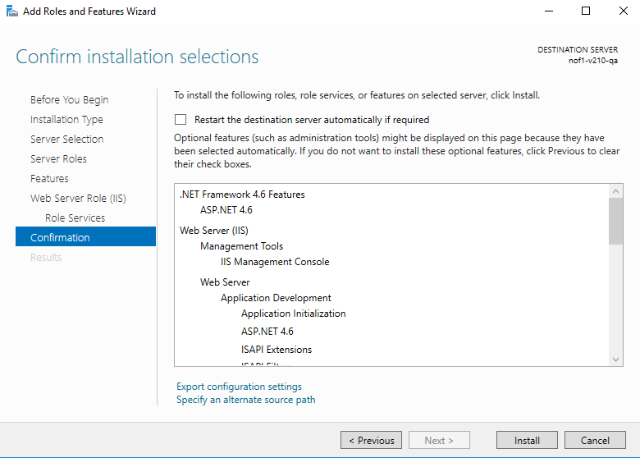

* Check the installation.

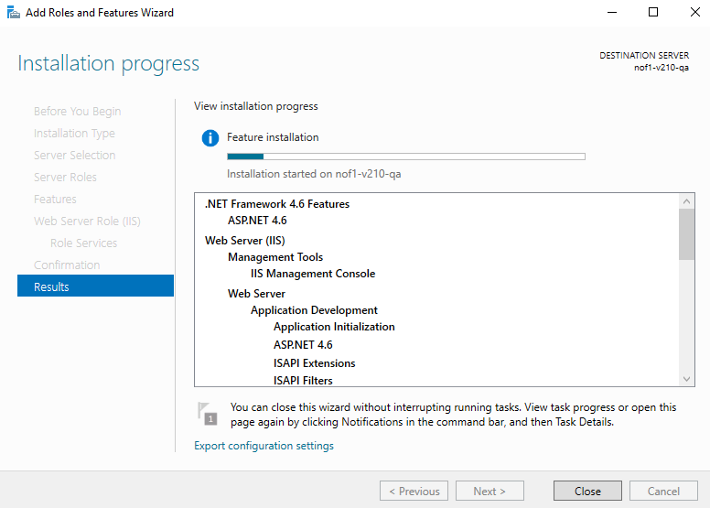

* Close once the installation is complete.
  1. **Setup DNN Portal**
* Copy the DNN Setup Files in the **C drive -> inetpub-> wwwroot** folder in the VM.

**Note**: You should get the files from the WIKI or any other previous VMs

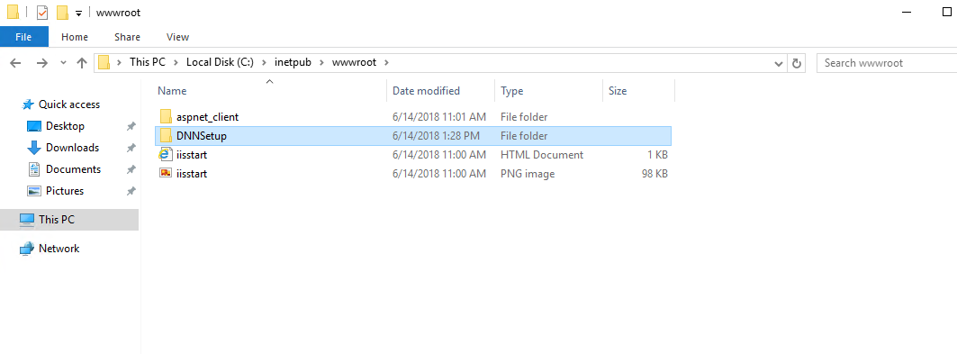

* Extract the files.
* Once the copying is complete click on the DNN Folder. Ensure that there is a file named **DNN_Platform_07.04.02_Install.zip**.

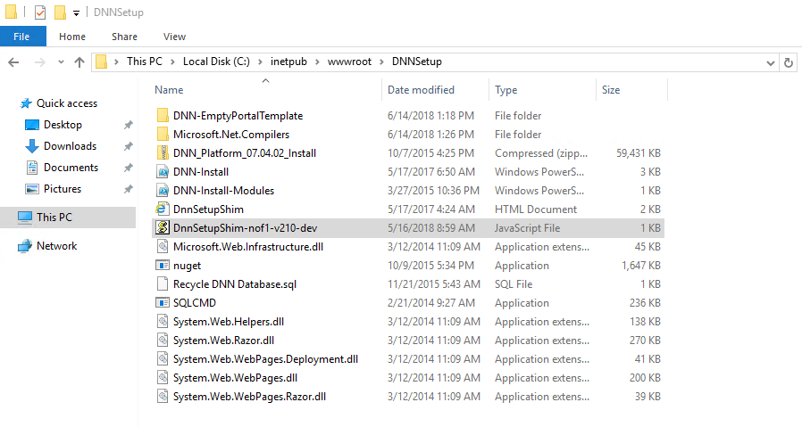

* Click View button on the top left corner of the **wwwroot** folder and select the check the **File name extensions** check box to make the file extensions visible

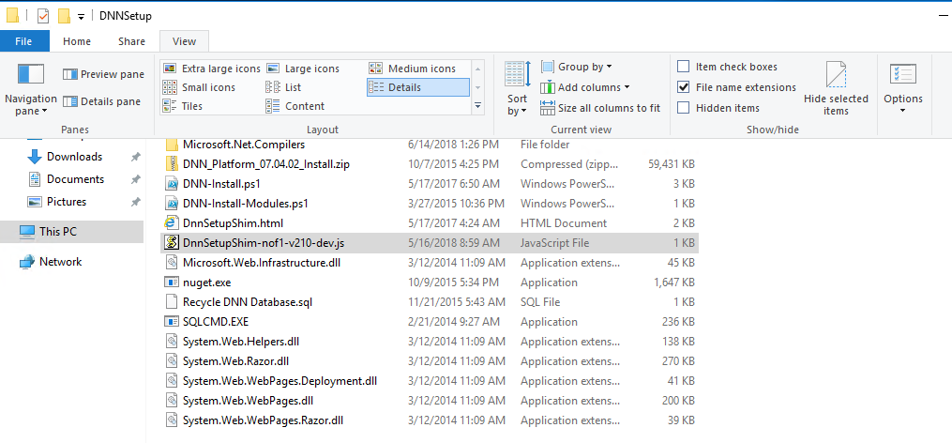

* Rename the **DnnSetupShim**-*customerIdentifier-version*-*environment*.js file to reflect your environment. Then right click and open the file in Notepad.

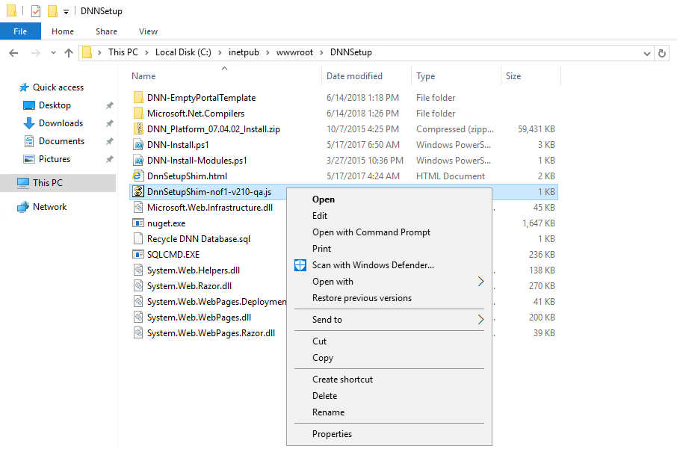

* Update the values for the items which are highlighted in red color box in the screenshot below. For e.g. 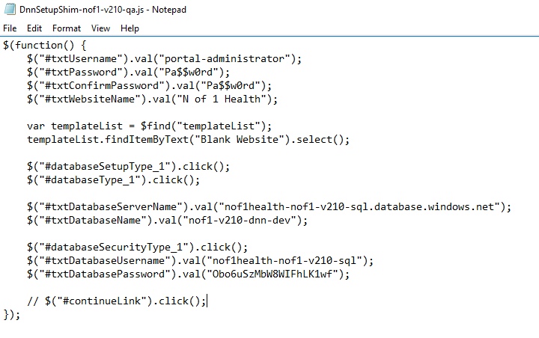
* Change the following fields.

|  |  |
| --- | --- |
| **DNNSetupShim Value** | **Value** |
| #textDatabaseServerName | the database server name will be in the following format.  **nofhealth**-*customerIdentifier-version*-**sql.database.windows.net** |
| #txtDatabaseName | the database server name will be in the following format.  *customerIdentifier-version*-**dnn**-Environment |
| #txtDatabaseUserName | the user name will be in the following format  **nofhealth***-CustomerIdentifier-version-***sql** |
| #txtDatabasePassword | will be the value of **sqlServerAdminPassword** variable you’ve stored in the keypass |

* Save and close the file.
* Press “Windows” key and type “PowerShell” and mouse right click the Windows PowerShell and click “Run as administrator” option.

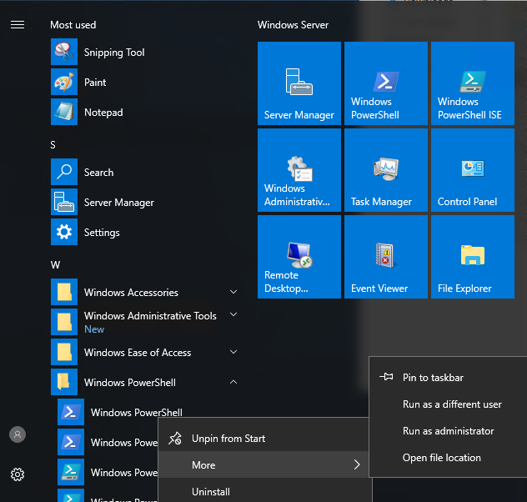

* Once the PowerShell window opened, type

|  |
| --- |
| **PowerShell script to change to the DNNSetup file** |
| **cd c:\inetpub\wwwroot\DNNSetup** |

* Press enter key.

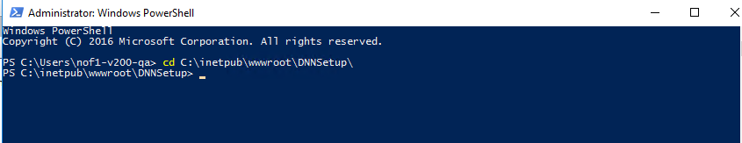

* Create the portal site in IIS by the giving the below command

|  |
| --- |
| **PowerShell script to create the portal site** |
| **.\DNN-Install.ps1 –portalDirectory C:\inetpub\wwwroot\nof1-portal –appPoolName nof1-portal** |

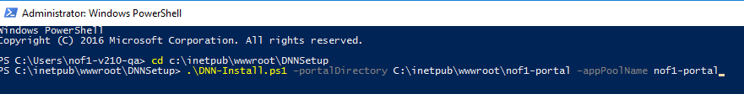

* The powershell script creates the **virtual directory** and **application pool.**

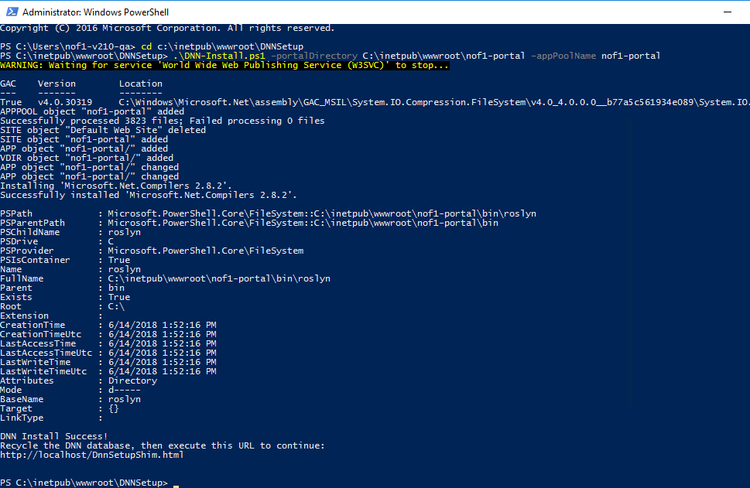

* Verify if a new folder with name **nof1-portal** gets created under **wwwroot.**

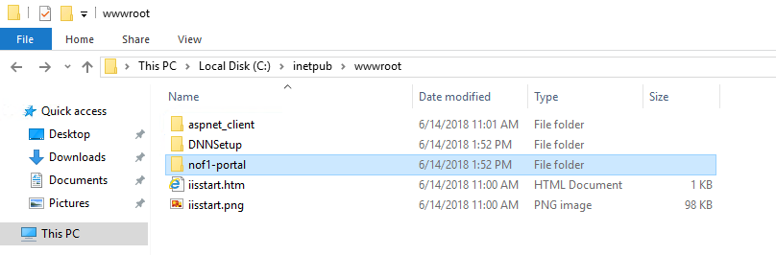

* Inside the **nof1-portal** folder, verify **DnnSetupShim.js** and **DnnSetupShim.html** files are available.

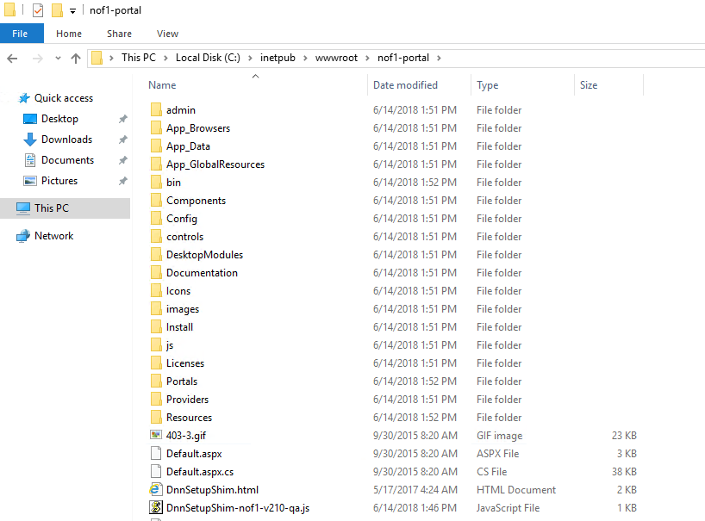

* Goto the Windows Search bar and type **inetmgr.**

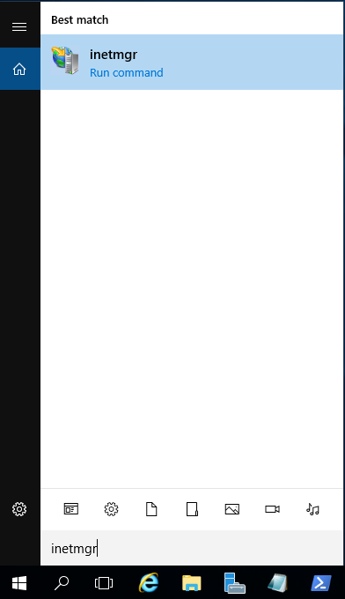

* Check if a new site called **nof1-portal** is created in IIS Manager.

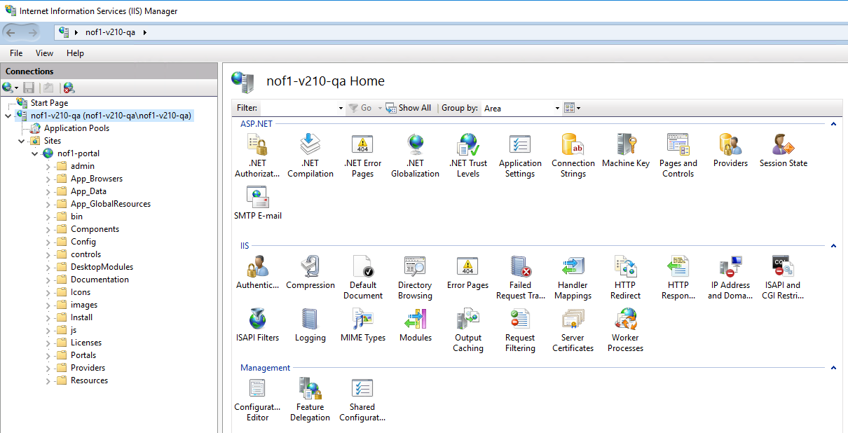

* Open browser in VM itself or in your machine and type the below url. The url format will

[http://*customerIdentifier-version-environment*.eastus2.cloudapp.azure.com/DnnSetupShim.html](http://customerIdentifier-version-environment.eastus2.cloudapp.azure.com/DnnSetupShim.html%20)  and press Enter key.

* Once you pressed the Enter key, you will get the below.

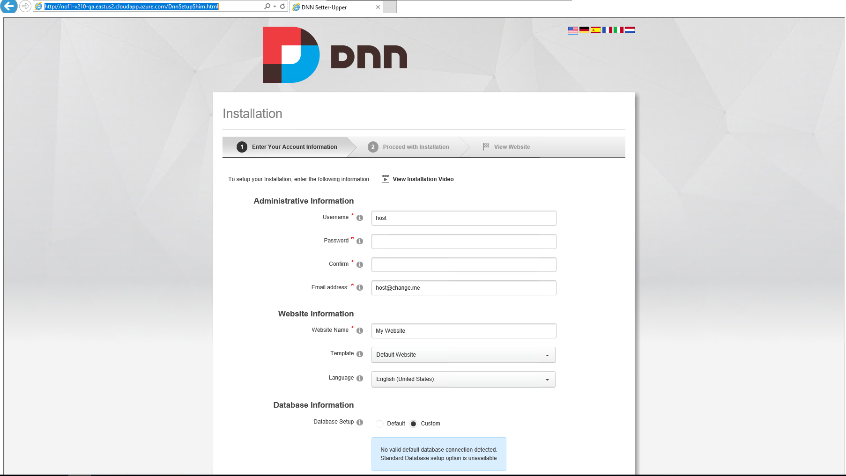

* In the Administrative section fill the following

|  |  |
| --- | --- |
| **DNN Setup Admin Section Details** | **Value** |
| Username | portal-administrator |
| password | Pa$$w0rd (or a password of your choice ) |
| Email address | keep the default value |

* In the Website section fill the following

|  |  |
| --- | --- |
| **DNN Setup Website Section Details** | **Value** |
| Website Name | No of 1 Health |

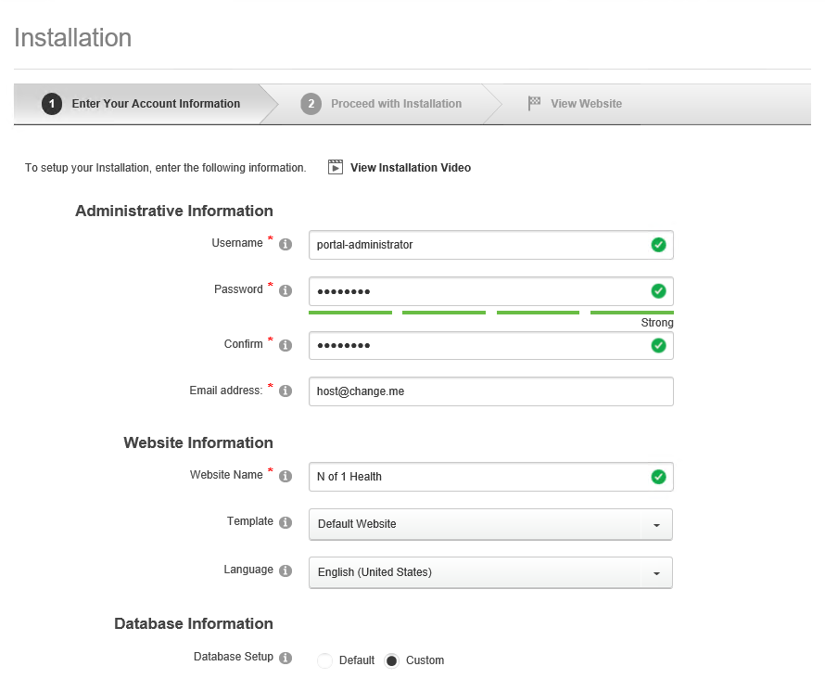

* In the **Database Information** Section select the following:

|  |  |
| --- | --- |
| **DNN Setup Database Information Section** | **Value** |
| Database Setup | Custom |
| Database Type | SQL Server/SQL Server Express Database |
| Server Name | **nof1health**-*customerIdentifier-version*-**sql.database.windows.net** |
| Database Name | *customerIdentifier-version*-**dnn**-*environment* |

* In the **Security** section**,** select the following:

|  |  |
| --- | --- |
| **DNN Setup Security Section** | **Value** |
| Database Setup | Custom |
| Database Type | SQL Server/SQL Server Express Database |
| Server Name | **nof1health**-*customerIdentifier-version*-**sql.database.windows.net** |
| Database Name | *customerIdentifier-version*-**dnn**-*environment* |
| Security | User Defined |
| **Database Username** | **nof1health-nof1-v220-sql** |
| **Password** | *Server password from keepass* |

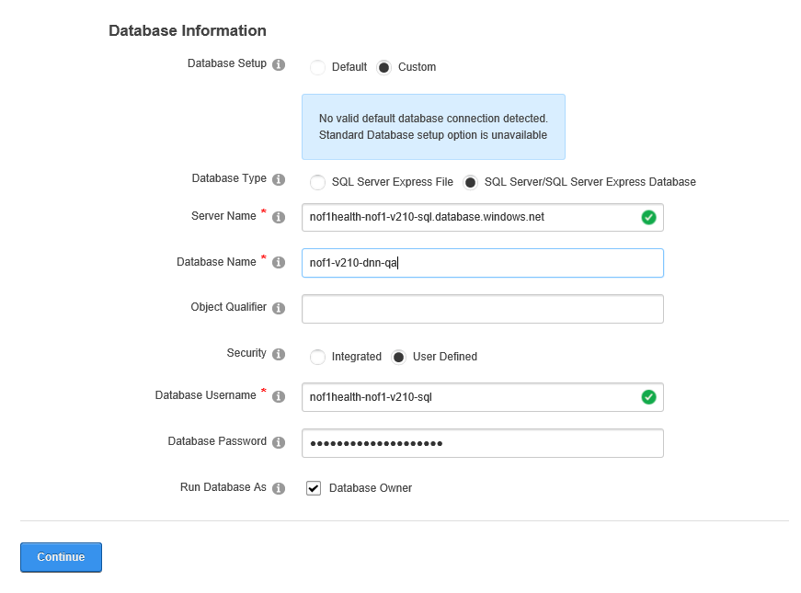

* Click on **Continue.** The installation process will begin.

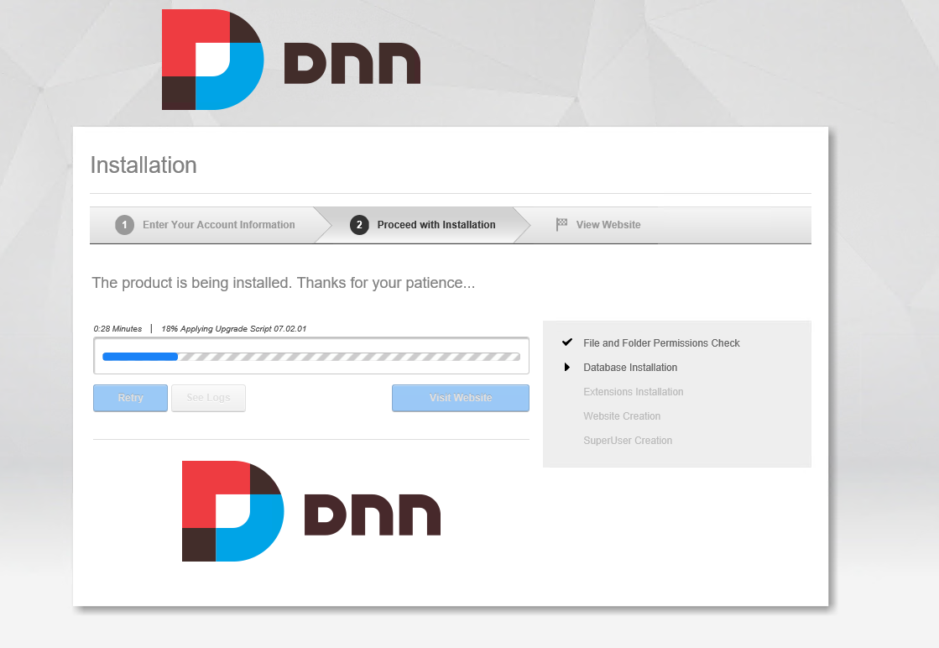

* Wait till you get the **Installation Complete!** message

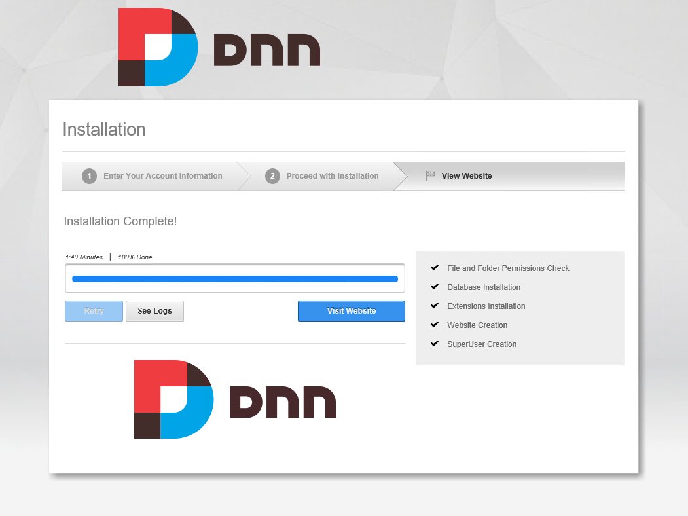

* Once you get the above installation complete window, click the **View website** button available in the installation complete window.
* It will take you to home page of DNN.

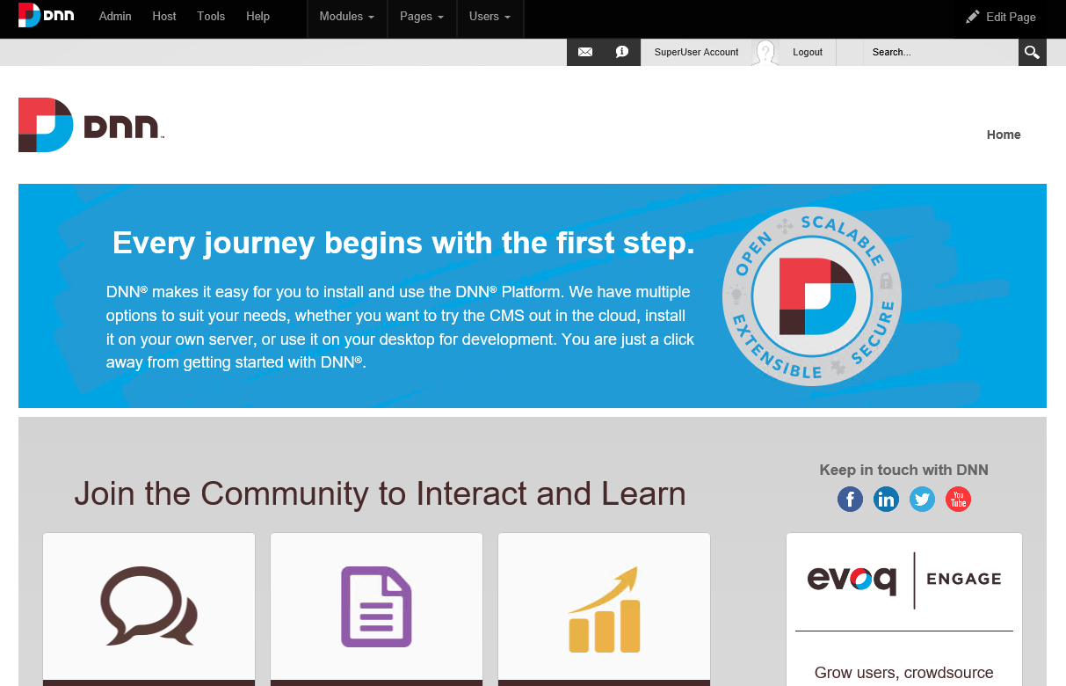

* click **Log In** link if you are not already logged-in.

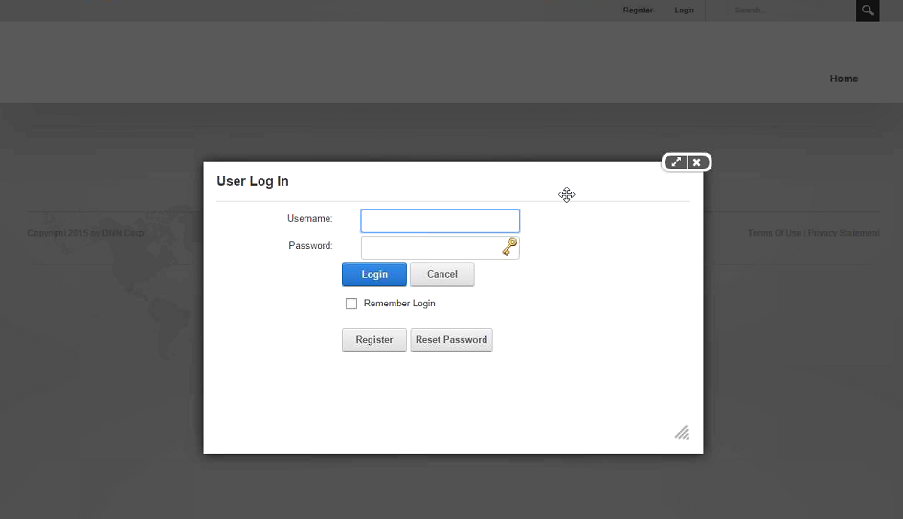

* Fill the Username and Password textboxes and click the **Login** button.

|  |  |
| --- | --- |
| **DNN Setup User Log-in Details** | **Value** |
| Username | portal-administrator |
| password | Pa$$w0rd (or the password you used during setup ) |

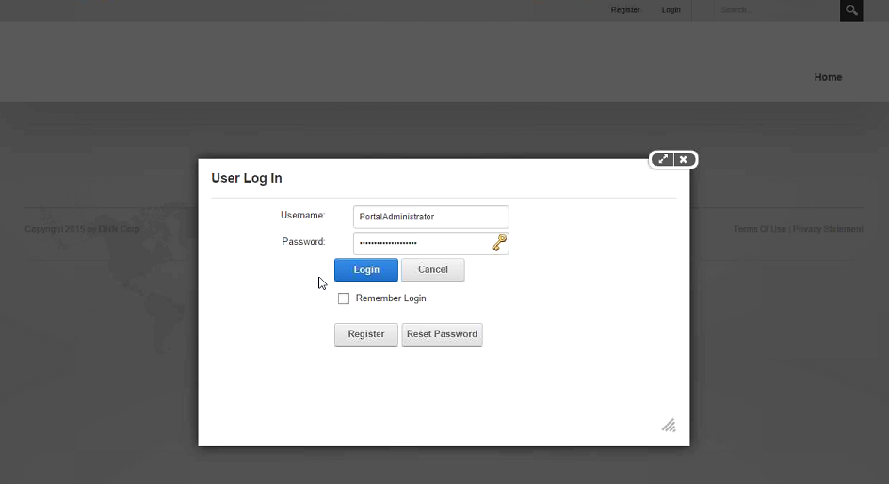

* Application will take you to home page.

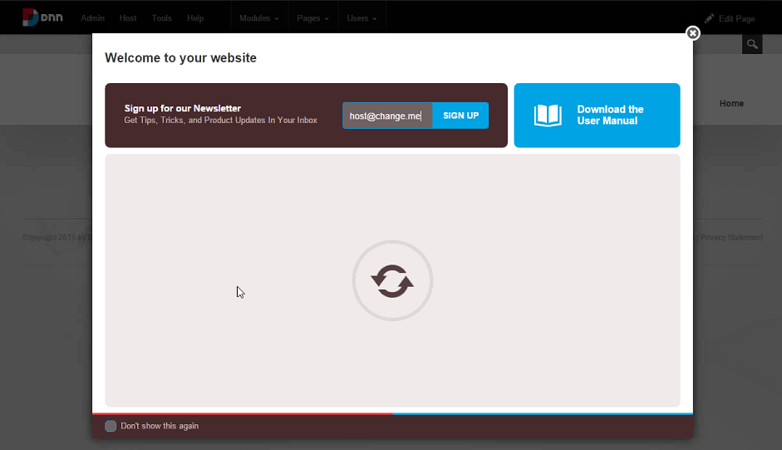

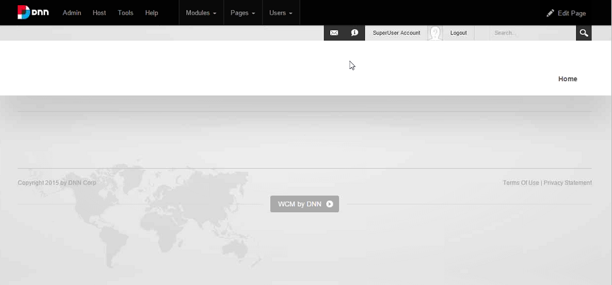

* DNN DB (without nof1 specific changes) should be available and able to connect to it
* Open Nof1 Portal URL and check if DNN screen shows up
* Now you are ready to deploy the DNN modules to the portal.

for ContentManagementDashboard module, first need to install BringtoMind (wiki page, provide wiki page url here) and then install the .zip file

Wiki Page (<https://nuget.nof1health.com:8443/wiki/10/bring2mind-configuration>)

* 1. **Install Rewrite Package**
* Install the attached Module on the Machine by downloading and copying it to the Virtual Machine.



* 1. **Deploy DNN Modules**

Install the module .zip files (all modules)

* Build and copy the DNN install zip file from **_installPackages** folder for the Portal project paste it to **C:\inetpub\wwwroot\nof1-portal\Install\Module** folder in the VM machine.

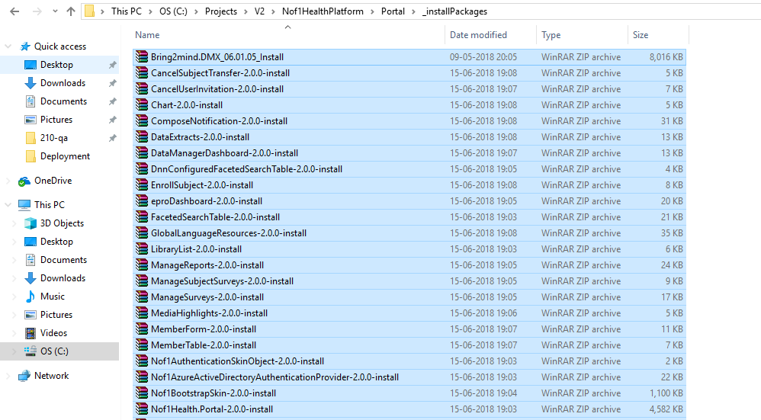

* WinSCP to the DNN VM and copy the files into the **nof1-portal/install/modules** folder.

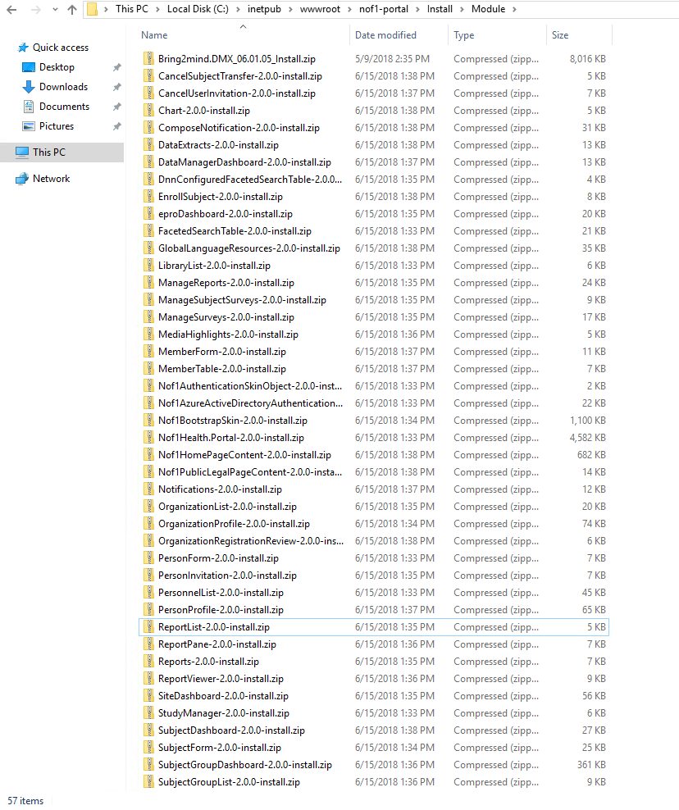

* Open browser in your local machine and type the below URL

[**http://localhost/install/install.aspx?mode=installresources**](http://localhost/install/install.aspx?mode=installresources)

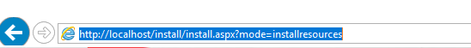

* Press **Enter** key.
* This will install the “Configuration” DNN modules and get the below success messages

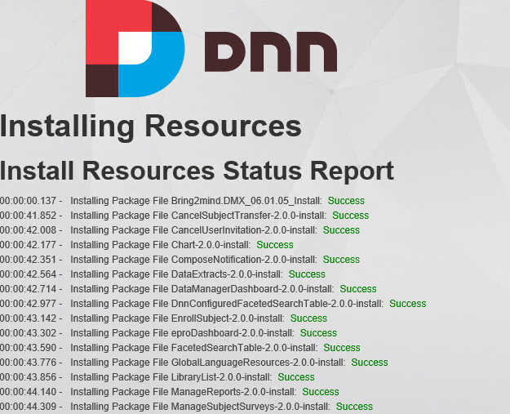

* Note: After this need to verify the portal **web.config** file will have the proper connection string and keys under the **c:\inetpub\wwwroot\nof1-portal** folder in the VM.
* Open the command line and type **iisreset.**
* Open Nof1 Portal URL and check if DNN screen shows up
  1. **Deploy DNN database**

Perform DotNetNukeSetup database project deployment using Publish

Navigate to the *localDirectoryToSolution***\Nof1HealthPlatform\Portal\Database\DotNetNukeSetup** project. Right click and click on **Publish**. It will take you to this screen.

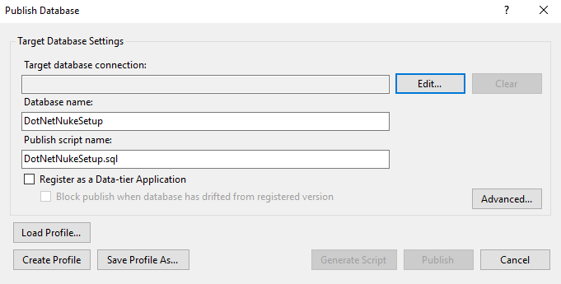

* Click on Edit. A new pop-un window will open.

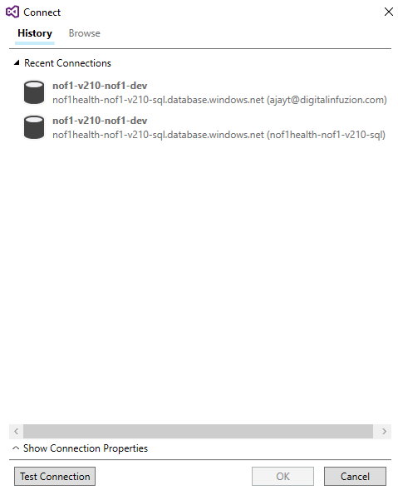

* Click on Show Connection Properties. Change the connection settings. Ensure that you are using the Active Directory credentials to login.

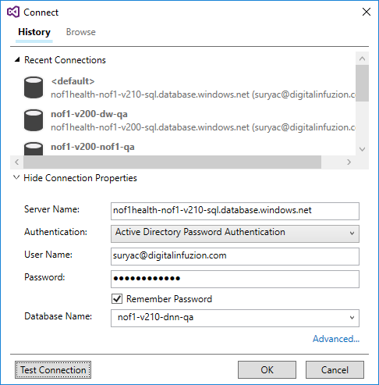

* Click on **Test Connection** and wait for the Connection to succeed.

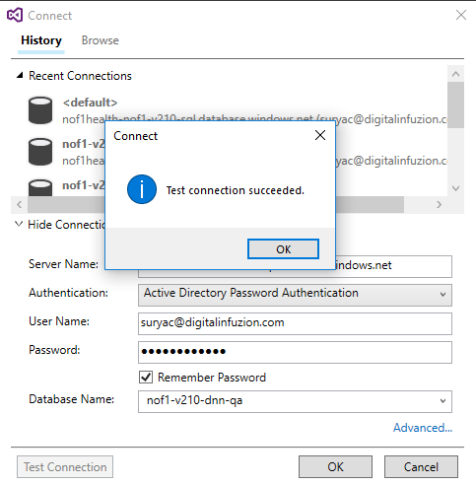

* Once you get the Test Connection Succeeded message, click on **Publish.**

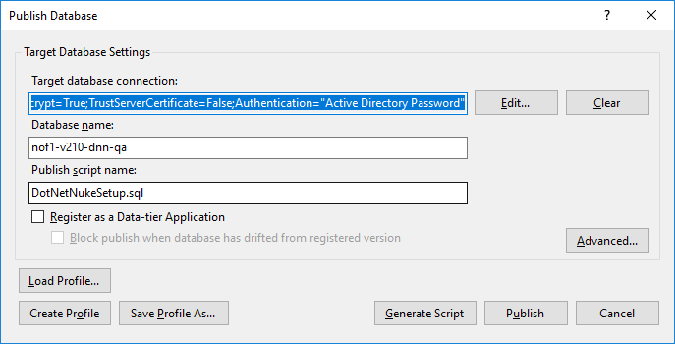

* Ensure that the Publish task completes properly.
* Open Nof1 Portal URL and check, the Nof1 home page should appear. Logn with Super User Id to ensure it works
* Once module installation is done, we will cross check it into DNN table using query.

Select * from [dbo].[ModuleDefinitions] Where FriendlyName Like '%Module _Name%'

* Need to comment out Nof1PublicLegalPageContent.sql script from post deployment script and deploy complete DNN SQL project directly using Azure Multifactor authentication.
* If modules not get installed properly, DNN DB deployment script will throw an error. And we need to follow the same sequence from PostDeployment script and run it manually one by one.
  1. **Add Standard Users and Portal Users**
* Login as the super admin ( portal-administrator ). Click on the settings button and select Manage users under Users menu and put the below entries

|  |  |
| --- | --- |
| **DNN Setup Standard User Creation** | **Value** |
| Username | portal-user |
| password | create from keepass(Update this password in the key-vault) |
| Email address | keep the default value |

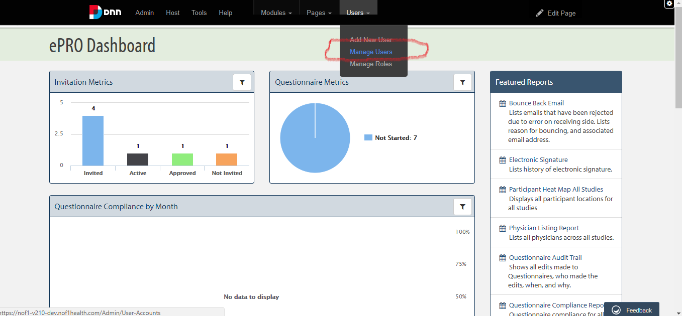

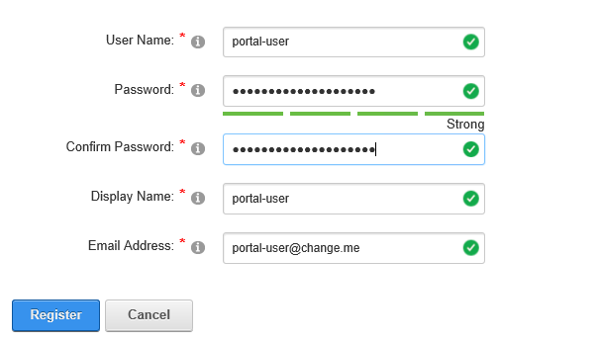

* 1. **BringToMind Configuration**
* Download version 06.01.05 from Bring2Mind website or you can copy it from any existing Virtual machine.
* Copy it to the install folder **C:\inetpub\wwwroot\nof1-portal\Install\module.**

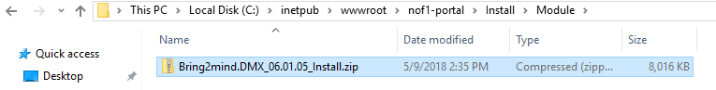

* Open the browser and put the below URL

<http://localhost/install/install.aspx?mode=installresources>

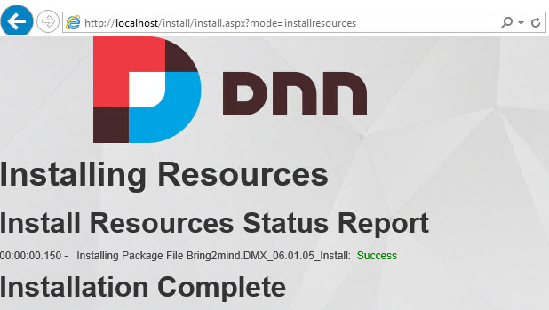

* Once the module has been installed Login to the portal as a super-user ( portal-administrator) and click on the **settings** button on the top right corner

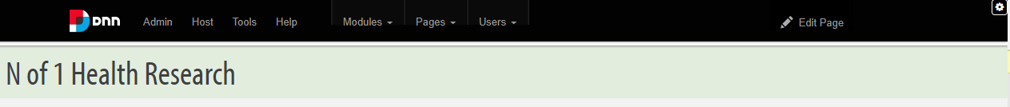

* Click on **Edit page>>Edit this Page**

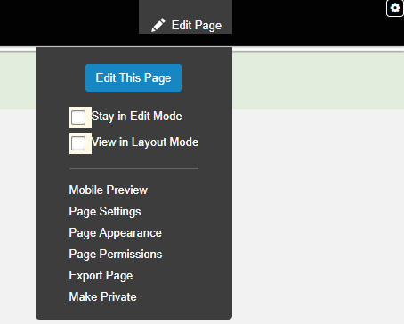

* Navigate to **Content Management dashboard** using the below URL

[https://*customerIdentifier-version-environment*.nof1health.com/Content-Management-Dashboard](https://customerIdentifier-version-environment.nof1health.com/Content-Management-Dashboard)

* If you can't see this page, make sure you have run the script.

|  |
| --- |
| **SQL script to fix the Content-Management Dashboard Page** |
| **\Nof1HealthPlatform\Portal\Database\DotNetNukeSetup\Scripts\Portals\Nof1Health**  **\Home\ContentManagementDashboard.sql** |

* Click on the settings button on the right-hand side corner. **Click Edit page -> Edit Page.**

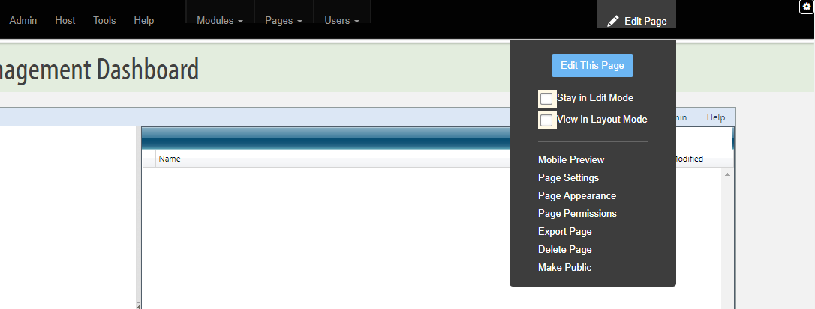

* On the page, you will see edit options for the module. Click on the pencil icon to see **License** option.

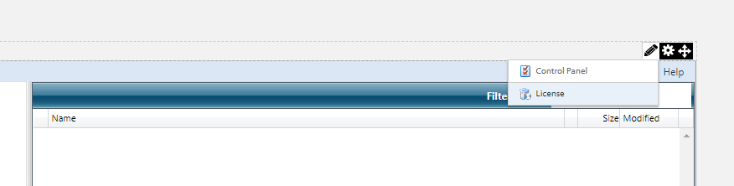

* On the license page enter the below

|  |  |
| --- | --- |
| **DNN License details** | **Value** |
| Email Address | [maureenm@digitalinfuzion.com](mailto:maureenm@digitalinfuzion.com) |
| password | DMX-01440 |

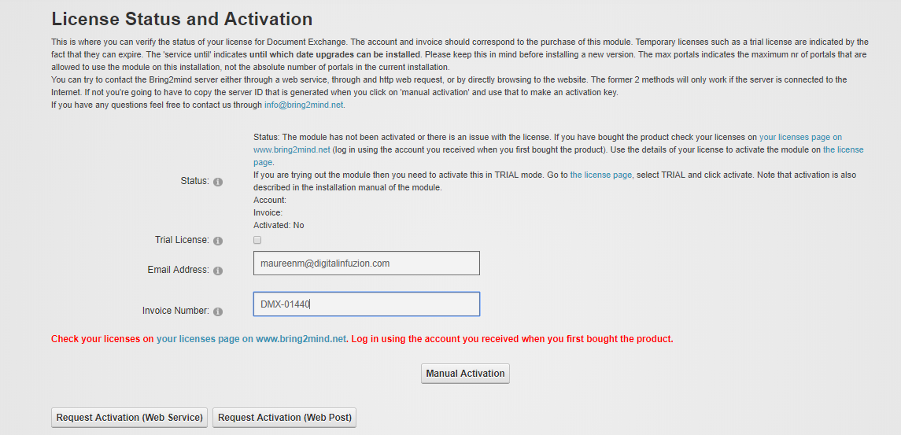

* Click on the button **Request Activation (Web Service)** button. This will automatically generate the Activation key. Save the Activation Key

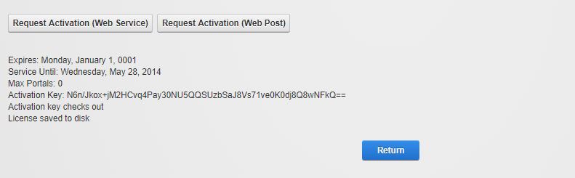

* Click on **Return**.
* Now select the **View in Layout Mode** Option.

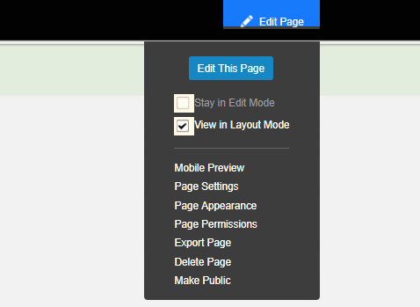

* You will see a drag and edit option. Click on the **Move** icon and select **contentPaneContainer1**.

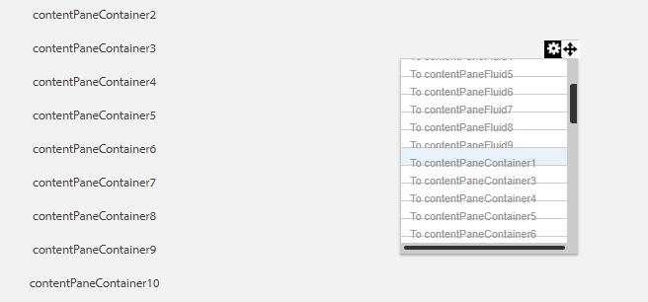

* Change the uploader: Go to Admin -> UploadSettings

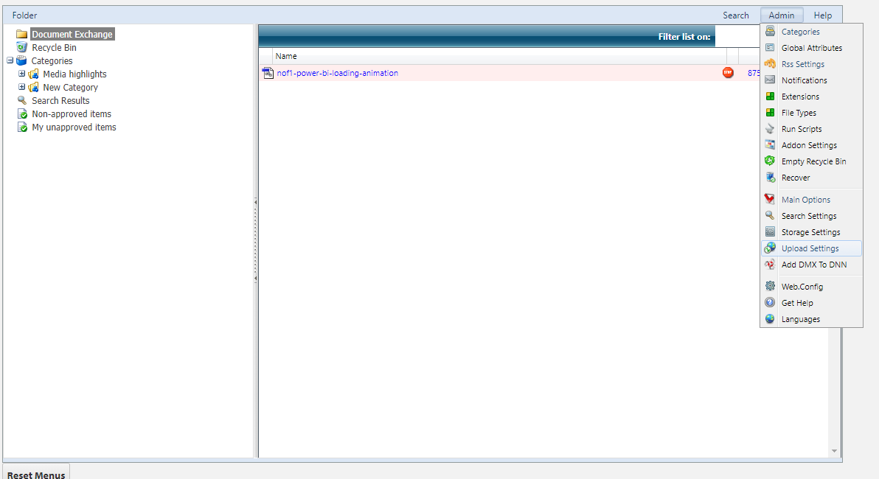

* Then Change Upload provider to AspnetUploadProvider

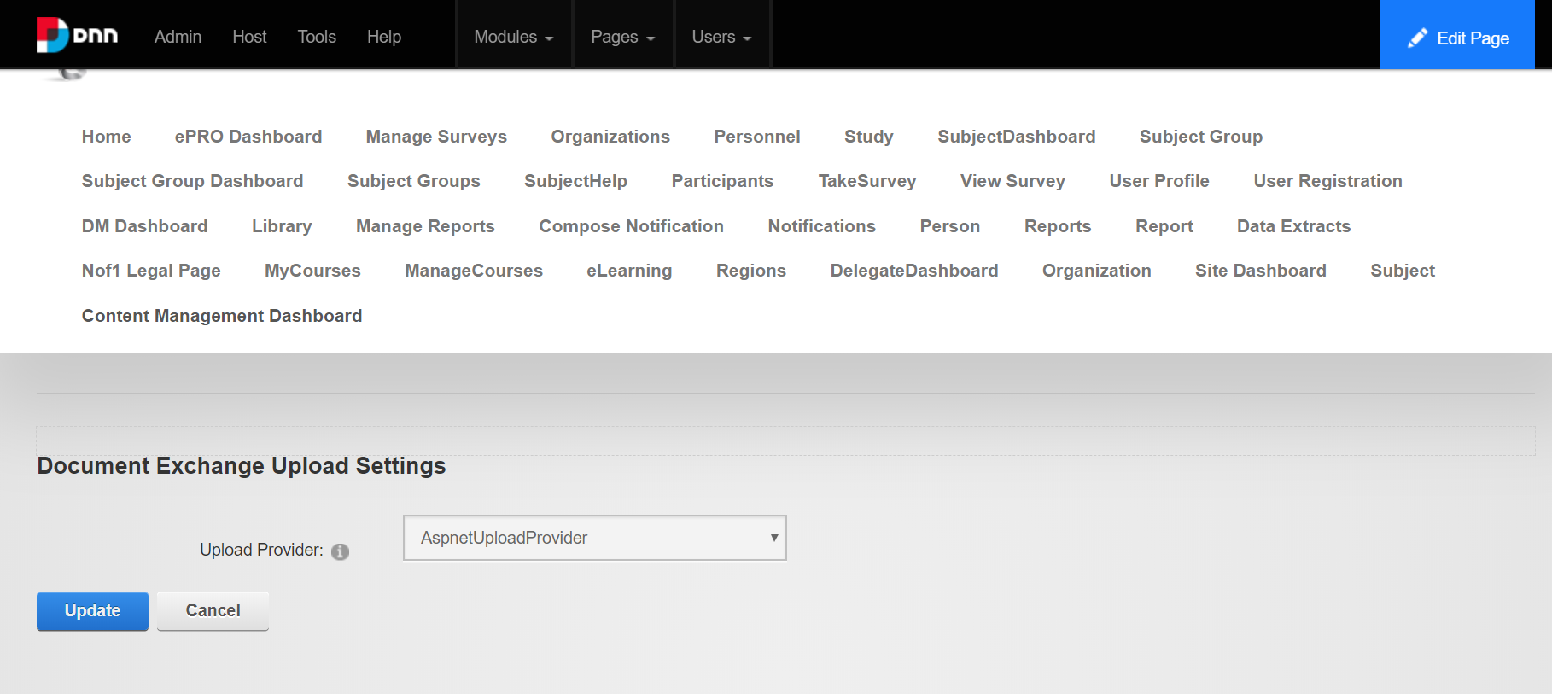

* Close the **View in Layout Mode** option. You will be taken to the **Content Management Dashboard** Section again. Select **Admin>>Main Options.**

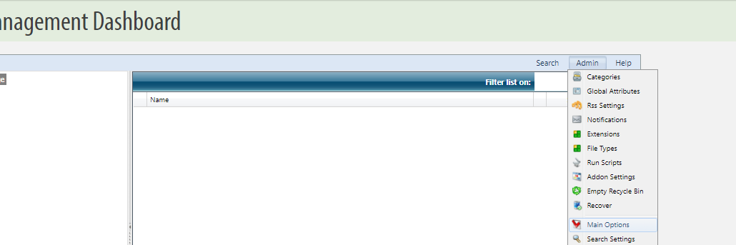

* Set the permissions as follows and click on **Update.**

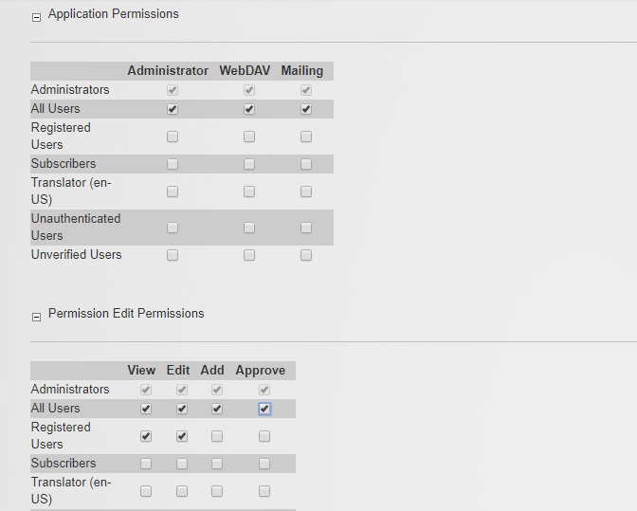

* After the permissions are set, run this sql script against the dnn database:

|  |
| --- |
| **SQL script to fix permissions** |
| **Alter PROCEDURE [dbo].[DMX_GetApplicationPermissionsForUser]**  **@PortalId INT,**  **@UserId INT**  **AS**  **SELECT TOP 1 \***  **FROM dbo.vw_DMX_ApplicationPermissions ap**  **LEFT JOIN dbo.vw_DMX_ActiveUserRoles aur**  **ON ap.RoleId=aur.RoleId**  **WHERE ap.PortalId = 0**  **AND PermissionId = 1**  **AND ap.AllowAccess = 1** |

* 1. **Populate Media Highlight Library Section on-Site Dashboard**
* Files to display in Media Highlight Library need to be uploaded in Category called “Media Highlights”. This folder may be missing in categories.
* 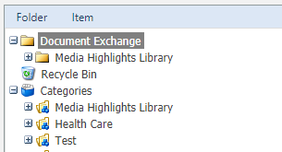
* Login to portal using Super User Credentials.
* Go to Library->CM Dashboard.
* Go to Admin (Right Hand side menu) -> Categories
* 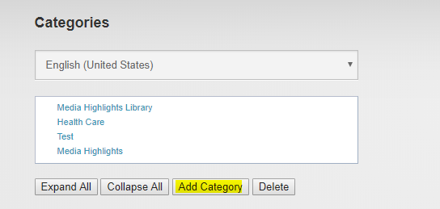
* Select Add Categories and add Category called “Media Highlights”. (Please make sure name should be exactly same as “Media Highlights”).
* Select “Update”.
* Upload Documents in this folder.
  1. **Install the Self-Signed Certificate on the Virtual Machine**
* Connect to the virtual machine over Remote Desktop. Make sure that you are sharing your local drive(s) with the VM over the Remote Desktop connection.
* Copy the self-signed certificate in the VM using FTP and then click on it.
* On the screen that appears, select **Current User.**

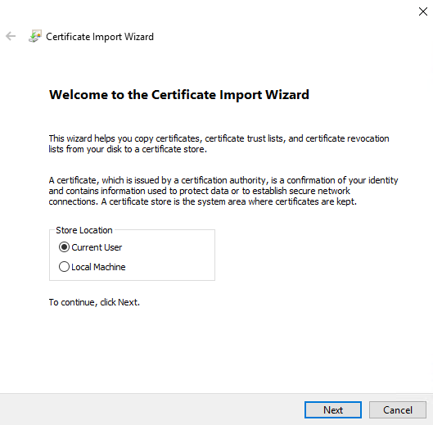

* Browse and upload the self-signed certificate to the virtual machine.

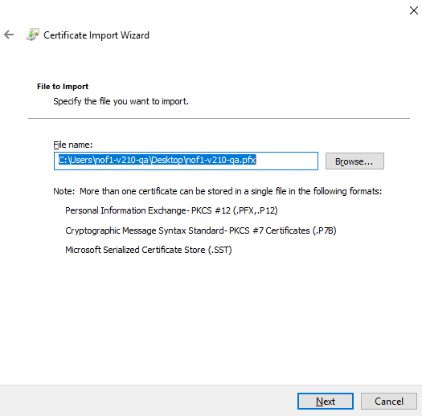

* Click on **Next**. You will need to provide the password. You had stored while creating the certificate.

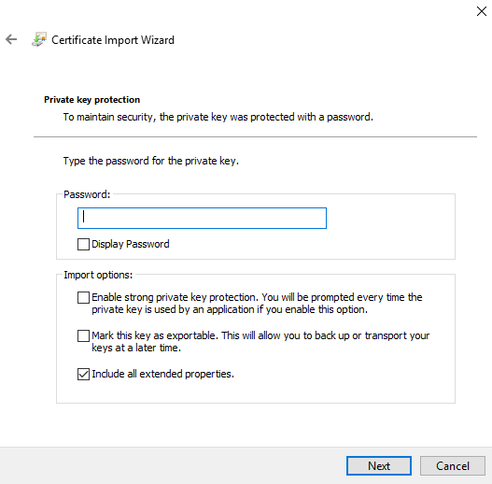

* On the next screen select **Next.**

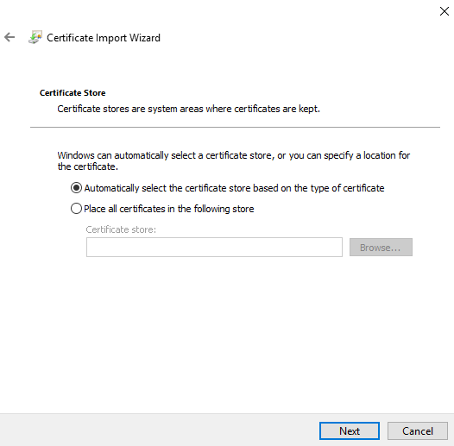

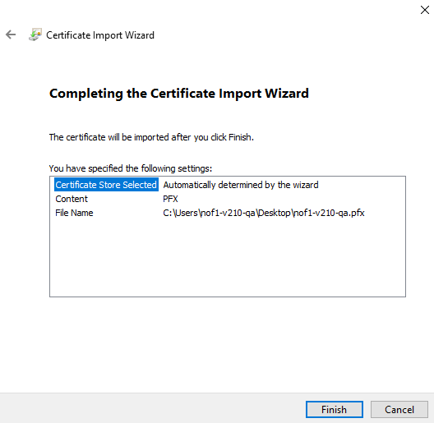

* Click on **Finish.**
  1. **Install the nof1health Certificate on the Virtual Machine**
* Copy the nof1health signed certificate on the VM. Select **Local Machine** as the Store location.

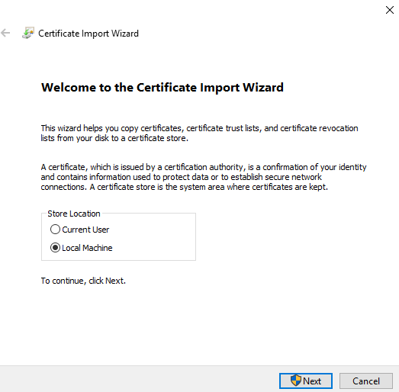

* On the next screen click on **Next.**

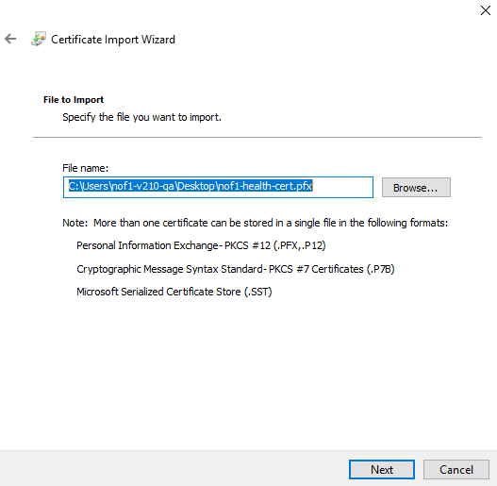

* On the next screen put the password and click on **Next.**



* On the next screen select the default value**.**



* Click on **Finish.**



* In IIS Manager, create an **https** binding for the portal website.

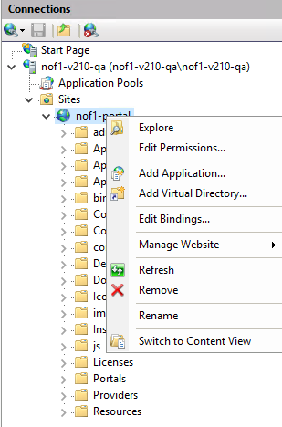

* Click on Add Bindings and Select the Type – **https**. Port number should be 443.
* Select the nof1health.com certificate from the SSL certificate dropdown menu.

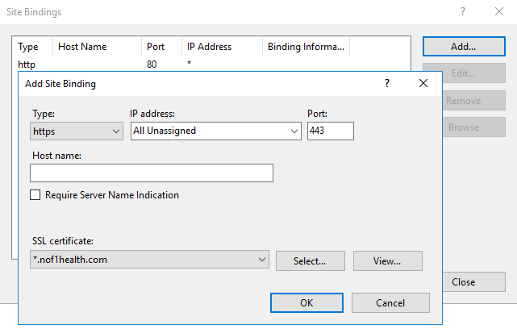

* Click on **OK.** Your deployment is now complete.
  1. **Install OpenSSH on the machine**
* Open power-shell download and https://github.com/PowerShell/Win32-OpenSSH/releases
  1. **Create azure storage blob container for portal styles**
* Open Storage Explorer, go to storage account of your azure environment.
* Right click on Blob Container and click on create blob container. Provide name ‘**portal-styles**’
* Once Container is created click on container. On top right grid select upload and upload ‘**variables-platform.less’** file on this container.

Setup Powerbi

* 1. **Registering the Power BI App**
* The Power BI app should be registered per environment. Use this [**link**](https://dev.powerbi.com/apps) to register the app to the Active Directory.
* You can find the instructions for registering the Power BI app [**here**](https://docs.microsoft.com/en-us/power-bi/developer/register-app#register-with-the-power-bi-app-registration-tool). Be sure to set up the app with the Read and Write options, as well as create content option, so that the API can read and make changes as necessary.
  1. **Setting the Power BI app permission in the AD app registry**
* Once you've registered the app in the Power BI Dev tool, you will need to register and configure the permissions on the Azure Active Directory. Setting additional permissions configurations is important to be able to embed content. You can find the instructions on how to do this [here](https://docs.microsoft.com/en-us/power-bi/developer/register-app#register-with-the-azure-portal).
* It is important, when setting the permissions, to un-check any options that require admin rights because the Master Account isn't necessarily an Azure AD Admin.

* 1. **Set up a Master account**
* To use Power BI to host the Nof1 platform, the Master account needs to be an Admin of the workspace it's accessing through the API. The account must be created by Difz IT and should be part of the accounts maintained in the Azure AD for which we set the permission in the above step.
  1. **Add a Power BI Pro Subscription to the Master account**
* Adding the subscription will need to be done by someone with access to the Office 365 store. The Product Owner is a good contact when trying to add the subscription to the user.
  1. **Creating a Power BI workspace using the Master account**
* Login using the Master Account

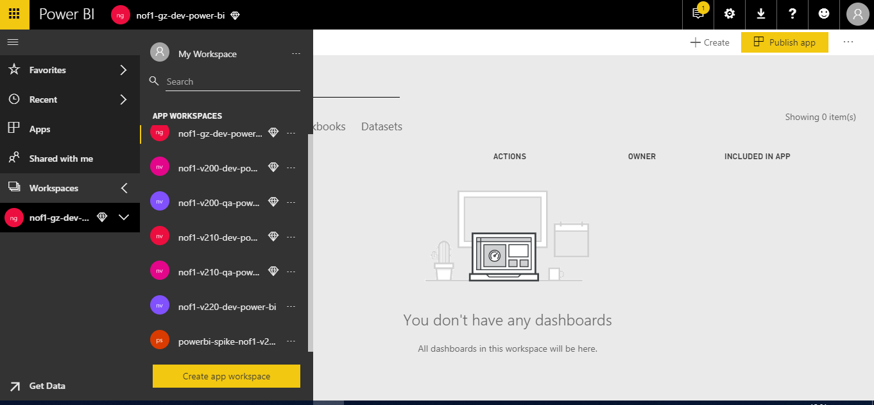

* Click on Create app workspace. You will see the below screen

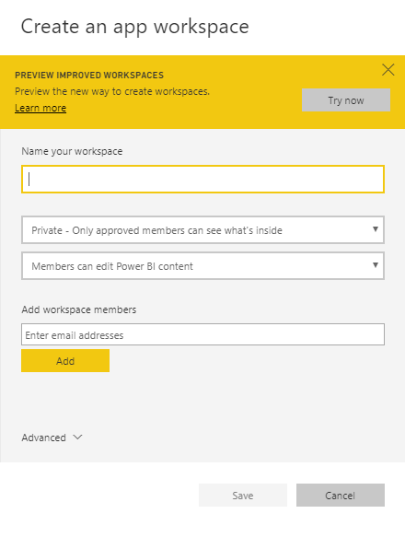

* Fill in the following details

|  |  |
| --- | --- |
| **Powerbi Workspace** | **Value** |
| Name your workspace | *Customeridentifier-version-environment-***power-bi** |
| Available | Keep default values |
| Email address | Put all stakeholders’ emails |

**Note:** While creating the workspace, you can also set the availability of the workspace as Private - Only approved members can see what's inside and you also have the option to add any Azure AD members that should have access to the workspace as well as their role at the workspace. For developers, Admin roles might be useful. The roles can be updated later.

* Once the workspace has been created, edit the workspace to set the dedicated capacity. This is only available if the master account has a Power BI Pro account and a capacity has been purchased. You can find purchase information about the capacity [here](https://docs.microsoft.com/en-us/power-bi/developer/embedding-content#embedding-for-your-customers).[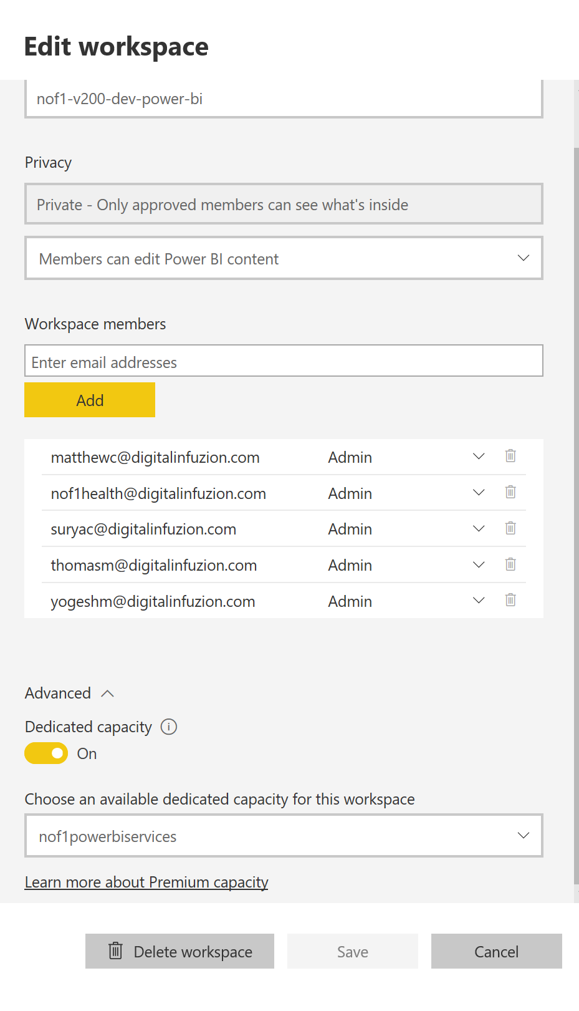](https://nuget.nof1health.com:8443/Attachments/powerbi-capacity.png)
  1. **Set the Configuration keys and values**
* You will need to save the Master Account Credentials in the environment's key vault as **PowerBI-MasterAccount-Username** and **PowerBI-MasterAccount-Password**. You will also need to get the workspace's groupid from the URL in the Power BI portal. For example, a sample url would look like: **https://app.powerbi.com/groups/04b1a7fa-82aa-4aac-ae85-c4bd2388560f/contentlist?onlySharedWithMe=false** where the group id is specified after groups.
* Once you have the group id, you can set the following values in the Azure Storage Table Configuration:

|  |  |  |
| --- | --- | --- |
| **Partition Key** | **Rowkey** | **Value** |
| Nof1:PowerBI | GroupId | {groupId} |
| Nof1:PowerBI | ResourceUrl | https://analysis.windows.net/powerbi/api |
| Nof1:PowerBI | AuthenticationContextUrl | https://login.windows.net/common/oauth2/authorize/ |

* 1. **Deploy PowerBI**
* Open the project  **Nof1Health.Utilities.CommandLineB2CAuth** and build it.
* Open the project **UploadPowerBiReport** and built it.
* Open the file **RunReportDev.ps1** from EnvironmentSetup\AzureSetup\Scripts\DataInitialization folder path into PowerShell ISE and check/update the target database and Datawarehouse values for following variables.

|  |
| --- |
| **Script to change in the RunReport{environment).ps1** |
| $Nof1Database = "*customeridentifier-version*-nof1-*environment*";  $DwDatabase = " *customeridentifier-version*-dw-*environment* "; |

* Check how many studies we have from the portal and from table [Study].[StudyProtocol]. Update their protocol ID and Display name for below variable. And commented out the value for non-existing study.

|  |
| --- |
| **Script to change in the RunReport{environment).ps1** |
| $studyProtocol1Id = "5681DFB1-CF49-4DD6-B576-E5CB4A46849B".ToLower();  $studyProtocol1DisplayName = "Study Name"; |

* There are total 12 roles on portal through which we can access the report. So update their Id’s into the script from table [Platform].[StudyRole]. You get these from the platform database.

|  |
| --- |
| **Script to change in the RunReport{environment).ps1** |
| $contentManagerId = "26657865-DF19-444E-BC2E-1BCAABC39FA2".ToLower();  $dataManagerId = "2B8021C8-8CBD-4AC5-A269-F24462761F9A".ToLower();  $edcCoordinatorId = "BE42B849-DD9C-4494-8188-F3CD6DE1C6D4".ToLower();  $eproCoordinatorId = "8D76ACCD-949D-4428-BE87-8A2533A146D1".ToLower();  $helpDeskId = "D1BF5F0E-61E0-48A8-BD83-0480DD52CEB3".ToLower();  $nof1ManagerId = "E052CA67-3885-4F65-BEE4-30DD15CFA18C".ToLower();  $nurseId = "863DE40C-D041-49CB-894C-6D72A5E1EFEB".ToLower();  $participantPersonnelManagerId = "DEACB10D-CBC3-49EB-BD55-EEA274308B3B".ToLower();  $participantManagerId = "01FA12FB-2C70-41F3-B400-4DCA127682A1".ToLower();  $personnelManagerId = "B2CA0D37-B591-4144-A622-6FA002A43A81".ToLower();  $physicianId = "86BC687A-7EC0-4263-9A9D-87A61690D698".ToLower();  $studyManagerId = "96470784-184B-4A61-9312-6D4F91BB5B7D".ToLower(); |

**Note:** Study Role ID from Database:

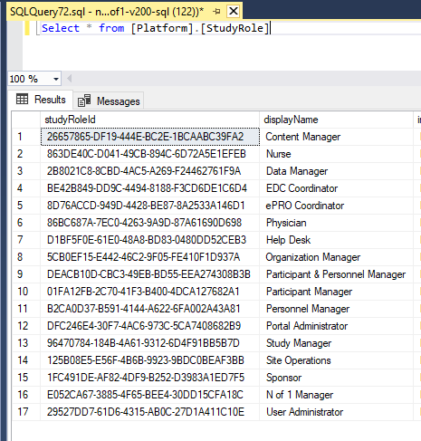

* If we have only one study, then comment out everything related to studyProtocol2 across the script.

|  |
| --- |
| **Script to change in the RunReport{environment).ps1** |
| #$studyProtocol2 = "true"; #NOF1 |

* Save all changes which are made in RunReportDev.ps1.
* Open **UploadReport.ps1** and Comment out everything related to studyProtocol2 as mentioned below.

|  |
| --- |
| **Script to change in the UploadReport.ps1** |
| <#  if ($studyProtocol2.ToLower() -eq "true")  {  $ReportStudyProtocols = $ReportStudyProtocols + ',';  }  #>  <#  if ($studyProtocol2.ToLower() -eq "true")  {  $ReportStudyProtocols = $ReportStudyProtocols + '  {{  "StudyProtocolId": "{0}",  "Id": null  }}' -f $studyProtocol2Id, $studyProtocol2DisplayName;  }  #> |

* Next open **Authenticateuser.ps1** and change the following code.

|  |
| --- |
| **Script to change in the Authenticateuser.ps1** |
| $B2CTenant = "customeridentifierversion**b2c**environment.onmicrosoft.com";  $B2CApplicationId = "b834bd61-1928-476f-9ae4-aa100bed1280";  $B2CApplicationName = "nof1-portal";  $B2CPolicy = "**B2C_1**_customeridentifier-environment-**signin**"; |

* Once all the changes are done, run **RunReportDev.ps1**. It will prompt you for log In. Use Nof1 Manager credential and login it. There are total 12 standard report we have as of now, once script execution is done you can go to the Manage Report and check the uploaded report.

B2C function configuration for B2C user account display name and e-mail ID update

Open Powershell command prompt and change command path to following path in Nof1 development source code: \GenesisNof1\Nof1HealthPlatform\EnvironmentSetup.

In the PowerShell console, execute these commands:

.\B2CGraphAPIService-AppRegistration.ps1 -TemplateParameterFile {TemplateParameterFileName}

.\Add-Key-Keyvault-StorageTable.ps1 -templateParameterFile {TemplateParameterFileName} -subscription {StorageTableSubscriptionName}

.\Import-Cetificate-AppSetting.ps1 -templateParameterFile {TemplateParameterFileName} -certificateFilePath {CertificateFilePath}

B2CGraphAPIService-AppRegistration.ps1 script will create an Azure AD Application which will be used to update user diaplay name and email ID in B2C AD tenant. Script will populate the azureADB2CGraphAPIAppId and azureADB2CGraphAPIAppPassword parameters in the parameters file.

Add-Key-Keyvault-StorageTable.ps1 script will add B2C-Graph-API, Nof1SharedFunction-B2CGraphAPI-DisplayName-FunctionKey and Nof1SharedFunction-B2CGraphAPI-LoginEmail-FunctionKey keys in keyvault. This script also add SharedFunctionBaseUrl and ApplicationName keys in configuration table on Azure Storage.

.\Import-Cetificate-AppSetting.ps1 script will import .pfx certificate and update WEBSITE_LOAD_CERTIFICATES application setting on Nof1-SharedFunctions Azure function.

Backup and Recovery

* 1. VM backup
* Ensure Recovery Services vault with {{customerIdentifier}}-recovery-vault naming convention present in {{customerIdentifier}}-shared resource group.
* If resource group with naming convention {{customerIdentifier}}-shared is not present in subscription then create the resource group.
* If {{customerIdentifier}}-recovery-vault is not present then go to azure portal and create new azure Recovery Services vault using {{customerIdentifier}}-recovery-vault naming convention in {{customerIdentifier}}-shared resource group. A new vault should be created in the same azure location as the virtual machine’s azure location.
* Ensure a backup policy with {{customerIdentifier}}-vm-backup-policy naming convention is present. Policy should be configured to retain daily backup for 90 days and monthly backup for 24 months. If policy is not present then create a new policy.
* Sign in to the Azure portal.
* In search, type Recovery Services. Under Services, click Recovery Services vaults.

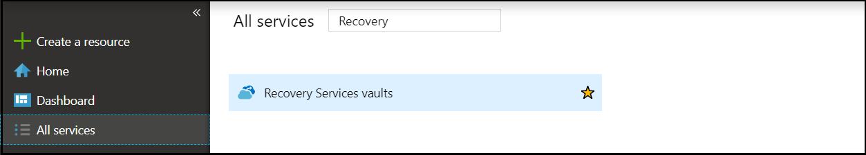

* In Recovery Services vaults menu, click +Add.

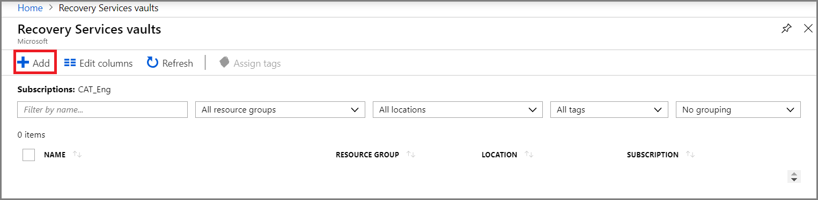

* Click Create a resource > Management Tools > Backup and Site Recovery.
* In Name, specify {{customerIdentifier}}-recovery-vault to identify the vault.
* select {{customerIdentifier}}-shared resource group. Specify East US2 in Azure region then click Create.
* In the backup vault properties go to getting started section and click on backup. In right side you will see below blade.

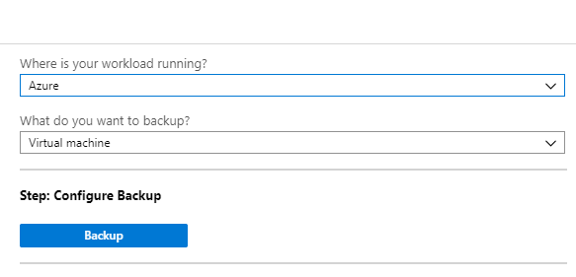

* Click on backup. Select {{customerIdentifier}}-vm-backup-policy in ‘Backup policy’ blade.

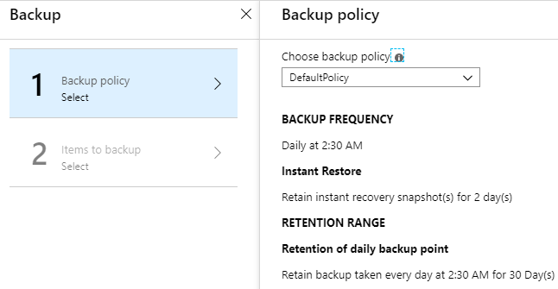

* In next blade ‘Items to backup’ select your virtuam machine.
* Then click on enable backup.
* You can also enable backup by going into the VM properties, then click Backup. The VM status is Initial Backup Pending until the initial backup runs
* Click Back up now to run an on-demand backup.

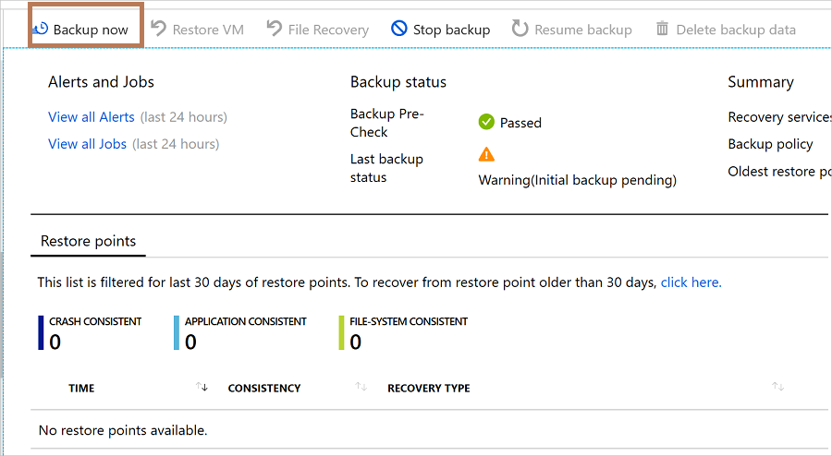

* 1. VM Disaster recovery
* This is recommended for VMs running in production. We can skip this part for Develop and QA environment.
* Log in to the Azure portal at <https://portal.azure.com>.
* In the Azure portal, click Virtual machines, and select the VM you want to replicate.
* In Operations, click Disaster recovery.
* In Configure disaster recovery > Target region select the target region ‘West US.

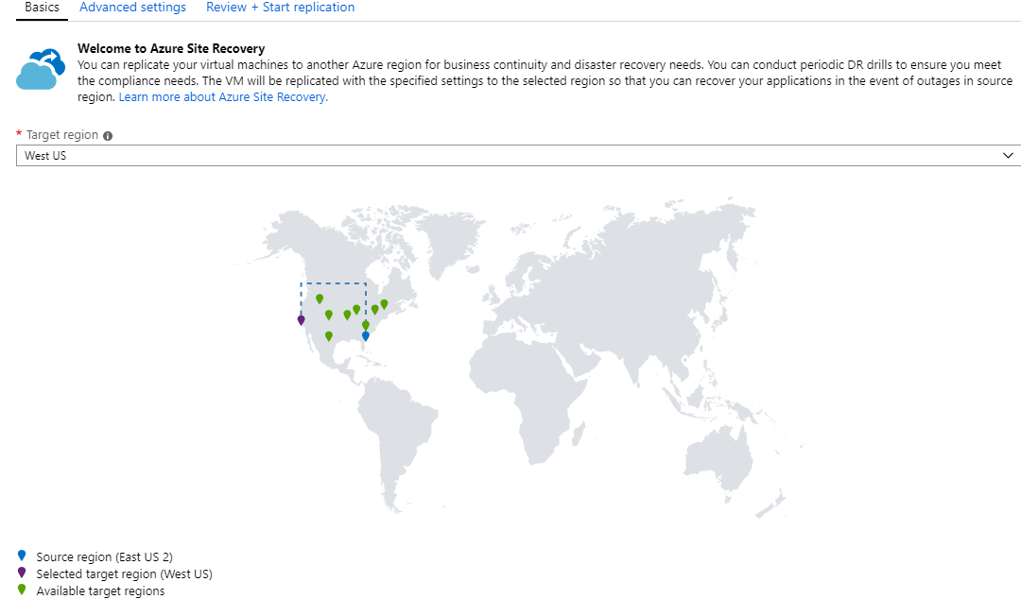

* In the right side blade click on Ádvanced Settings’. Here select your subscription then click on ‘Next: Review + Start replication’

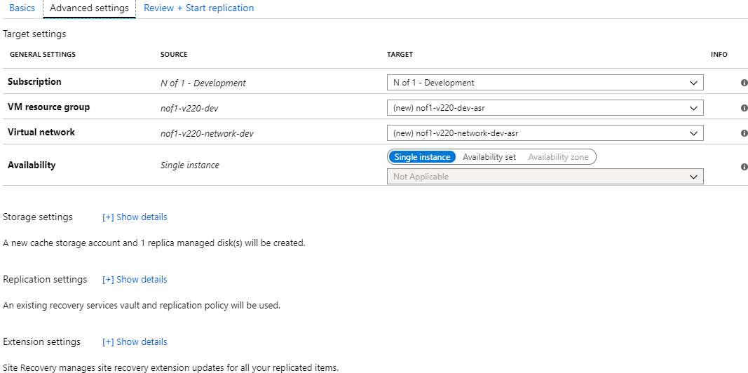

* Click ‘Start replication’. This starts a job to enable replication for the VM.

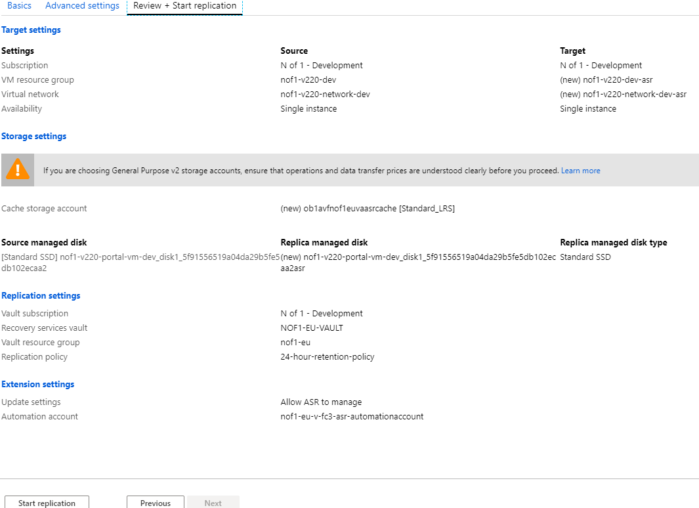

* 1. Cost on Virtual Machine Backup and DR

For virtual machines (VM) backup, the size calculation is based on actual (used) size of VM. This is the sum of all data in the VM, excluding temporary storage. You have the flexibility to choose between locally redundant storage (LRS) or geo-redundant storage (GRS). Both LRS and GRS are Block Blob Storage. Charges for storage are separate from the cost of Azure Backup.

|  |  |
| --- | --- |
| **SIZE OF EACH INSTANCE** | **AZURE BACKUP PRICE PER MONTH** |
| Instance < or = 50 GB | $5 + storage consumed |
| Instance is > 50 but < or = 500 GB | $10 + storage consumed |
| Instance > 500 GB | $10 for each 500 GB increment + storage consumed |

**Backup Storage**

Azure Backup uses Block Blob storage for backing up your instances. You have the flexibility to choose between locally redundant storage (LRS) or geo-redundant storage (GRS). Both LRS and GRS are Block Blob Storage.

|  |  |  |
| --- | --- | --- |
| **Storage Type** | **LRS** | **GRS** |
| Storage in GB/Month | $0.0224 per GB | $0.0448 per GB |

**Cost on disaster recovery of Azure VM:**

* ASR licensing cost per VM.
* Network egress costs to replicate data changes from the source VM disks to another Azure region. ASR uses built-in compression to reduce the data transfer requirements by approximately 60 percent.
* Storage costs on the recovery site. This is typically the same as the source region storage plus any additional storage needed to maintain the recovery points as snapshots for recovery.

|  |  |  |
| --- | --- | --- |
| **Scenario** | **PRICE FOR FIRST 31 DAYS** | **PRICE AFTER 31 DAYS** |
| Azure Site Recovery to customer owned sites | Free | $16/month per instance protected |
| Azure Site Recovery to Azure | Free | $25/month per instance protected |

* 1. Azure SQL Backup

**Automated backups**

SQL Database automatically creates the database backups that are kept between 7 and 35 days, and uses Azure read-access geo-redundant storage (RA-GRS) to ensure that they are preserved even if the data center is unavailable. These backups are created automatically. SQL Database uses SQL Server technology to create full backups every week, differential backups every 12 hours, and transaction log backups every 5-10 minutes. The backups are stored in RA-GRS storage blobs that are replicated to a paired data center for protection against a data center outage. All Azure SQL databases (single, pooled, and managed instance databases) have a default backup retention period of seven days. You can change backup retention period up to 35 days.

**Long-term backup retention**

* This is recommended for VMs running in production. We can skip this part for Develop and QA environment.
* In the Azure portal, select your SQL server and then click Manage Backups. On the Configure policies tab, select the checkbox for the database on which you want to set or modify long-term backup retention policies. If the checkbox next to the database is not selected, the changes for the policy will not apply to that database.

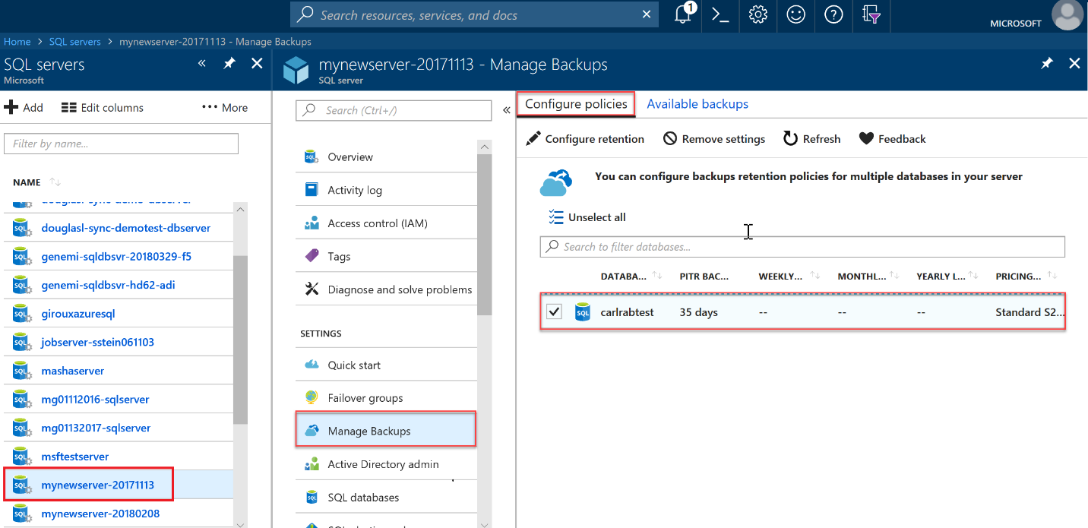

* In the Configure policies pane, select if want to retain weekly, monthly or yearly backups and specify the retention period for each. Its recommended to select 3 weekly backups and 24 monthly backups. Please also check with customer if they have any suggestion.
* When complete, click Apply.

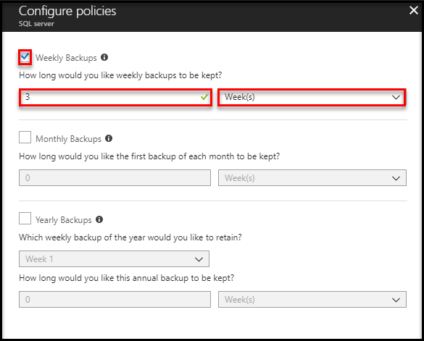

* 1. Cost on Azure SQL backup

**Extra Data Storage:**

|  |  |
| --- | --- |
| **SERVICE TIER** | **PRICE** |
| Standard | $0.204/GB/month |
| Premium | $0.408/GB/month |

**Long-term retention:**

|  |  |
| --- | --- |
| **Location** | **PRICE** |
| RA-GRS | $0.05/GB/month |
| ZRS | $0.0313/GB/month |
| LRS | $0.025/GB/month |

Configure PHI Audit Trail

We have added Phi Audit Trail functionality in N of 1. Here are the steps to follow for deploying PHI Audit Trail:

1. Create a container called “phi-audit-trail” in blob storage.
2. Browse to Azure Function app called “Nof1FunctionStarter”. If not exist create a new one.
3. Add a new Cosmos DB trigger function from azure portal called “nof1-{customer name}-{environment}-PhiAuditTrail”.
4. While creating function use Cosmos DB settings as per environment .
5. Add collection as “phi”.
6. Keep checkbox as “Checked” for Create lease collection if it does not exist.
7. Keep collection name for leases as “leases”.
8. Create function.
9. Replace function code by below code.

if (documents != null && documents.Count > 0)

    {

        for (var doc = 0; doc < documents.Count; doc++)

            {

                log.Info($"C# Cosmos Db Trigger function for N of 1 executed at: {DateTime.Now}");

                HttpClient client = new HttpClient();

                var apiURL = "<https://nof1-sharedfunctions.azurewebsites.net/api/audittrail/phi?code=ZKgeMEmpQ1BBVybeH4wMZvT5QVF2ClcCBggKK/kSoiisMBeF0GhtXg==&ApplicationID=f2452055-443b-40b9-8041-1d355930ad0b&CertificateThumbPrint=7E9B913C2720EE44D740094415C7D846D82919C1&ApplicationName=Nof1&KeyVaultBaseURL=https://nof1-v220-keyvault-qa.vault.azure.net/secrets/>";

                var json = JObject.Parse(documents[doc].ToString());

                // Use the JSON formatter to create the content of the request body.

                HttpContent content  = new StringContent(json.ToString(), Encoding.UTF8, "application/json");

                var response = client.PostAsync(apiURL, content);

                var responseString = response.Result.Content.ReadAsStringAsync();

                log.Info(responseString.Result);

            }

    }

1. Replace highlighted URL by environment specific values.
2. Replace namespace and reference values by below code :

#r "Microsoft.Azure.Documents.Client"

#r "Newtonsoft.Json"

using System;

using System.Collections.Generic;

using Microsoft.Azure.Documents;

using Newtonsoft.Json;

using System.Net.Http.Formatting;

using Newtonsoft.Json.Linq;

using System.Text;

1. Save the function.

Manage wild card certificates on VM

* 1. Import Certificate

Import new *\*.nof1health.com* certificate to keyvault.

Open powershell as admin and Go to following path in source code nof1HealthPlatform\EnvironmentSetup\Certificate.

In the PowerShell console, execute this command:

.\ImportCert.ps1 -CertificateName {Nof1Health-WildCard} -keyVaultName {name of keyVault} -CertificateFilename {physical path of certificate} -CertificatePassword { Certificate Password} -keyVaultAdminTenant {Tenant of vault}

* 1. Create Virtual Machine Managed Identity

Create a Managed Identity for VM. VM use this ID to access Certificate on Vault.

Open powershell as admin and Go to following path in source code nof1HealthPlatform\EnvironmentSetup\Certificate.

In the PowerShell console, execute this command:

.\createManagedIdentity.ps1 -VMResourceGroup { VM Resource Group } -VMName { VM Name} -VmSubscriptionId { Vm Subscription Id } -VaultName { Vault Name } -VaultSubscriptionId { Vault Subscription Id } -VaultResourceGroupName { Vault Resource Group Name }

* 1. Deploy Key vault Extension on VM

Deploy Key vault Extension on VM using powershell.

Open powershell as admin and Go to following path in source code nof1HealthPlatform\EnvironmentSetup\Certificate.

In the PowerShell console, execute this command:

.\VMExtension-sharedKV.ps1 -keyVaultName { Vault Name } -portalVmName { VM Name} -VMresourceGroupName { VM Resource Group } -VMLocation { VM Location } -CertificateName { CertificateName } -VmSubscriptionId { VM Subscription Id }

* 1. Binding IIS web site with certificate

Certificate will be deployed to VM using key vault extension. This step use VM extension to run powershell script on VM to bind web site with wild card certificate on port 443. You can upload ExtensionSetting.ps1 script on any blob storage and set anonymous read access for blob folder so that VM extension can read ExtensionSetting.ps1 script.

Open powershell as admin and Go to following path in source code nof1HealthPlatform\EnvironmentSetup\Certificate.

In the PowerShell console, execute this command:

.\IISBinding.ps1 -VMResourceGroup {VM Resource Group} -VMName {VM Name} -VMLocation { VM Location } -URI {URI of blob storage of ExtensionSetting.ps1 script } -scriptName {ExtensionSetting.ps1}

Study Color Configuration

This section include guidelines to automate steps we need to change the colors of the study using study color configuration.

Please refer following document for more detail of Study Color Configuration:

<https://tfssp.digitalinfuzion.com/sites/GenesisNof1/_layouts/15/WopiFrame2.aspx?sourcedoc=/sites/GenesisNof1/Technical%20Content/Configuration%20Guides/Study%20Color%20Configuration/Study%20Color%20Configuration.docx&action=default>

* 1. Build ConfigurationStudyColor Project

Open Nof1helathPlatform Solution in latest Visual Studio and go to Utils folder and build ConfigurationStudyColor Project.

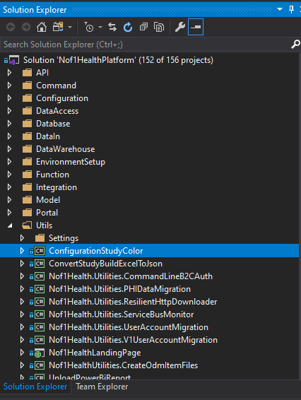

* 1. Copy ConfigurationStudyColor folder to C drive on Portal VM
* Open Source code in File Explorer.
* Go to following path *\GenesisNof1\Nof1HealthPlatform\Utils in File Explorer.
* Copy ConfigurationStudyColor folder to C drive on Portal VM
  1. Run Powershell Script to Create Blob Container

Here we will use Create-Blob-Container.ps1 script to create Blob container with name study-colors-config in storage account.

Open powershell as admin and Go to following path in source code nof1HealthPlatform\EnvironmentSetup\.

In the PowerShell console, execute this command:

.\Create-Blob-Container.ps1 -Subscription {Azure Subscription ID} -TemplateParameterFile {Path of Parameter File}

* 1. Run Powershell Script to Create Task Schedular

In this section we will use ColorConfigTaskSchedular.ps1 to use VM extension and run another script named Set-ColorConfigTaskSchedular.ps1 to create task schedular task which will execute ConfigurationStudyColor.exe in portal VM from folder ‘C:\ConfigurationStudyColor\ConfigurationStudyColor\bin\Release’.

Open powershell as admin and Go to following path in source code nof1HealthPlatform\EnvironmentSetup\.

In the PowerShell console, execute this command:

.\Set-ColorConfigTaskSchedular.ps1 -TemplateParameterFile {Template Parameter File path}

1. Create Function to Process Mobile Data into Novi

For each environment that support mobile integration we need to create azure function to process mobile data into Novi.

* 1. Go to azure function name Nof1FunctionStarter on azure portal and copy content from existing ProcessMobileDataToNovi_env_Starter function

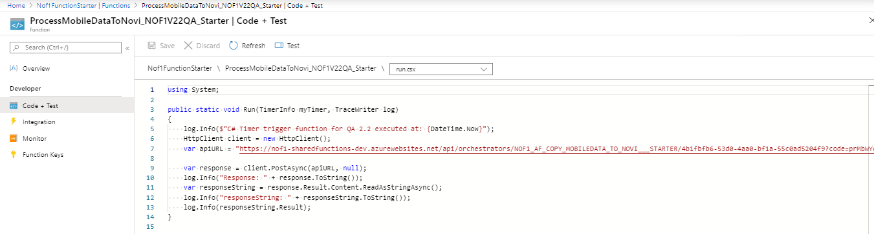

* 1. Change apiURL in copied function content based on new environment details:
     + - 1. Generate a Guid and put it in between below 2 sections: /NOF1_AF_COPY_MOBILEDATA_TO_NOVI___STARTER/{New Guid for Function} ?code=

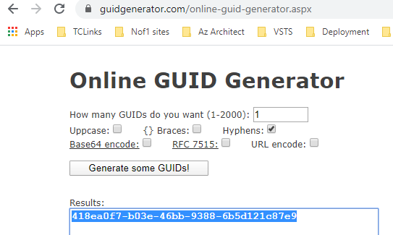

* + - * 1. **Function app url and function key:** [https://nof1-sharedfunctions-dev.azurewebsites.net/api/orchestrators/NOF1_AF_COPY_MOBILEDATA_TO_NOVI___STARTER/{New Guid}?code=prMbWYq4jl/ZBXa2rvEWdHSau9rEgyWZH/0wk7GXI8svXofJ2UQVig==](https://nof1-sharedfunctions-dev.azurewebsites.net/api/orchestrators/NOF1_AF_COPY_MOBILEDATA_TO_NOVI___STARTER/%7bNew%20Guid%7d?code=prMbWYq4jl/ZBXa2rvEWdHSau9rEgyWZH/0wk7GXI8svXofJ2UQVig==)

This url will remain the same unless until someone refresh the Functon Keys of Function apps.

* + - * 1. **ApplicationID:** Its same as activeDirectoryApplicationId of environment paramenter file.

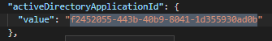

* + - * 1. **Nof1DWConnStringSecretIdentifierURL:** It’s a Keyvault secret ID for DataWarehouse-ConnectionString. Copy it from azure portal or powershell

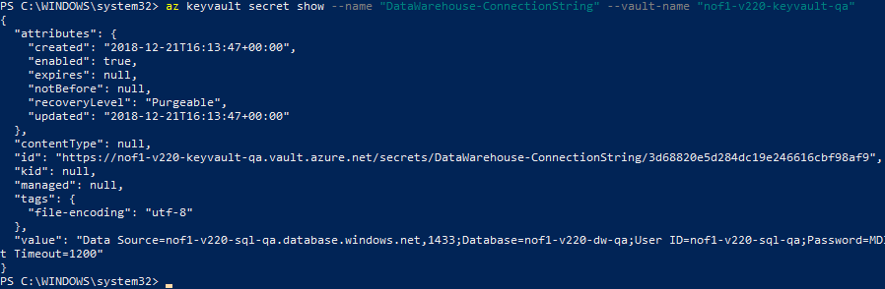

* + - * 1. : **CertificateThumbPrint:** Its same as **selfSignedCertificateThumbprint** of environment paramenter file:

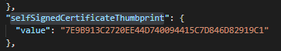

* + - * 1. **AppName:** Give a suitable name to application like:

DotNetCoreV21-QA

DotNetCoreV22-QA

DotNetCoreV22-Dev

* + - * 1. **HasUnprocessedMobileSurveys**: True or False, its based on support of Unprocessed Mobile Surveys of environment.
        2. **Nof1DBConnStringSecretIdentifierURL:** It’s a Keyvault secret ID for Entity-ConnectionString. Copy it from azure portal or powershell:

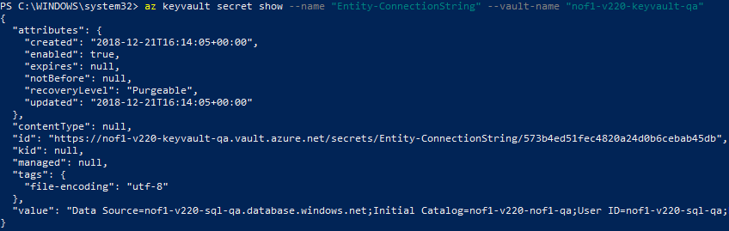

* + - * 1. **Nof1SBConnStringSecretIdentifierURL:** It’s a Keyvault secret ID for ServiceBus-ConnectionString. Copy it from azure portal or powershell:

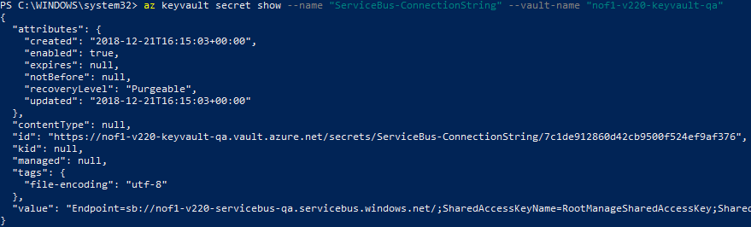

* 1. Create New Funtion and name it as existing naming convention:

Naming convention : ProcessMobileDataToNovi_{CusomterIdentifier+Environment}_Starter

Click on +Add button to create new azure function and choose Timer Trigger C#. Keep default time tigger of 5 minutes.

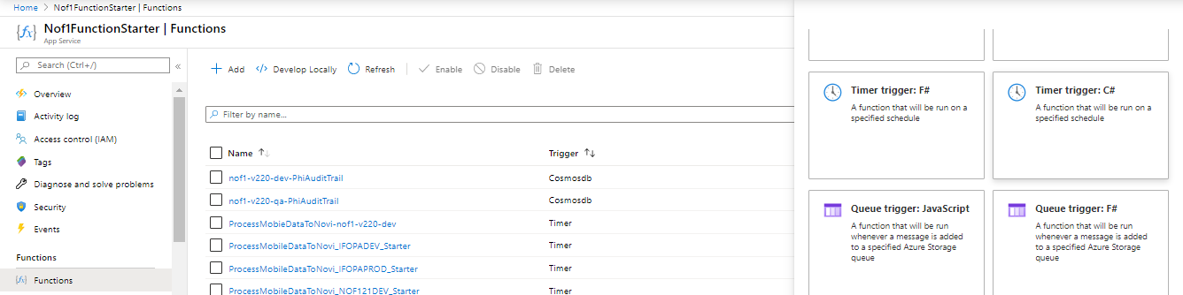

* 1. On New created function go to ‘ Code + Test’ section and paste the updated Function content

It Should look like below function app content with updated apiURL from section 26.2. Click on save button to save the new function app.

using System;

public static void Run(TimerInfo myTimer, TraceWriter log)

{

log.Info($"C# Timer trigger function for QA 2.2 executed at: {DateTime.Now}");

HttpClient client = new HttpClient();

var apiURL = "https://nof1-sharedfunctions-dev.azurewebsites.net/api/orchestrators/NOF1_AF_COPY_MOBILEDATA_TO_NOVI___STARTER/4b1fbfb6-53d0-4aa0-bf1a-55c0ad5204f9?code=prMbWYq4jl/ZBXa2rvEWdHSau9rEgyWZH/0wk7GXI8svXofJ2UQVig==&ApplicationID=f2452055-443b-40b9-8041-1d355930ad0b&Nof1DWConnStringSecretIdentifierURL=https://nof1-v220-keyvault-qa.vault.azure.net/secrets/DataWarehouse-ConnectionString/3d68820e5d284dc19e246616cbf98af9&CertificateThumbPrint=7E9B913C2720EE44D740094415C7D846D82919C1&AppName=DotNetCoreV22-QA&HasUnprocessedMobileSurveys=true&Nof1DBConnStringSecretIdentifierURL=https://nof1-v220-keyvault-qa.vault.azure.net/secrets/Entity-ConnectionString/573b4ed51fec4820a24d0b6cebab45db&Nof1SBConnStringSecretIdentifierURL=https://nof1-v220-keyvault-qa.vault.azure.net/secrets/ServiceBus-ConnectionString/7c1de912860d42cb9500f524ef9af376";

var response = client.PostAsync(apiURL, null);

log.Info("Response: " + response.ToString());

var responseString = response.Result.Content.ReadAsStringAsync();

log.Info("responseString: " + responseString.ToString());

log.Info(responseString.Result);

}

1. Issues faced during new environment setup

Note1 : Nof1:AzureAd:Authority this key should be present in configuration table .Value : <https://takedab2cdev.b2clogin.com/takedab2cdev.onmicrosoft.com>, Otherwise API may not work and you will get b2c signup configuration download error.

Note2 : if you are creating new environment then you can not access site out side the portal VM without DNS entries. Inside VM you may access it with [http://localhost](http://localhost/) but from outside you will get 404 host not found error. Its because of web.config of application. You need to set up dns of nof1health.com first for new environment

Note3 : I was not able to login. Whenever I was clicking on login page it was not going forward. But After adding URL rewrite I was able to login and it was going forward and able to see dashboard.

Note4 : run this SQL query on DNN database update PortalLocalization set Custom404TabId=0

Note: Clear DNN cache

Note5 : Verify all out of box secrets-template.json keyvault Keys with any existing environment. If you missed any of these keyvault keys or given any wring value then sometime you may not able to see dashboard.

Note 6: All API error should be resolved else your Menu may not come

Note 7: Mega Menu folder is not there in skin project in source code I had to copy it from VM.

Note8 : Super user or other user should be added in Studyprotocolmember if not then user will get claim Issues

Note9 : Super user should be added in a studySite in database else he wont see any study site

Note10 : Nof1:AzureAd:Authority this key should be present in configuration table .Value : <https://takedab2cdev.b2clogin.com/takedab2cdev.onmicrosoft.com>, Otherwise API may not work

Note11 : Following module pages were not uploading:

* <https://takeda-dev.nof1health.com/Honorariums>
* <https://takeda-dev.nof1health.com/eLearningDashboard>
* <https://takeda-dev.nof1health.com/Regions>
* <https://takeda-dev.nof1health.com/eLearning>
* <https://takeda-dev.nof1health.com/Communications>

1. eLearning Dashboard
2. Incentives
3. Communications Dashboard
4. Manage eLearning Courses
5. Regions Listing page
6. Data Extract
7. Reports

This error was coming due to no entry of these pages in [dbo].[Tabs] table of DNN Database. I have compared tabs in takeda with tabs in v22 qa. And To create these missing entries we have to run sql queries given in the following path:

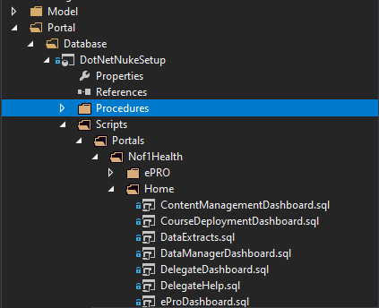

Note12 : For new instance of config tool always upload self signed certificate and its thumbprint in a variable for new environment in shared functions and we need to add this step in instance configuration guide as well

Note: 13 Add or Update RowKey for Study Acronym in configuration azure table storage

